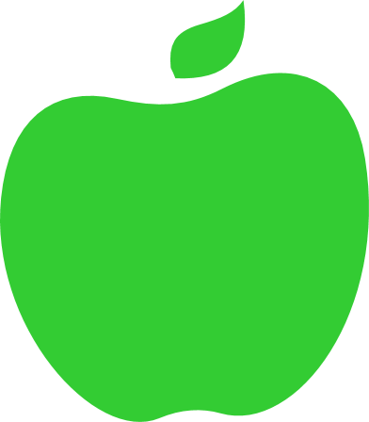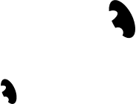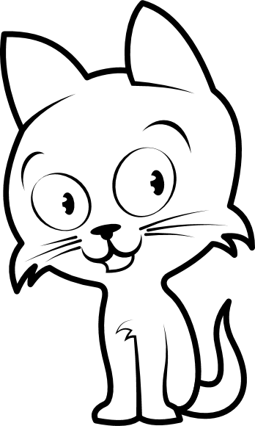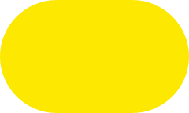

John 的每周奖励图表

|  |  |  |  |  |  |  |  |  |  |  |  |  |  |  |  |
| --- | --- | --- | --- | --- | --- | --- | --- | --- | --- | --- | --- | --- | --- | --- | --- |
| 我将… | | | | 周一 | | 周二 | | 周三 | | 周四 | 周五 | | 周六 | 周日 | |
|  | | 体育运动 练习 | |  | |  | |  | |  |  | |  |  | |
|  | | 健康饮食 | |  | |  | |  | |  |  | |  |  | |
|  | | 看书 | |  | |  | |  | |  |  | |  |  | |
|  | | 打扫我的房间 | |  | |  | |  | |  |  | |  |  | |
|  | | 做家庭作业 | |  | |  | |  | |  |  | |  |  | |
| 本周奖励： | |  | | 星 | |  | |  | | | 星 | | |
|  | | 星 | |  | |  | | | 星 | | |

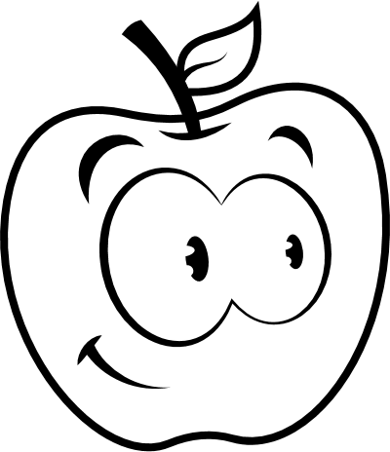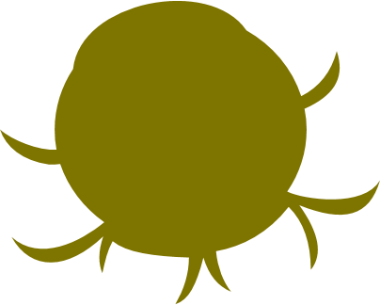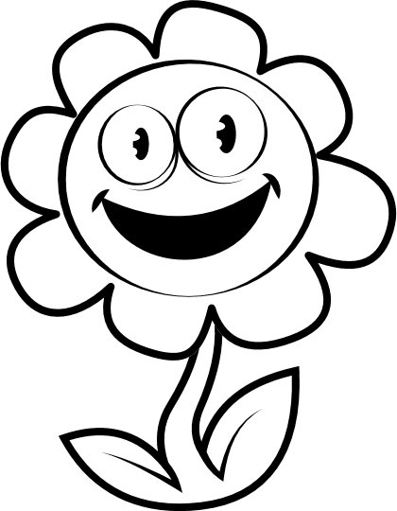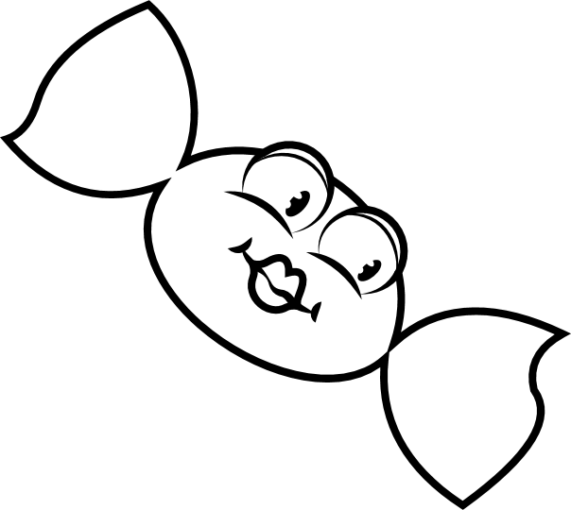

KATE 的每周奖励图表

|  |  |  |  |  |  |  |  |  |  |  |  |  |  |
| --- | --- | --- | --- | --- | --- | --- | --- | --- | --- | --- | --- | --- | --- |
| 我将… | | | 周一 | | 周二 | | 周三 | 周四 | 周五 | | 周六 | 周日 | |
|  | 体育运动 练习 | |  | |  | |  |  |  | |  |  | |
|  | 健康饮食 | |  | |  | |  |  |  | |  |  | |
|  | 看书 | |  | |  | |  |  |  | |  |  | |
|  | 打扫我的房间 | |  | |  | |  |  |  | |  |  | |
|  | 做家庭作业 | |  | |  | |  |  |  | |  |  | |
| 本周奖励： | | |  | | 星 | |  | |  | | 星 | | |
|  | | 星 | |  | |  | | 星 | | |



ALEX 的每周奖励图表

|  |  |  |  |  |  |  |  |  |  |  |  |  |
| --- | --- | --- | --- | --- | --- | --- | --- | --- | --- | --- | --- | --- |
| 我将… | | 周一 | | 周二 | | 周三 | 周四 | | 周五 | | 周六 | 周日 |
|  | 体育运动练习 |  | |  | |  |  | |  | |  |  |
|  | 健康饮食 |  | |  | |  |  | |  | |  |  |
|  | 看书 |  | |  | |  |  | |  | |  |  |
|  | 打扫我的房间 |  | |  | |  |  | |  | |  |  |
|  | 做家庭作业 |  | |  | |  |  | |  | |  |  |
| 本周奖励： | | |  | | 星 |  | |  | | 星 | | | |
|  | | 星 |  | |  | | 星 | | | |

#### 让我们收集需要获得的星星

