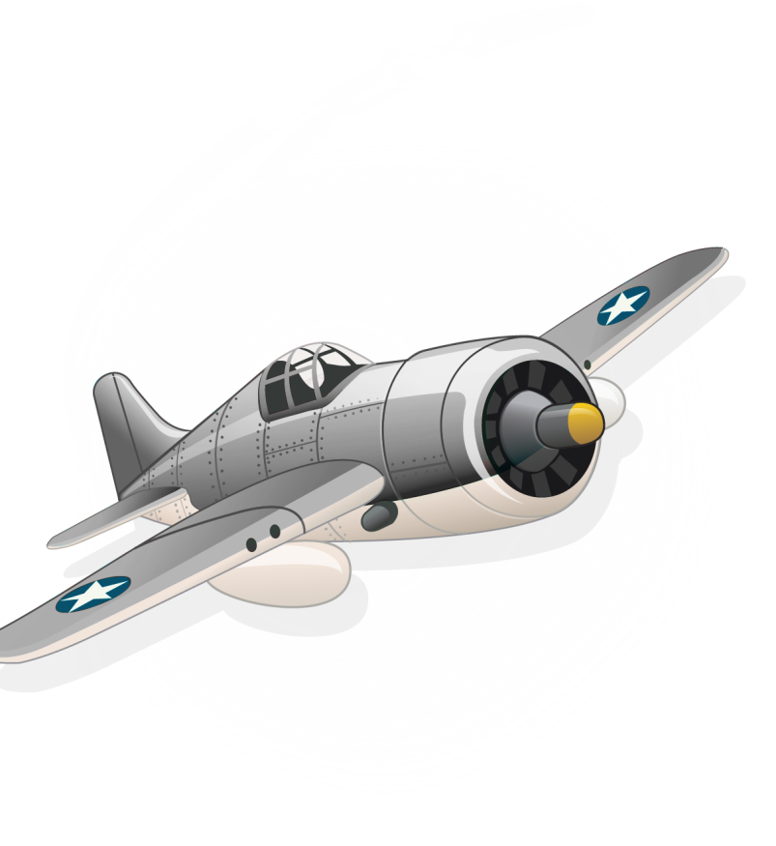

Суббота

|  |  |
| --- | --- |
| **1.** |  |
| **2.** |  |
| **3.** |  |
| **4.** |  |
| **5.** |  |
| **6.** |  |
| **7.** |  |
| **8.** |  |
| **9.** |  |

Среда

|  |  |
| --- | --- |
| **1.** |  |
| **2.** |  |
| **3.** |  |
| **4.** |  |
| **5.** |  |
| **6.** |  |
| **7.** |  |
| **8.** |  |
| **9.** |  |

Пятница

|  |  |
| --- | --- |
| **1.** |  |
| **2.** |  |
| **3.** |  |
| **4.** |  |
| **5.** |  |
| **6.** |  |
| **7.** |  |
| **8.** |  |
| **9.** |  |

Вторник

|  |  |
| --- | --- |
| **1.** |  |
| **2.** |  |
| **3.** |  |
| **4.** |  |
| **5.** |  |
| **6.** |  |
| **7.** |  |
| **8.** |  |
| **9.** |  |

|  |  |
| --- | --- |
| **1.** | **08.30 – 09.10** |
| **2.** | **09.20 – 10.00** |
| **3.** | **10.20 – 11.00** |
| **4.** | **11.20 – 12.00** |
| **5.** | **12.10 – 12.50** |
| **6.** | **13.00 – 13.40** |
| **7.** | **13.50 – 14.30** |
| **8.** | **14.40 – 15.20** |
| **9.** |  |

Звонки

|  |  |
| --- | --- |
| **1.** | **08.30 – 09.10** |
| **2.** | **09.20 – 10.00** |
| **3.** | **10.20 – 11.00** |
| **4.** | **11.20 – 12.00** |
| **5.** | **12.10 – 12.50** |
| **6.** | **13.00 – 13.40** |
| **7.** | **13.50 – 14.30** |
| **8.** | **14.40 – 15.20** |
| **9.** |  |

Четверг

|  |  |
| --- | --- |
| **1.** |  |
| **2.** |  |
| **3.** |  |
| **4.** |  |
| **5.** |  |
| **6.** |  |
| **7.** |  |
| **8.** |  |
| **9.** |  |

Понедельник

|  |  |
| --- | --- |
| **1.** |  |
| **2.** |  |
| **3.** |  |
| **4.** |  |
| **5.** |  |
| **6.** |  |
| **7.** |  |
| **8.** |  |
| **9.** |  |