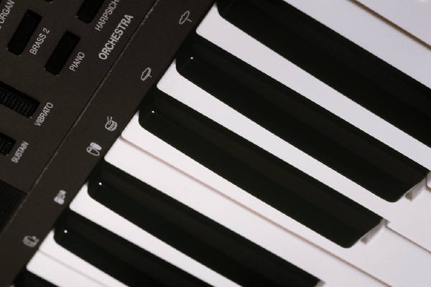

Song 1 -- Composer 1

Song 2 -- Composer 2

Song 3 -- Composer 3

Song 4 -- Composer 4

Song 5 -- Composer 5

Song 6 -- Composer 6

Song 7 -- Composer 7

Song 8 -- Composer 8

Song 9 -- Composer 9

Song 10 -- Composer 10

Song 11 -- Composer 11

Song 12 -- Composer 12

Song 13 -- Composer 13

Song 14 -- Composer 14

## ***My piano music***

***Volume 1***

My Piano Music

My Piano Music

*Front*

*Back and sides*

*Front*