|  |  |  |  |  |  |  |  |
| --- | --- | --- | --- | --- | --- | --- | --- |
| Janvāris 2010 | | | | | | | |
| Pirmdiena | Otrdiena | Trešdiena | Ceturtdiena | Piektdiena | | Sestdiena | Svētdiena |
|  |  |  |  | 1 | | 2 | 3 |
| 4 | 5 | 6 | 7    Pēdējais ceturksnis  10:39 UT | 8 | | 9 | 10 |
| 11 | 12 | 13 | 14 | 15    Jauns mēness  07:11 UT | Gredzenveida saules aptumsums | 16 | 17 |
| 18 | 19 | 20    Ūdensvīrs | 21 | 22 | | 23    Pirmais ceturksnis  10:53 UT | 24 |
| 25 | 26 | 27 | 28 | 29 | | 30    Pilns mēness  06:18 UT | 31 |

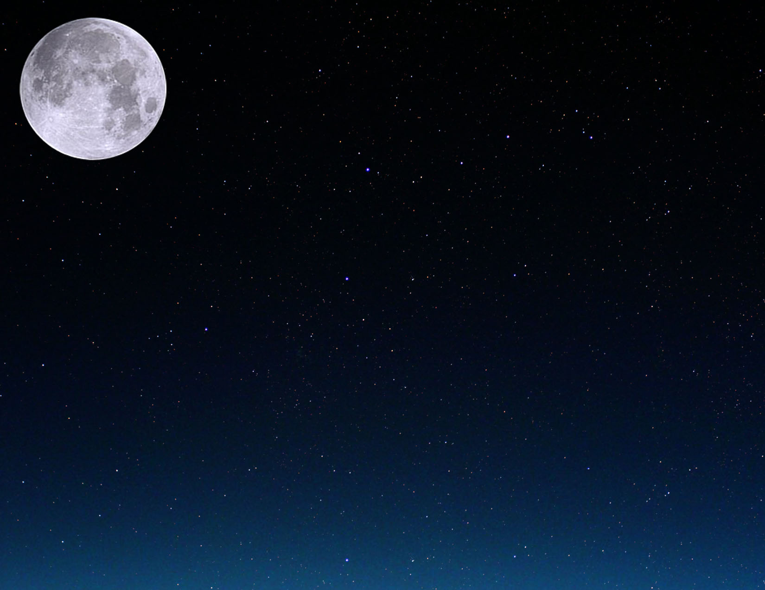

|  |  |  |  |  |  |  |
| --- | --- | --- | --- | --- | --- | --- |
| Februāris, 2010 | | | | | | |
| Pirmdiena | Otrdiena | Trešdiena | Ceturtdiena | Piektdiena | Sestdiena | Svētdiena |
| 1 | 2 | 3 | 4 | 5    Pēdējais ceturksnis  23:48 UT | 6 | 7 |
| 8 | 9 | 10 | 11 | 12 | 13 | 14    Jauns mēness  02:51 UT |
| 15 | 16 | 17 | 18 | 19    Zivis | 20 | 21 |
| 22    Pirmais ceturksnis  00:42 UT | 23 | 24 | 25 | 26 | 27 | 28    Pilns mēness  16:38 UT |

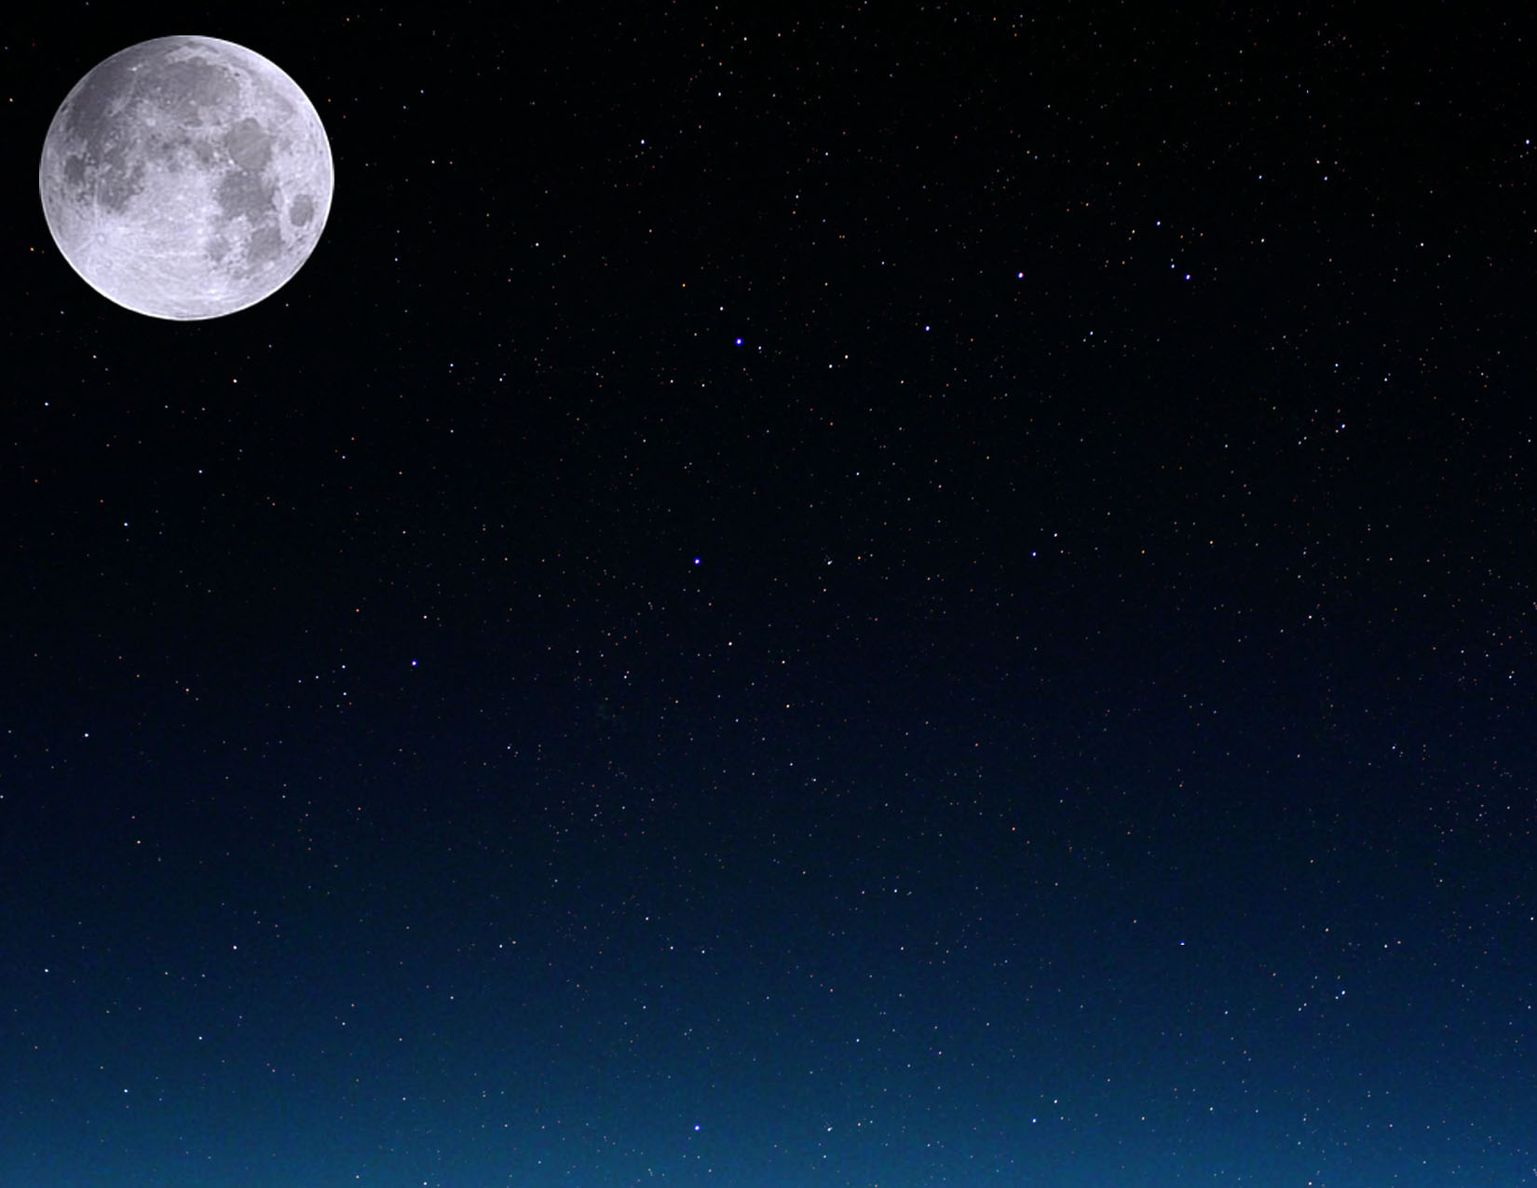

|  |  |  |  |  |  |  |
| --- | --- | --- | --- | --- | --- | --- |
| Marts, 2010 | | | | | | |
| Pirmdiena | Otrdiena | Trešdiena | Ceturtdiena | Piektdiena | Sestdiena | Svētdiena |
| 1 | 2 | 3 | 4 | 5 | 6 | 7    Pēdējais ceturksnis  15:42 UT |
| 8 | 9 | 10 | 11 | 12 | 13 | 14 |
| 15    Jauns mēness  21:01 UT | 16 | 17 | 18 | 19 | 20  Pavasara ekvinokcija  17:32 UT | 21    Auns |
| 22 | 23    Pirmais ceturksnis  11:00 UT | 24 | 25 | 26 | 27 | 28 |
| 29 | 30    Pilns mēness  02:25 UT | 31 |  |  |  |  |

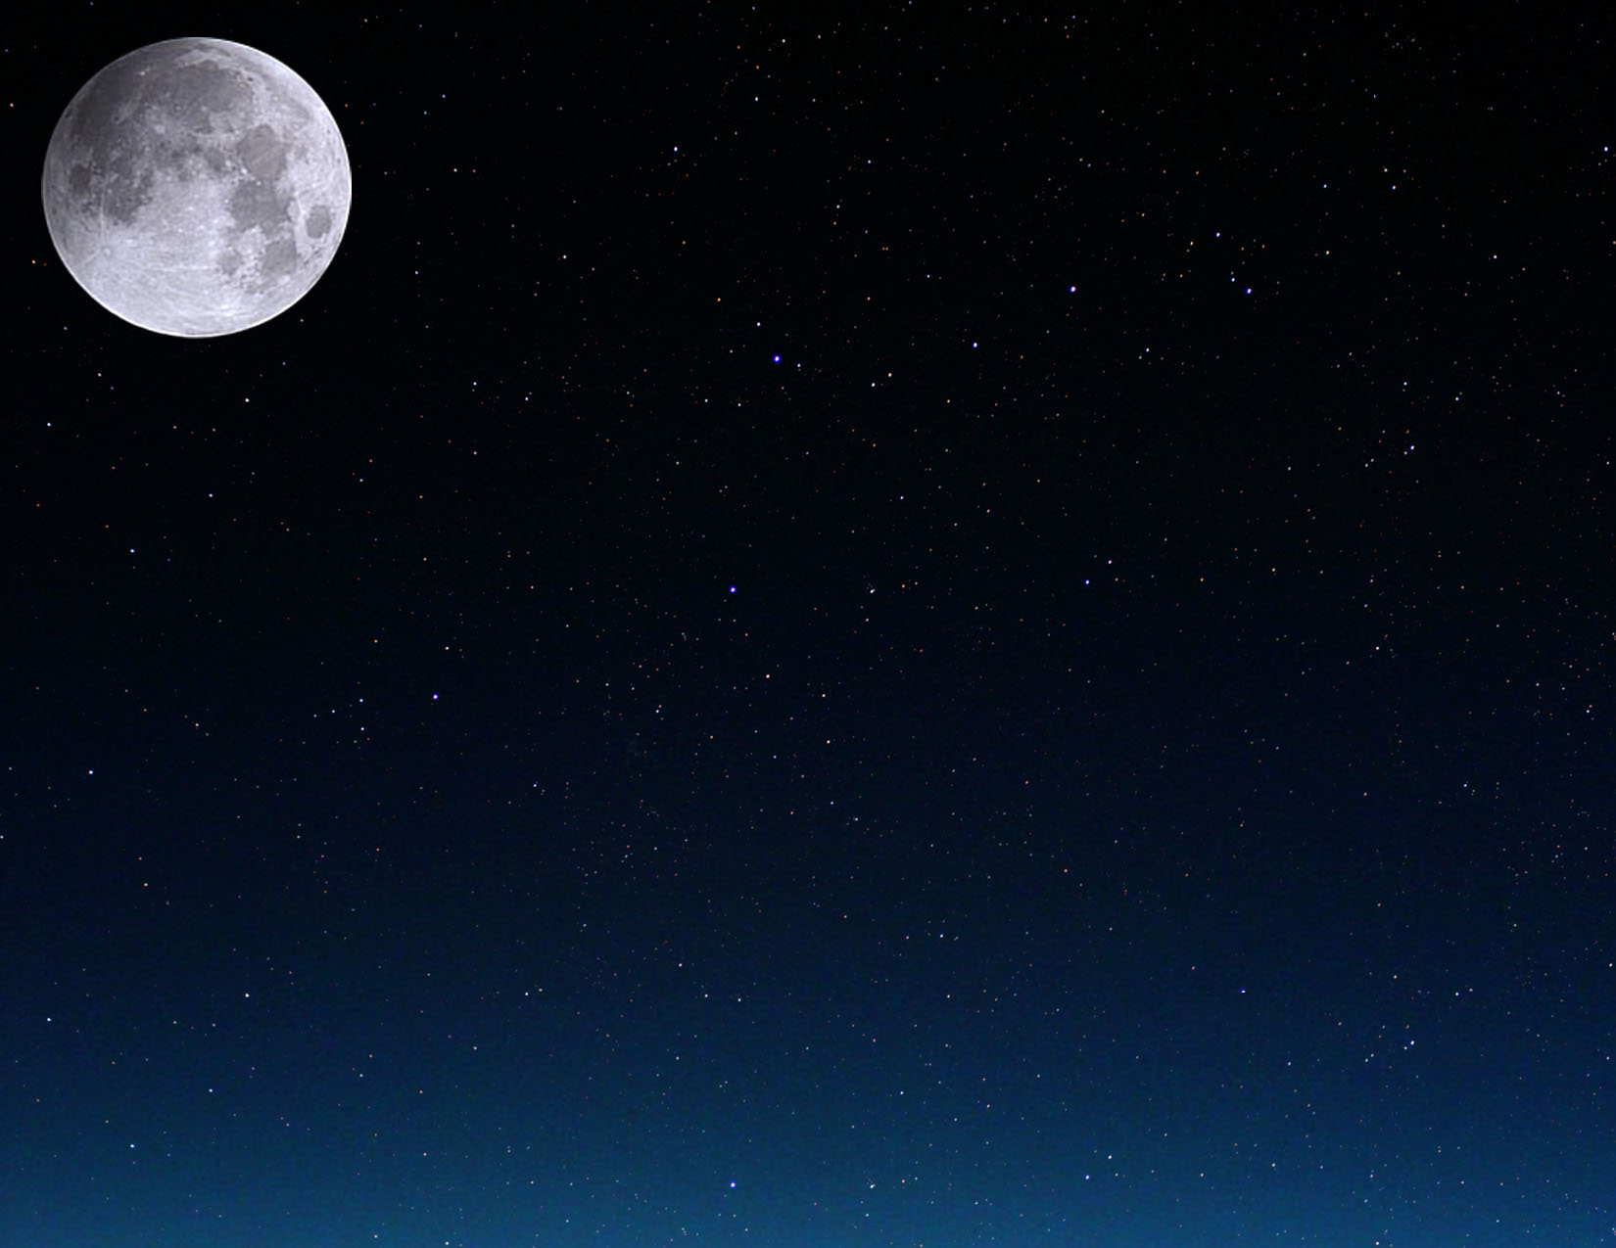

|  |  |  |  |  |  |  |
| --- | --- | --- | --- | --- | --- | --- |
| Aprīlis, 2010 | | | | | | |
| Pirmdiena | Otrdiena | Trešdiena | Ceturtdiena | Piektdiena | Sestdiena | Svētdiena |
|  |  |  | 1 | 2 | 3 | 4 |
| 5 | 6    Pēdējais ceturksnis  09:37 UT | 7 | 8 | 9 | 10 | 11 |
| 12 | 13 | 14    Jauns mēness  12:29 UT | 15 | 16 | 17 | 18 |
| 19 | 20    Vērsis | 21    Pirmais ceturksnis  18:20 UT | 22 | 23 | 24 | 25 |
| 26 | 27 | 28    Pilns mēness  12:18 UT | 29 | 30 |  |  |

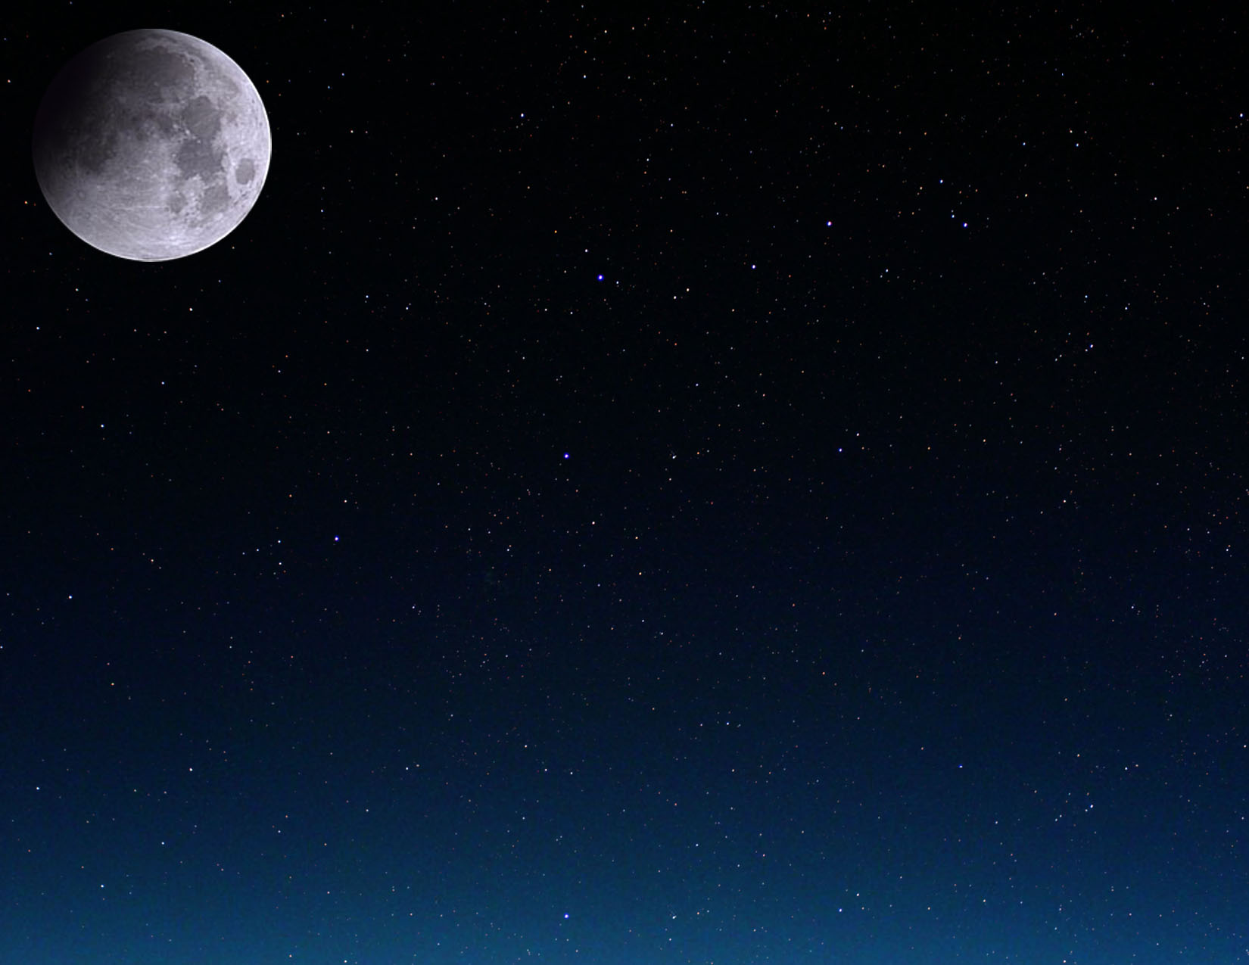

|  |  |  |  |  |  |  |
| --- | --- | --- | --- | --- | --- | --- |
| Maijs, 2010 | | | | | | |
| Pirmdiena | Otrdiena | Trešdiena | Ceturtdiena | Piektdiena | Sestdiena | Svētdiena |
|  |  |  |  |  | 1 | 2 |
| 3 | 4 | 5 | 6    Pēdējais ceturksnis  04:15 UT | 7 | 8 | 9 |
| 10 | 11 | 12 | 13 | 14    Jauns mēness  01:04 UT | 15 | 16 |
| 17 | 18 | 19 | 20    Pirmais ceturksnis  23:43 UT | 21    Dvīņi | 22 | 23 |
| 24 | 25 | 26 | 27    Pilns mēness  23:07 UT | 28 | 29 | 30 |
| 31 |  |  |  |  |  |  |

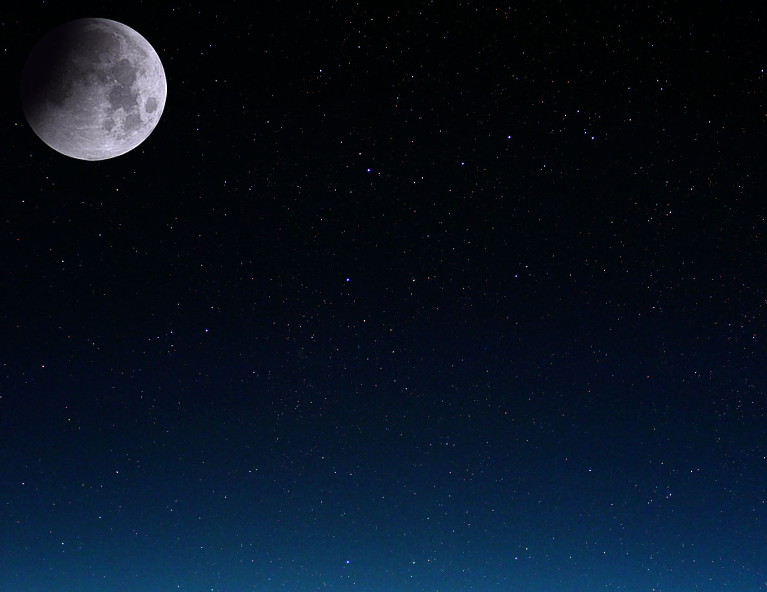

|  |  |  |  |  |  |  |  |
| --- | --- | --- | --- | --- | --- | --- | --- |
| Jūnijs, 2010 | | | | | | | |
| Pirmdiena | Otrdiena | Trešdiena | Ceturtdiena | Piektdiena | Sestdiena | | Svētdiena |
|  | 1 | 2 | 3 | 4    Pēdējais ceturksnis  22:13 UT | 5 | | 6 |
| 7 | 8 | 9 | 10 | 11 | 12    Jauns mēness  11:15 UT | | 13 |
| 14 | 15 | 16 | 17 | 18 | 19    Pirmais ceturksnis  04:29 UT | | 20 |
| 21  Vasaras saulgrieži  11:28 UT | 22    Vēzis | 23 | 24 | 25 | 26    Pilns mēness  11:30 UT | Daļējs mēness aptumsums | 27 |
| 28 | 29 | 30 |  |  |  | |  |

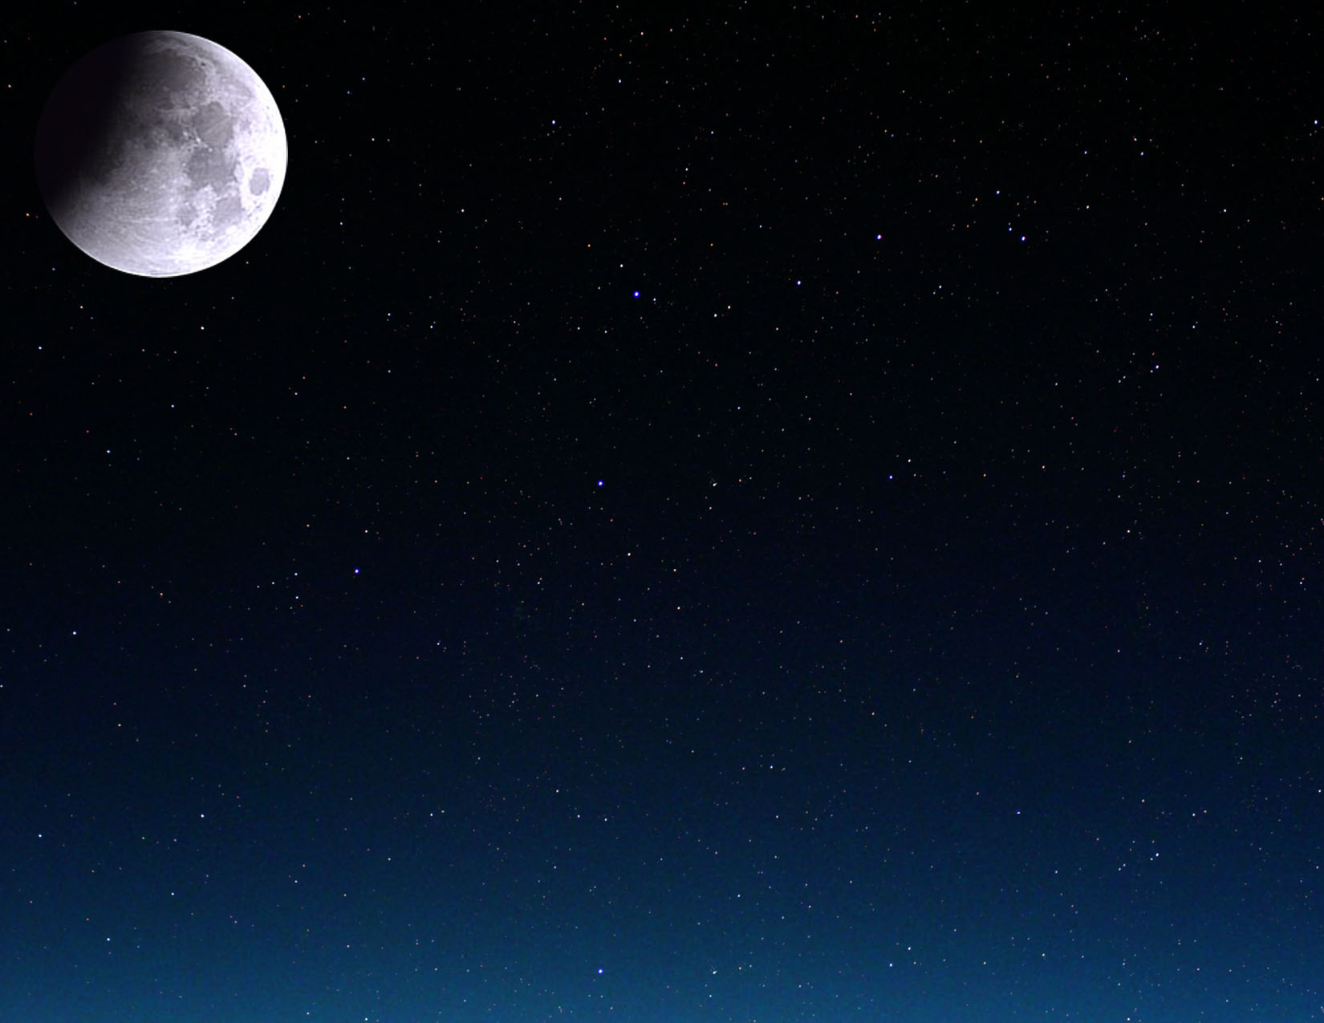

|  |  |  |  |  |  |  |  |
| --- | --- | --- | --- | --- | --- | --- | --- |
| Jūlijs, 2010 | | | | | | | |
| Pirmdiena | Otrdiena | Trešdiena | Ceturtdiena | Piektdiena | Sestdiena | Svētdiena | |
|  |  |  | 1 | 2 | 3 | 4    Pēdējais ceturksnis  14:35 UT | |
| 5 | 6 | 7 | 8 | 9 | 10 | 11    Jauns mēness  19:40 UT | Pilns saules aptumsums |
| 12 | 13 | 14 | 15 | 16 | 17 | 18    Pirmais ceturksnis  10:11 UT | |
| 19 | 20 | 21 | 22 | 23    Lauva | 24 | 25 | |
| 26    Pilns mēness  01:37 UT | 27 | 28 | 29 | 30 | 31 |  | |

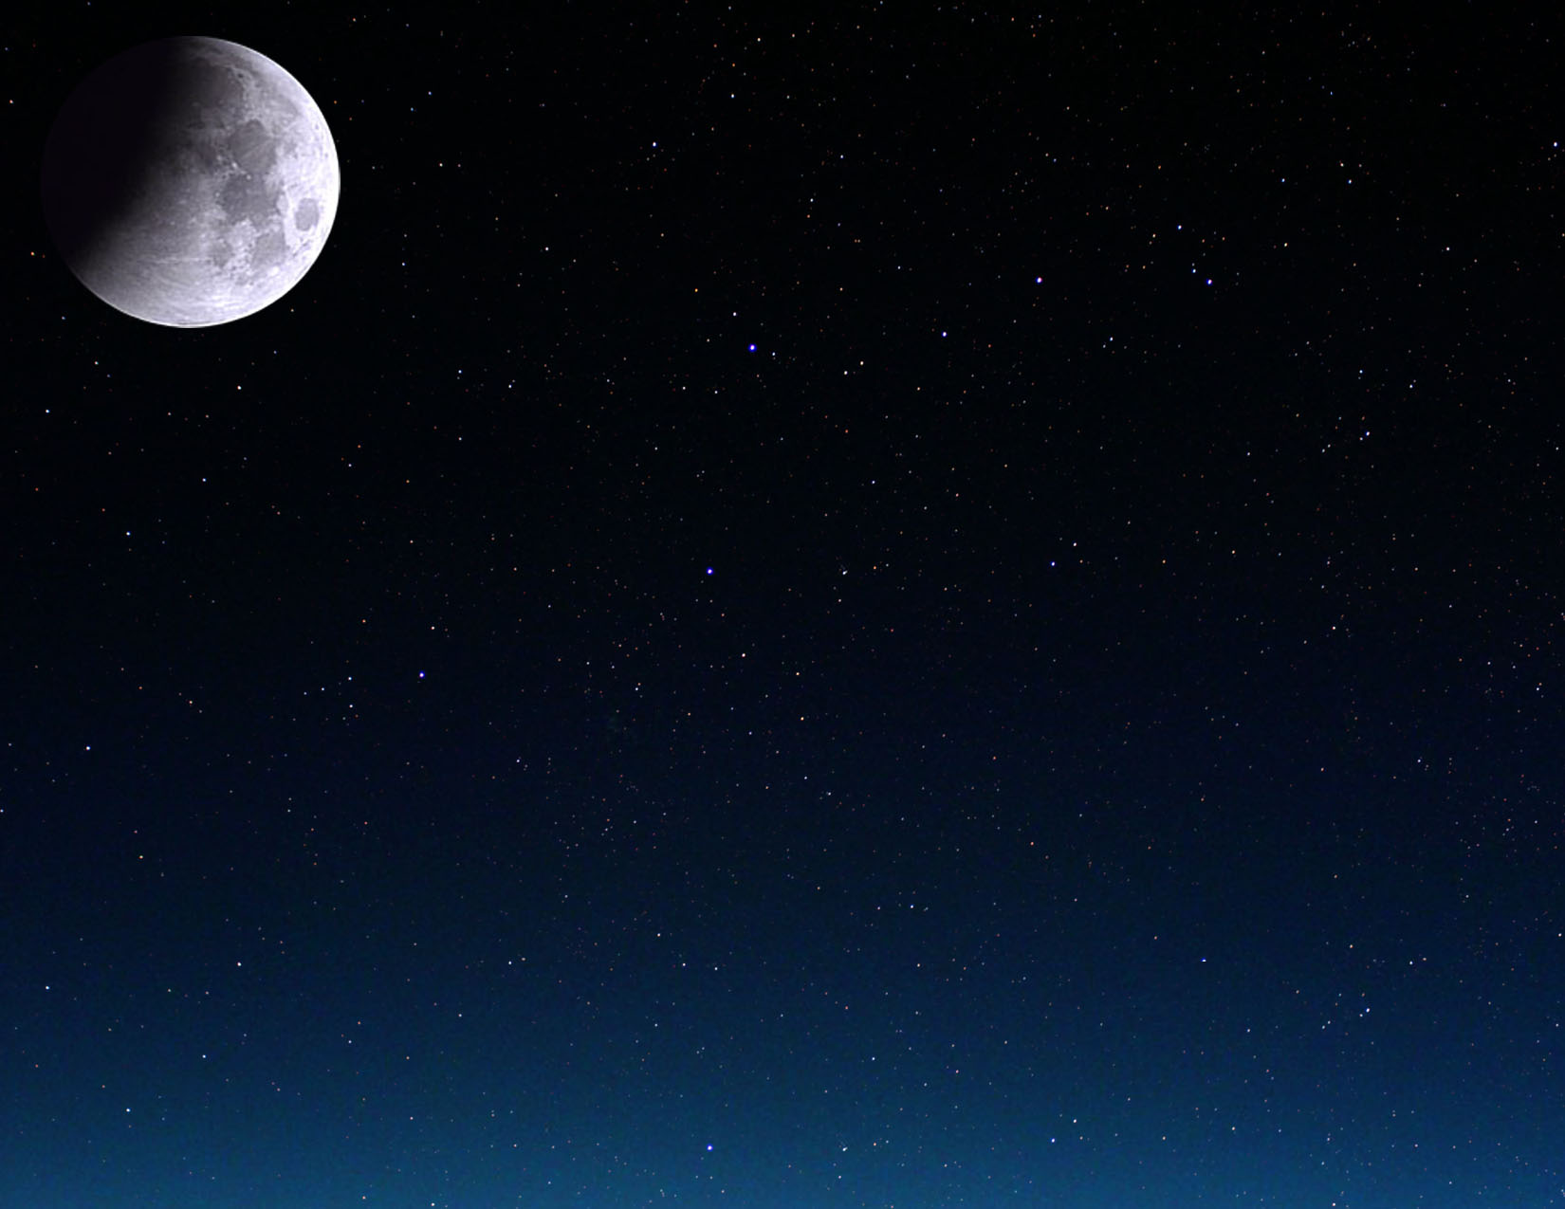

|  |  |  |  |  |  |  |
| --- | --- | --- | --- | --- | --- | --- |
| Augusts, 2010 | | | | | | |
| Pirmdiena | Otrdiena | Trešdiena | Ceturtdiena | Piektdiena | Sestdiena | Svētdiena |
|  |  |  |  |  |  | 1 |
| 2 | 3    Pēdējais ceturksnis  04:59 UT | 4 | 5 | 6 | 7 | 8 |
| 9 | 10    Jauns mēness  03:08 UT | 11 | 12 | 13 | 14 | 15 |
| 16    Pirmais ceturksnis  18:14 UT | 17 | 18 | 19 | 20 | 21 | 22 |
| 23    Jaunava | 24    Pilns mēness  17:05 UT | 25 | 26 | 27 | 28 | 29 |
| 30 | 31 |  |  |  |  |  |

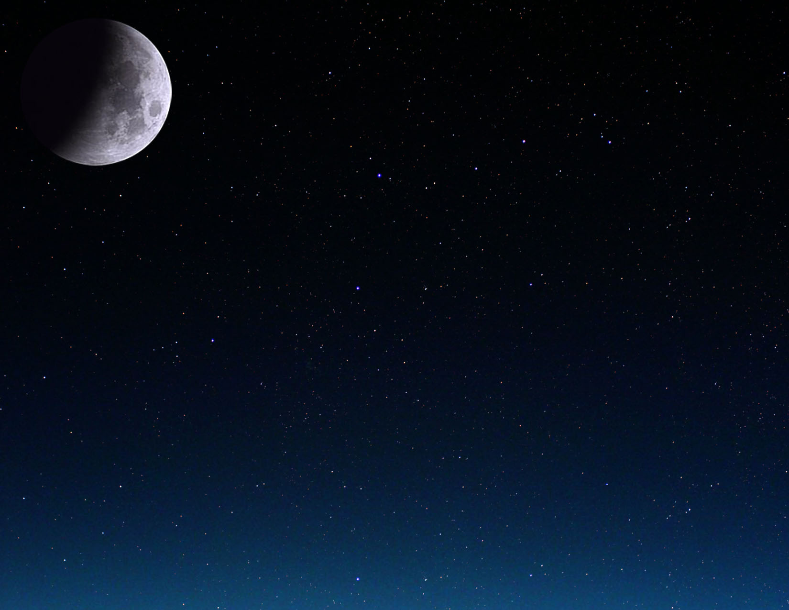

|  |  |  |  |  |  |  |  |
| --- | --- | --- | --- | --- | --- | --- | --- |
| Septembris, 2010 | | | | | | | |
| Pirmdiena | Otrdiena | Trešdiena | Ceturtdiena | | Piektdiena | Sestdiena | Svētdiena |
|  |  | 1    Pēdējais ceturksnis  17:22 UT | 2 | | 3 | 4 | 5 |
| 6 | 7 | 8    Jauns mēness  10:30 UT | 9 | | 10 | 11 | 12 |
| 13 | 14 | 15    Pirmais ceturksnis  05:50 UT | 16 | | 17 | 18 | 19 |
| 20 | 21 | 22  Rudens ekvinokcija  03:09 UT | 23    Pilns mēness  09:17 UT | Svari | 24 | 25 | 26 |
| 27 | 28 | 29 | 30 | |  |  |  |



|  |  |  |  |  |  |  |  |
| --- | --- | --- | --- | --- | --- | --- | --- |
| Oktobris, 2010 | | | | | | | |
| Pirmdiena | Otrdiena | Trešdiena | Ceturtdiena | Piektdiena | Sestdiena | | Svētdiena |
|  |  |  |  | 1    Pēdējais ceturksnis  03:52 UT | 2 | | 3 |
| 4 | 5 | 6 | 7    Jauns mēness  18:44 UT | 8 | 9 | | 10 |
| 11 | 12 | 13 | 14    Pirmais ceturksnis  21:27 UT | 15 | 16 | | 17 |
| 18 | 19 | 20 | 21 | 22 | 23    Pilns mēness  01:36 UT | Skorpions | 24 |
| 25 | 26 | 27 | 28 | 29 | 30    Pēdējais ceturksnis  12:46 UT | | 31 |

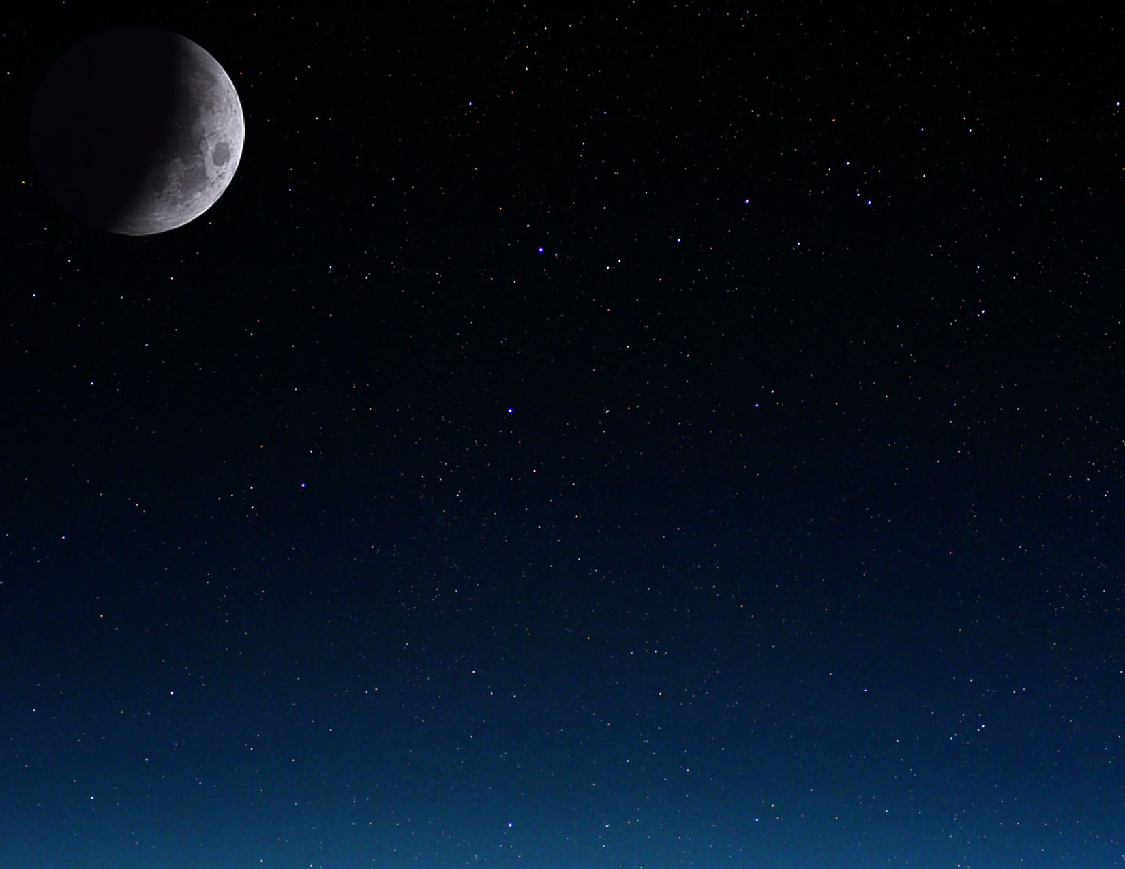

|  |  |  |  |  |  |  |
| --- | --- | --- | --- | --- | --- | --- |
| Novembris, 2010 | | | | | | |
| Pirmdiena | Otrdiena | Trešdiena | Ceturtdiena | Piektdiena | Sestdiena | Svētdiena |
| 1 | 2 | 3 | 4 | 5 | 6    Jauns mēness  04:52 UT | 7 |
| 8 | 9 | 10 | 11 | 12 | 13    Pirmais ceturksnis  16:39 UT | 14 |
| 15 | 16 | 17 | 18 | 19 | 20 | 21    Pilns mēness  17:27 UT |
| 22    Strēlnieks | 23 | 24 | 25 | 26 | 27 | 28    Pēdējais ceturksnis  20:36 UT |
| 29 | 30 |  |  |  |  |  |

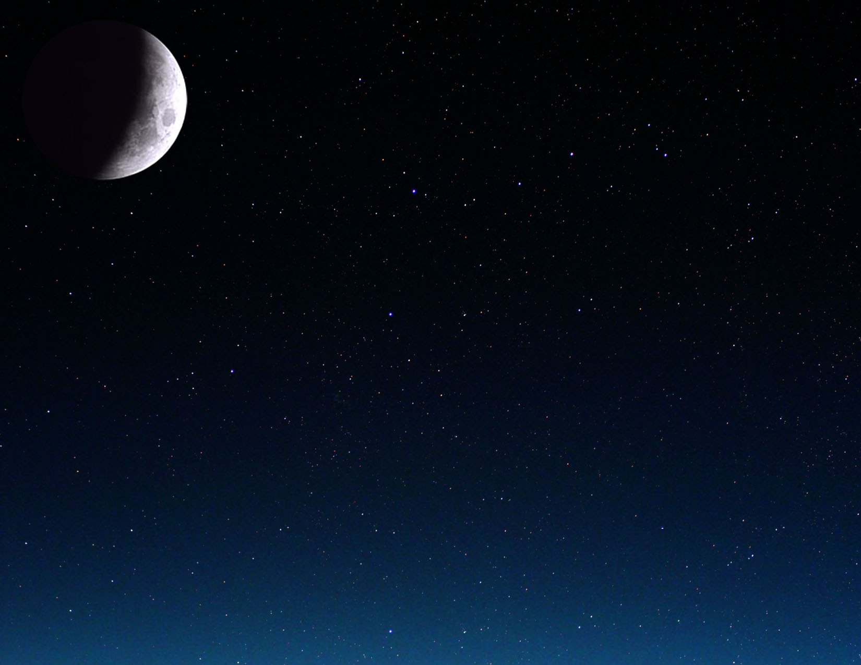

|  |  |  |  |  |  |  |  |
| --- | --- | --- | --- | --- | --- | --- | --- |
| Decembris, 2010 | | | | | | | |
| Pirmdiena | Otrdiena | | Trešdiena | Ceturtdiena | Piektdiena | Sestdiena | Svētdiena |
|  |  | | 1 | 2 | 3 | 4 | 5    Jauns mēness  17:36 UT |
| 6 | 7 | | 8 | 9 | 10 | 11 | 12 |
| 13    Pirmais ceturksnis  13:59 UT | 14 | | 15 | 16 | 17 | 18 | 19 |
| 20 | 21    Pilns mēness  08:13 UT | Ziemas saulgrieži  23:38 UT  Pilns mēness aptumsums | 22    Mežāzis | 23 | 24 | 25 | 26 |
| 27 | 28    Pēdējais ceturksnis  04:18 UT | | 29 | 30 | 31 |  |  |

