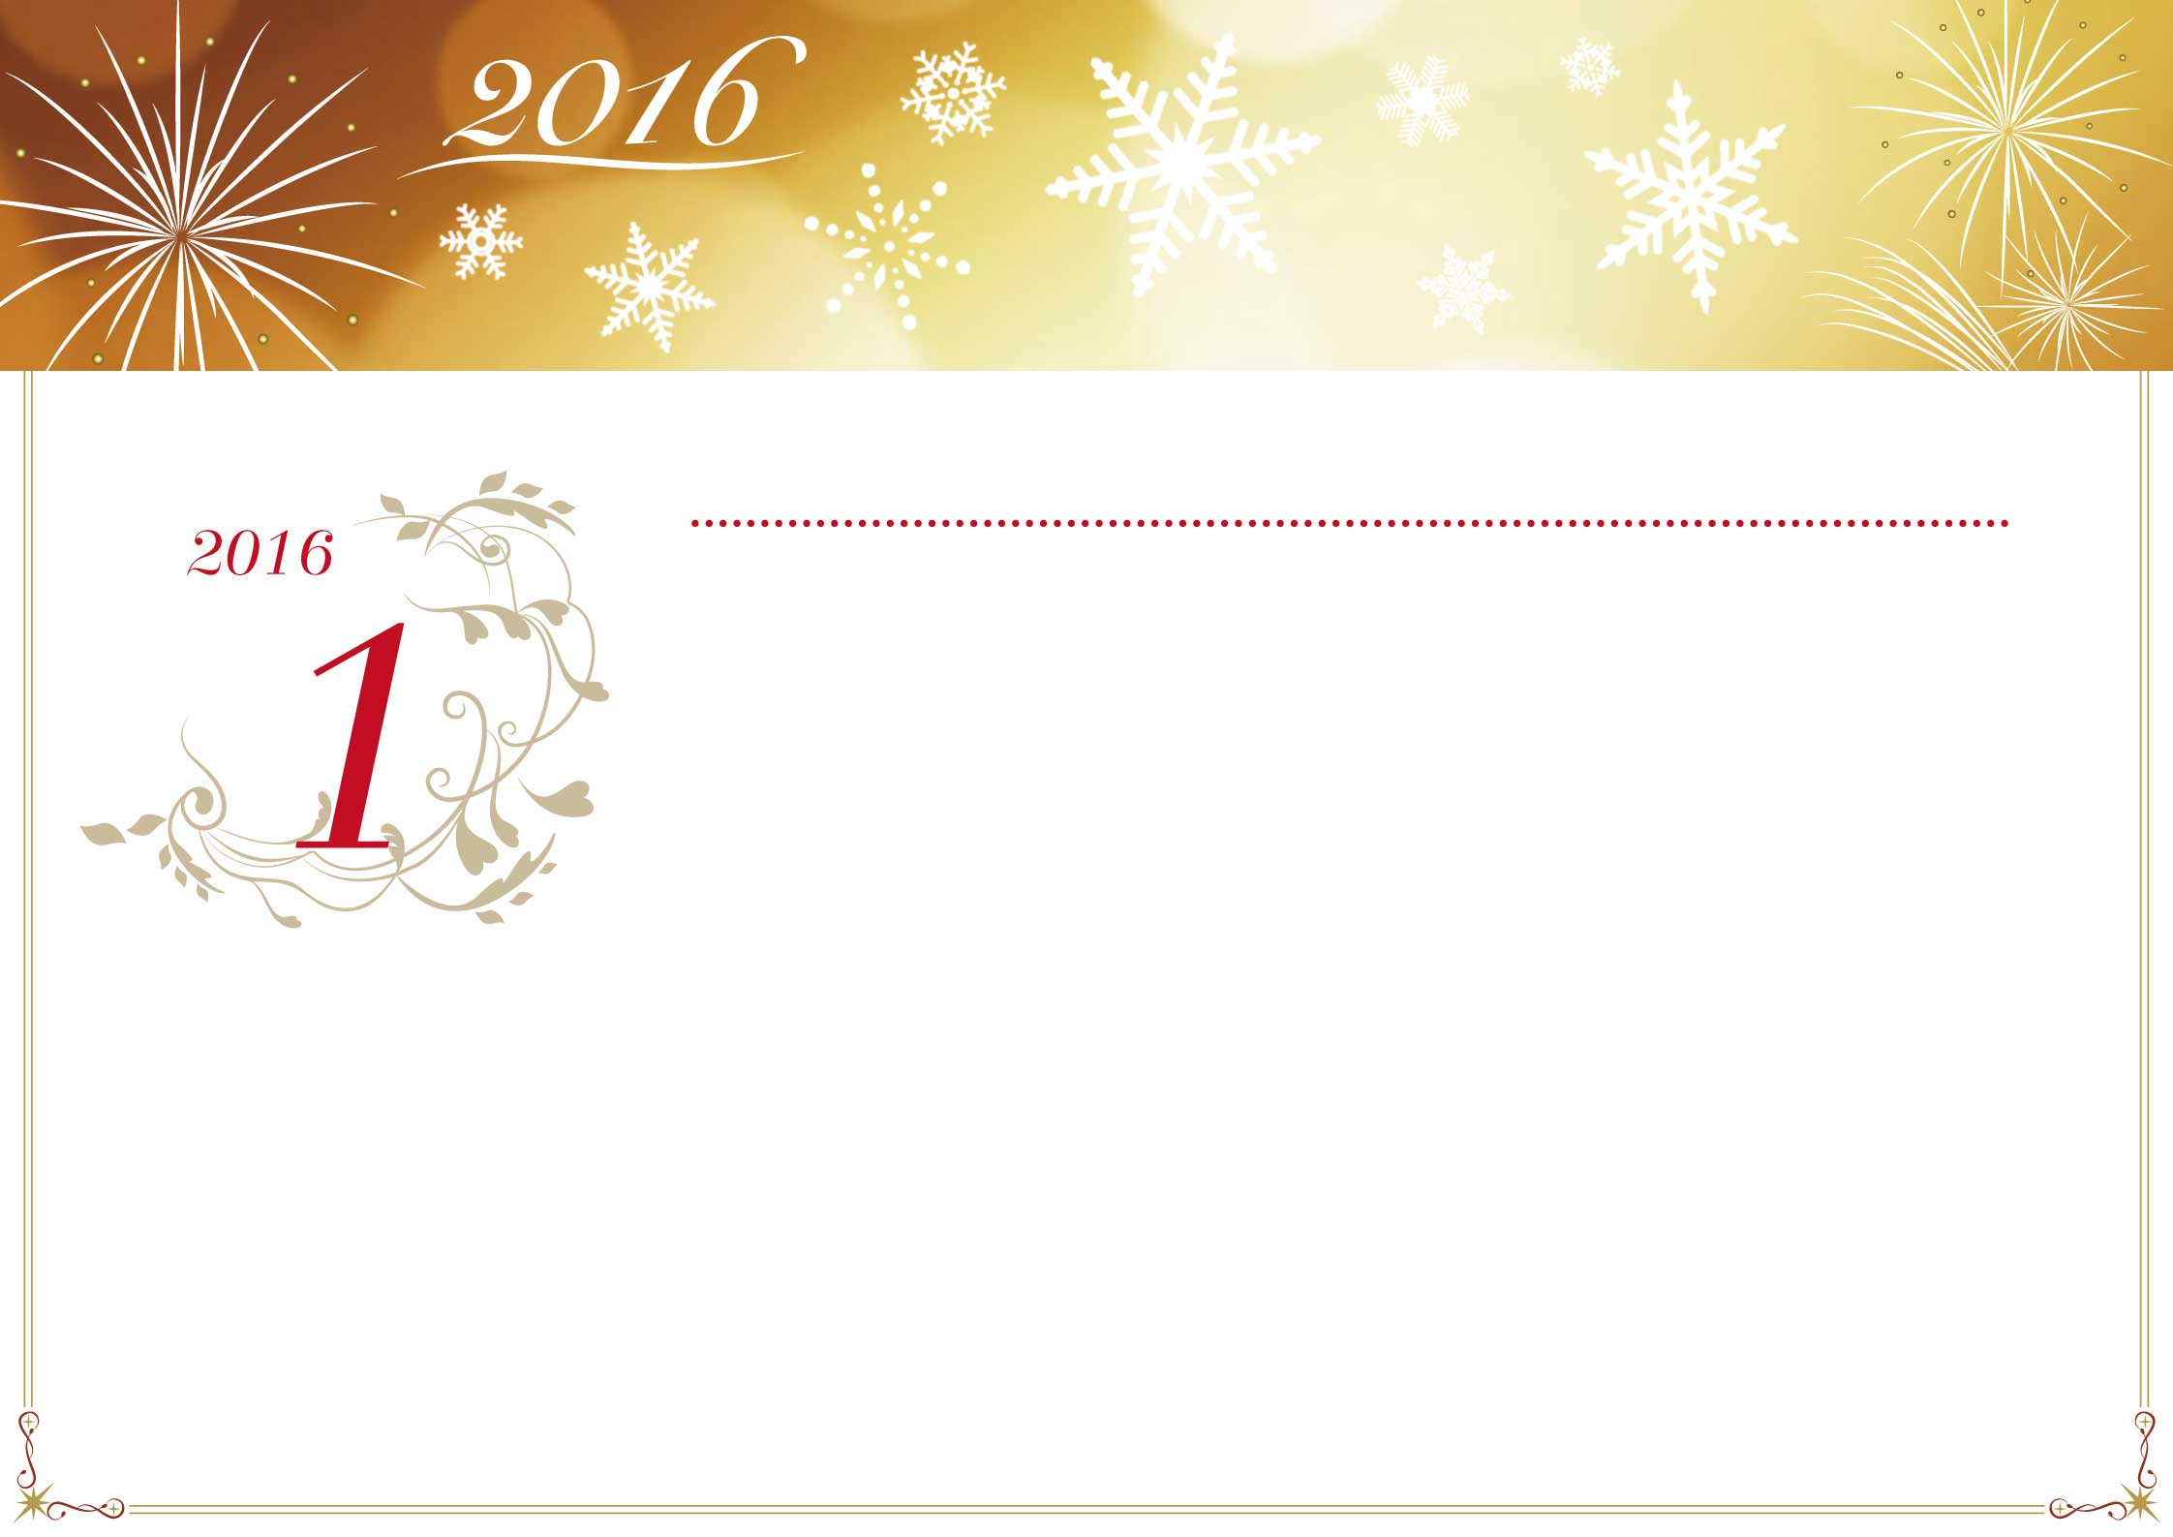

|  |  |  |  |  |  |  |
| --- | --- | --- | --- | --- | --- | --- |
| **日** | **月** | **火** | **水** | **木** | **金** | **土** |
|  |  |  |  |  |  |  |
| 27 | 28 | 29 | 30 | 31 | 1 | 2 |
| 先負 | 仏滅 | 大安 | 赤口 | 先勝 | 友引 | 先負 |
|  |  |  |  |  | 元旦 |  |
| 3 | 4 | 5 | 6 | 7 | 8 | 9 |
| 仏滅 | 大安 | 赤口 | 先勝 | 友引 | 先負 | 仏滅 |
|  |  |  |  |  |  |  |
| 10 | 11 | 12 | 13 | 14 | 15 | 16 |
| 赤口 | 先勝 | 友引 | 先負 | 仏滅 | 大安 | 赤口 |
|  | **成人の日** |  |  |  |  |  |
| 17 | 18 | 19 | 20 | 21 | 22 | 23 |
| 先勝 | 友引 | 先負 | 仏滅 | 大安 | 赤口 | 先勝 |
|  |  |  |  |  |  |  |
| 24 | 25 | 26 | 27 | 28 | 29 | 30 |
| 友引 | 先負 | 仏滅 | 大安 | 赤口 | 先勝 | 友引 |
|  |  |  |  |  |  |  |
| 31 | 1 | 2 | 3 | 4 | 5 | 6 |
| 先負 | 仏滅 | 大安 | 赤口 | 先勝 | 友引 | 先負 |
|  |  |  |  |  |  |  |

*January*



|  |  |  |  |  |  |  |
| --- | --- | --- | --- | --- | --- | --- |
| **日** | **月** | **火** | **水** | **木** | **金** | **土** |
|  |  |  |  |  |  |  |
| 31 | 1 | 2 | 3 | 4 | 5 | 6 |
| 先負 | 仏滅 | 大安 | 赤口 | 先勝 | 友引 | 先負 |
|  |  |  |  |  |  |  |
| 7 | 8 | 9 | 10 | 11 | 12 | 13 |
| 仏滅 | 先勝 | 友引 | 先負 | 仏滅 | 大安 | 赤口 |
|  |  |  |  | 建国記念日 |  |  |
| 14 | 15 | 16 | 17 | 18 | 19 | 20 |
| 先勝 | 友引 | 先負 | 仏滅 | 大安 | 赤口 | 先勝 |
|  |  |  |  |  |  |  |
| 21 | 22 | 23 | 24 | 25 | 26 | 27 |
| 友引 | 先負 | 仏滅 | 大安 | 赤口 | 先勝 | 友引 |
|  |  |  |  |  |  |  |
| 28 | 29 | 1 | 2 | 3 | 4 | 5 |
| 先負 | 仏滅 | 大安 | 赤口 | 先勝 | 友引 | 先負 |
|  |  |  |  |  |  |  |
| 6 | 7 | 8 | 9 | 10 | 11 | 12 |
| 仏滅 | 大安 | 赤口 | 友引 | 先負 | 仏滅 | 大安 |
|  |  |  |  |  |  |  |

*February*



|  |  |  |  |  |  |  |
| --- | --- | --- | --- | --- | --- | --- |
| **日** | **月** | **火** | **水** | **木** | **金** | **土** |
|  |  |  |  |  |  |  |
| 28 | 29 | 1 | 2 | 3 | 4 | 5 |
| 先負 | 仏滅 | 大安 | 赤口 | 先勝 | 友引 | 先負 |
|  |  |  |  |  |  |  |
| 6 | 7 | 8 | 9 | 10 | 11 | 12 |
| 仏滅 | 大安 | 赤口 | 友引 | 先負 | 仏滅 | 大安 |
|  |  |  |  |  |  |  |
| 13 | 14 | 15 | 16 | 17 | 18 | 19 |
| 赤口 | 先勝 | 友引 | 先負 | 仏滅 | 大安 | 赤口 |
|  |  |  |  |  |  |  |
| 20 | 21 | 22 | 23 | 24 | 25 | 26 |
| 先勝 | 友引 | 先負 | 仏滅 | 大安 | 赤口 | 先勝 |
| 春分の日 | 振替休日 |  |  |  |  |  |
| 27 | 28 | 29 | 30 | 31 | 1 | 2 |
| 友引 | 先負 | 仏滅 | 大安 | 赤口 | 先勝 | 友引 |
|  |  |  |  |  |  |  |
| 3 | 4 | 5 | 6 | 7 | 8 | 9 |
| 先負 | 仏滅 | 大安 | 赤口 | 先負 | 仏滅 | 大安 |
|  |  |  |  |  |  |  |

*March*



|  |  |  |  |  |  |  |
| --- | --- | --- | --- | --- | --- | --- |
| **日** | **月** | **火** | **水** | **木** | **金** | **土** |
|  |  |  |  |  |  |  |
| 27 | 28 | 29 | 30 | 31 | 1 | 2 |
| 友引 | 先負 | 仏滅 | 大安 | 赤口 | 先勝 | 友引 |
|  |  |  |  |  |  |  |
| 3 | 4 | 5 | 6 | 7 | 8 | 9 |
| 先負 | 仏滅 | 大安 | 赤口 | 先負 | 仏滅 | 大安 |
|  |  |  |  |  |  |  |
| 10 | 11 | 12 | 13 | 14 | 15 | 16 |
| 赤口 | 先勝 | 友引 | 先負 | 仏滅 | 大安 | 赤口 |
|  |  |  |  |  |  |  |
| 17 | 18 | 19 | 20 | 21 | 22 | 23 |
| 先勝 | 友引 | 先負 | 仏滅 | 大安 | 赤口 | 先勝 |
|  |  |  |  |  |  |  |
| 24 | 25 | 26 | 27 | 28 | 29 | 30 |
| 友引 | 先負 | 仏滅 | 大安 | 赤口 | 先勝 | 友引 |
|  |  |  |  |  | 昭和の日 |  |
| 1 | 2 | 3 | 4 | 5 | 6 | 7 |
| 先負 | 仏滅 | 大安 | 赤口 | 先勝 | 友引 | 仏滅 |
|  |  |  |  |  |  |  |

*April*



|  |  |  |  |  |  |  |
| --- | --- | --- | --- | --- | --- | --- |
| **日** | **月** | **火** | **水** | **木** | **金** | **土** |
|  |  |  |  |  |  |  |
| 1 | 2 | 3 | 4 | 5 | 6 | 7 |
| 先負 | 仏滅 | 大安 | 赤口 | 先勝 | 友引 | 仏滅 |
|  |  | **憲法記念日** | **みどりの日** | **こどもの日** |  |  |
| 8 | 9 | 10 | 11 | 12 | 13 | 14 |
| 大安 | 赤口 | 先勝 | 友引 | 先負 | 仏滅 | 大安 |
|  |  |  |  |  |  |  |
| 15 | 16 | 17 | 18 | 19 | 20 | 21 |
| 赤口 | 先勝 | 友引 | 先負 | 仏滅 | 大安 | 赤口 |
|  |  |  |  |  |  |  |
| 22 | 23 | 24 | 25 | 26 | 27 | 28 |
| 先勝 | 友引 | 先負 | 仏滅 | 大安 | 赤口 | 先勝 |
|  |  |  |  |  |  |  |
| 29 | 30 | 31 | 1 | 2 | 3 | 4 |
| 友引 | 先負 | 仏滅 | 大安 | 赤口 | 先勝 | 友引 |
|  |  |  |  |  |  |  |
| 5 | 6 | 7 | 8 | 9 | 10 | 11 |
| 大安 | 赤口 | 先勝 | 友引 | 先負 | 仏滅 | 大安 |
|  |  |  |  |  |  |  |

*May*



|  |  |  |  |  |  |  |
| --- | --- | --- | --- | --- | --- | --- |
| **日** | **月** | **火** | **水** | **木** | **金** | **土** |
|  |  |  |  |  |  |  |
| 29 | 30 | 31 | 1 | 2 | 3 | 4 |
| 友引 | 先負 | 仏滅 | 大安 | 赤口 | 先勝 | 友引 |
|  |  |  |  |  |  |  |
| 5 | 6 | 7 | 8 | 9 | 10 | 11 |
| 大安 | 赤口 | 先勝 | 友引 | 先負 | 仏滅 | 大安 |
|  |  |  |  |  |  |  |
| 12 | 13 | 14 | 15 | 16 | 17 | 18 |
| 赤口 | 先勝 | 友引 | 先負 | 仏滅 | 大安 | 赤口 |
|  |  |  |  |  |  |  |
| 19 | 20 | 21 | 22 | 23 | 24 | 25 |
| 先勝 | 友引 | 先負 | 仏滅 | 大安 | 赤口 | 先勝 |
|  |  |  |  |  |  |  |
| 26 | 27 | 28 | 29 | 30 | 1 | 2 |
| 友引 | 先負 | 仏滅 | 大安 | 赤口 | 先勝 | 友引 |
|  |  |  |  |  |  |  |
| 3 | 4 | 5 | 6 | 7 | 8 | 9 |
| 先負 | 赤口 | 先勝 | 友引 | 先負 | 仏滅 | 大安 |
|  |  |  |  |  |  |  |

*June*



|  |  |  |  |  |  |  |
| --- | --- | --- | --- | --- | --- | --- |
| **日** | **月** | **火** | **水** | **木** | **金** | **土** |
|  |  |  |  |  |  |  |
| 26 | 27 | 28 | 29 | 30 | 1 | 2 |
| 友引 | 先負 | 仏滅 | 大安 | 赤口 | 先勝 | 友引 |
|  |  |  |  |  |  |  |
| 3 | 4 | 5 | 6 | 7 | 8 | 9 |
| 先負 | 赤口 | 先勝 | 友引 | 先負 | 仏滅 | 大安 |
|  |  |  |  |  |  |  |
| 10 | 11 | 12 | 13 | 14 | 15 | 16 |
| 赤口 | 先勝 | 友引 | 先負 | 仏滅 | 大安 | 赤口 |
|  |  |  |  |  |  |  |
| 17 | 18 | 19 | 20 | 21 | 22 | 23 |
| 先勝 | 友引 | 先負 | 仏滅 | 大安 | 赤口 | 先勝 |
|  | **海の日** |  |  |  |  |  |
| 24 | 25 | 26 | 27 | 28 | 29 | 30 |
| 友引 | 先負 | 仏滅 | 大安 | 赤口 | 先勝 | 友引 |
|  |  |  |  |  |  |  |
| 31 | 1 | 2 | 3 | 4 | 5 | 6 |
| 先負 | 仏滅 | 大安 | 先勝 | 友引 | 先負 | 仏滅 |
|  |  |  |  |  |  |  |

*July*



|  |  |  |  |  |  |  |
| --- | --- | --- | --- | --- | --- | --- |
| **日** | **月** | **火** | **水** | **木** | **金** | **土** |
|  |  |  |  |  |  |  |
| 31 | 1 | 2 | 3 | 4 | 5 | 6 |
| 先負 | 仏滅 | 大安 | 先勝 | 友引 | 先負 | 仏滅 |
|  |  |  |  |  |  |  |
| 7 | 8 | 9 | 10 | 11 | 12 | 13 |
| 大安 | 赤口 | 先勝 | 友引 | 先負 | 仏滅 | 大安 |
|  |  |  |  | **山の日** |  |  |
| 14 | 15 | 16 | 17 | 18 | 19 | 20 |
| 赤口 | 先勝 | 友引 | 先負 | 仏滅 | 大安 | 赤口 |
|  |  |  |  |  |  |  |
| 21 | 22 | 23 | 24 | 25 | 26 | 27 |
| 先勝 | 友引 | 先負 | 仏滅 | 大安 | 赤口 | 先勝 |
|  |  |  |  |  |  |  |
| 28 | 29 | 30 | 31 | 1 | 2 | 3 |
| 友引 | 先負 | 仏滅 | 大安 | 友引 | 先負 | 仏滅 |
|  |  |  |  |  |  |  |
| 4 | 5 | 6 | 7 | 8 | 9 | 10 |
| 大安 | 赤口 | 先勝 | 友引 | 先負 | 仏滅 | 大安 |
|  |  |  |  |  |  |  |

*August*

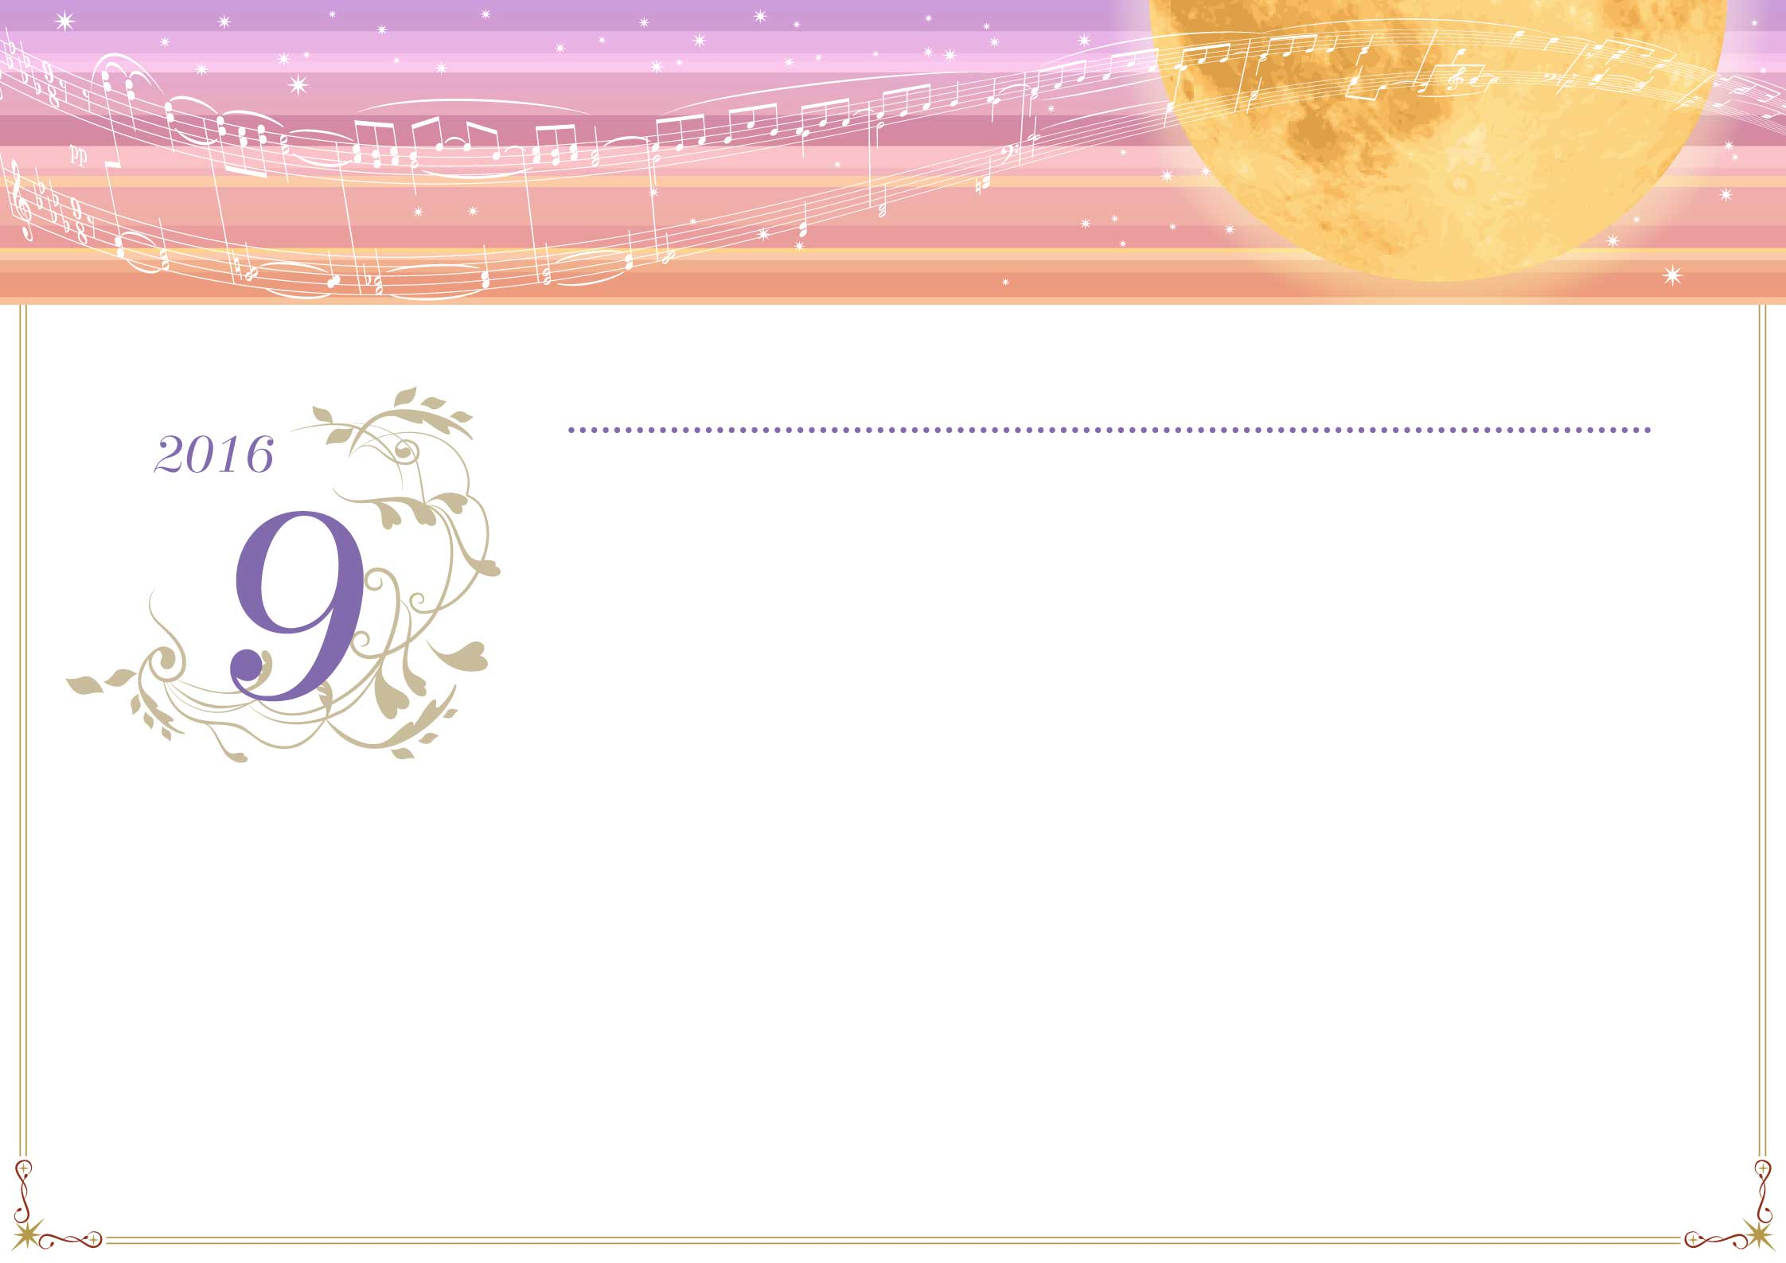

|  |  |  |  |  |  |  |
| --- | --- | --- | --- | --- | --- | --- |
| **日** | **月** | **火** | **水** | **木** | **金** | **土** |
|  |  |  |  |  |  |  |
| 28 | 29 | 30 | 31 | 1 | 2 | 3 |
| 友引 | 先負 | 仏滅 | 大安 | 友引 | 先負 | 仏滅 |
|  |  |  |  |  |  |  |
| 4 | 5 | 6 | 7 | 8 | 9 | 10 |
| 大安 | 赤口 | 先勝 | 友引 | 先負 | 仏滅 | 大安 |
|  |  |  |  |  |  |  |
| 11 | 12 | 13 | 14 | 15 | 16 | 17 |
| 赤口 | 先勝 | 友引 | 先負 | 仏滅 | 大安 | 赤口 |
|  |  |  |  |  |  |  |
| 18 | 19 | 20 | 21 | 22 | 23 | 24 |
| 先勝 | 友引 | 先負 | 仏滅 | 大安 | 赤口 | 先勝 |
|  | **敬老の日** |  |  | **秋分の日** |  |  |
| 25 | 26 | 27 | 28 | 29 | 30 | 1 |
| 友引 | 先負 | 仏滅 | 大安 | 赤口 | 先勝 | 先負 |
|  |  |  |  |  |  |  |
| 2 | 3 | 4 | 5 | 6 | 7 | 8 |
| 仏滅 | 大安 | 赤口 | 先勝 | 友引 | 先負 | 仏滅 |
|  |  |  |  |  |  |  |

*September*

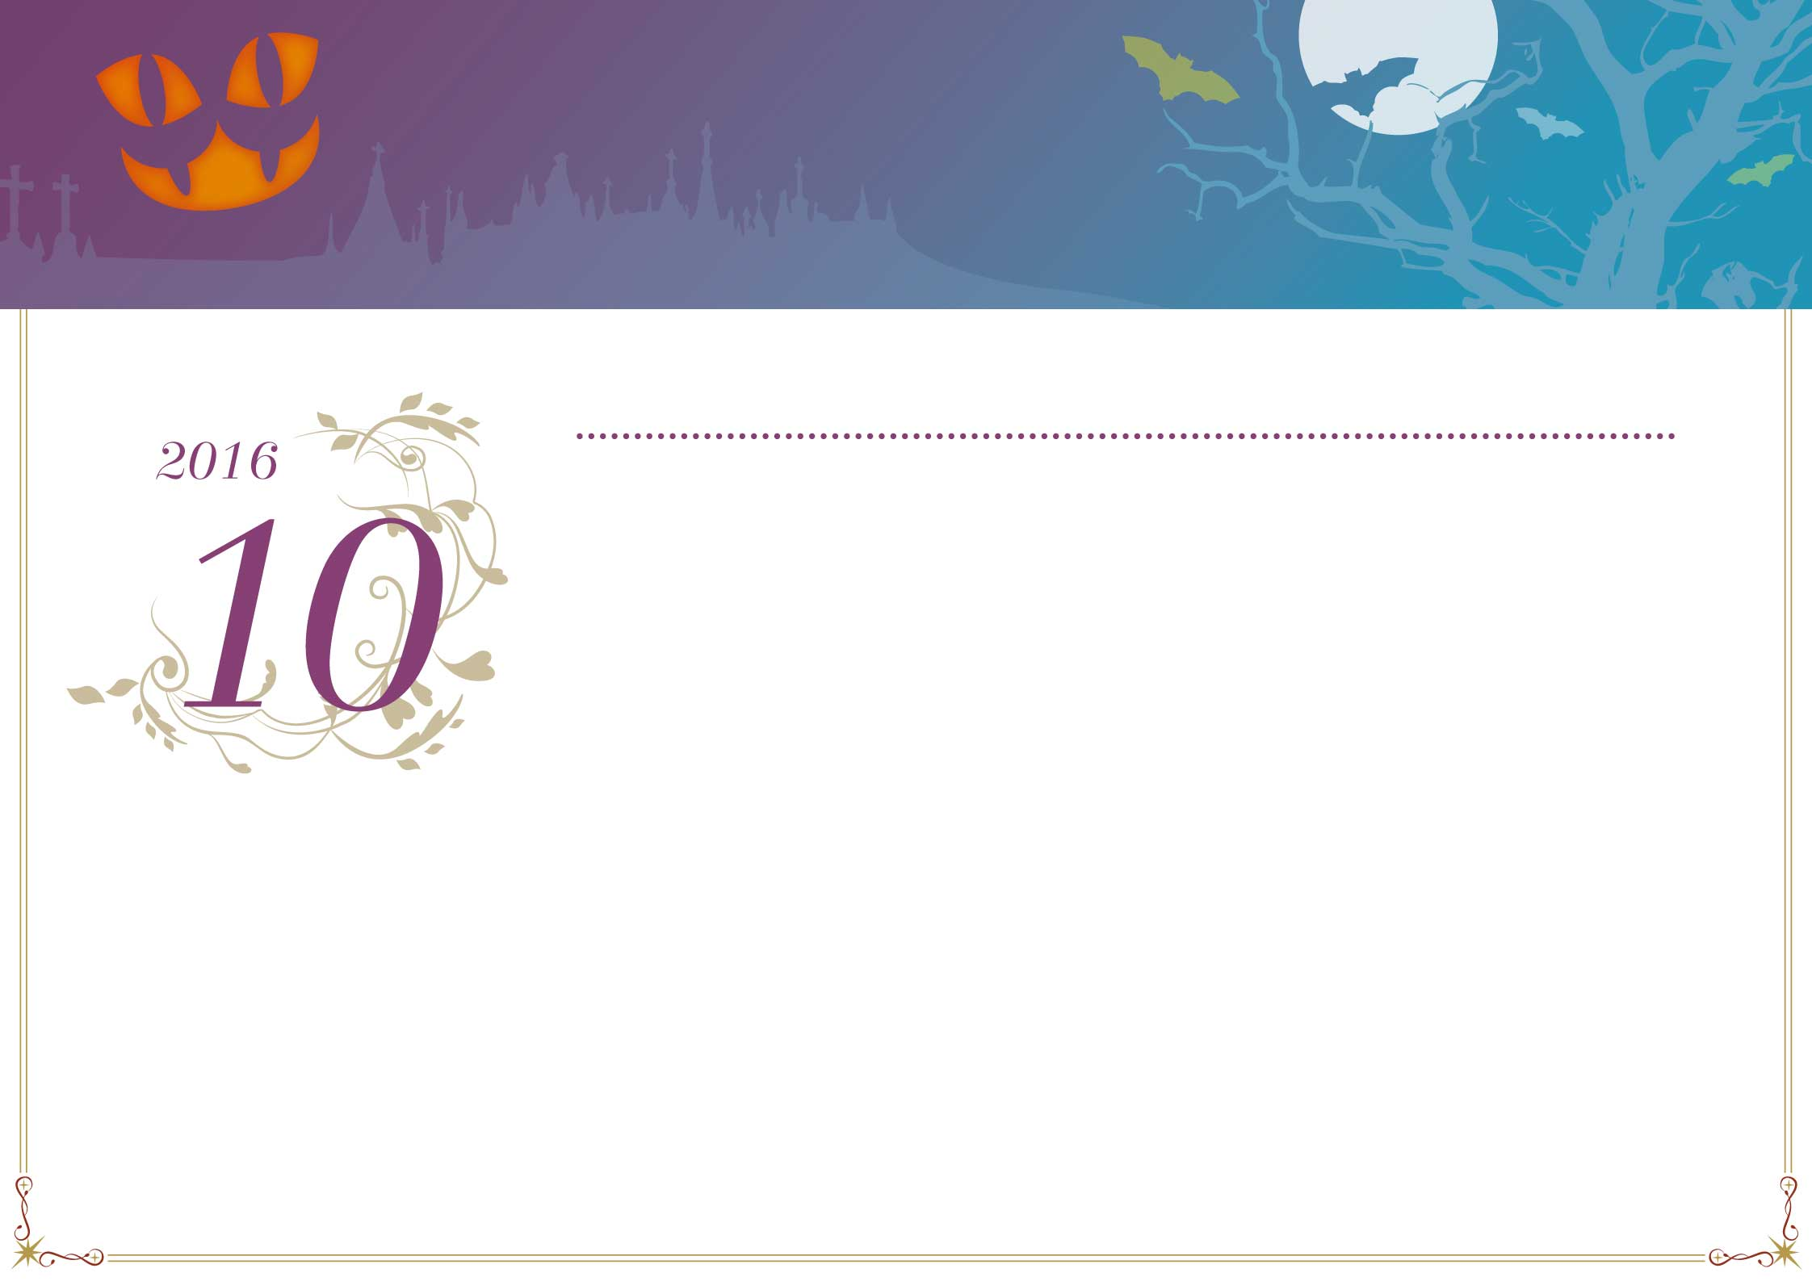

|  |  |  |  |  |  |  |
| --- | --- | --- | --- | --- | --- | --- |
| **日** | **月** | **火** | **水** | **木** | **金** | **土** |
|  |  |  |  |  |  |  |
| 25 | 26 | 27 | 28 | 29 | 30 | 1 |
| 友引 | 先負 | 仏滅 | 大安 | 赤口 | 先勝 | 先負 |
|  |  |  |  |  |  |  |
| 2 | 3 | 4 | 5 | 6 | 7 | 8 |
| 仏滅 | 大安 | 赤口 | 先勝 | 友引 | 先負 | 仏滅 |
|  |  |  |  |  |  |  |
| 9 | 10 | 11 | 12 | 13 | 14 | 15 |
| 大安 | 赤口 | 先勝 | 友引 | 先負 | 仏滅 | 大安 |
|  | 体育の日 |  |  |  |  |  |
| 16 | 17 | 18 | 19 | 20 | 21 | 22 |
| 赤口 | 先勝 | 友引 | 先負 | 仏滅 | 大安 | 赤口 |
|  |  |  |  |  |  |  |
| 23 | 24 | 25 | 26 | 27 | 28 | 29 |
| 先勝 | 友引 | 先負 | 仏滅 | 大安 | 赤口 | 先勝 |
|  |  |  |  |  |  |  |
| 30 | 31 | 1 | 2 | 3 | 4 | 5 |
| 友引 | 仏滅 | 大安 | 赤口 | 先勝 | 友引 | 先負 |
|  |  |  |  |  |  |  |

*October*

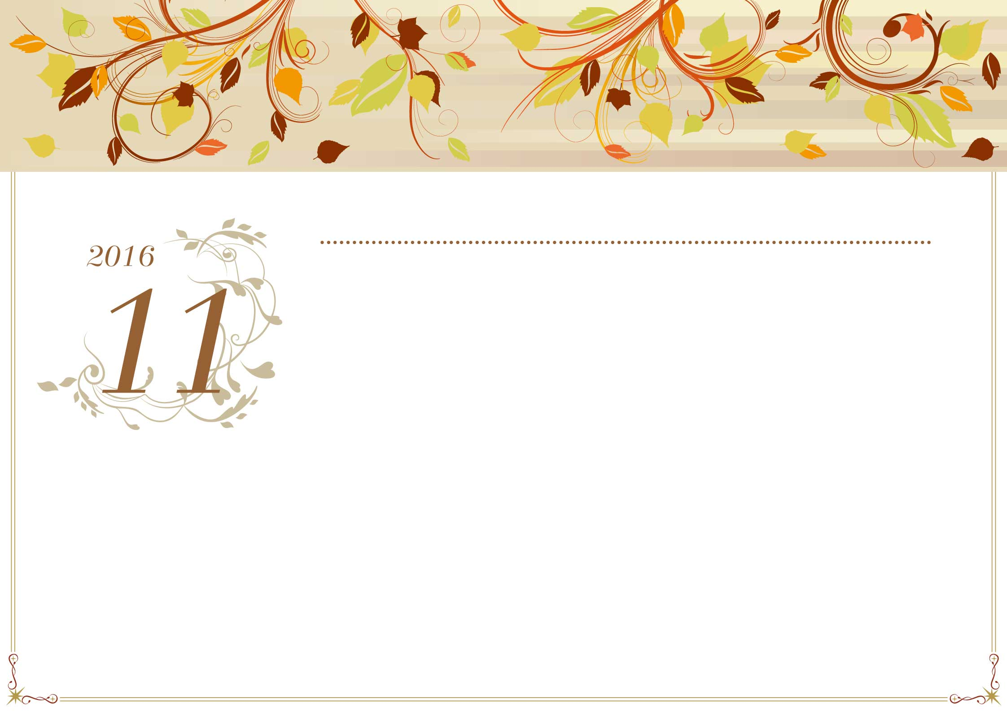

|  |  |  |  |  |  |  |
| --- | --- | --- | --- | --- | --- | --- |
| **日** | **月** | **火** | **水** | **木** | **金** | **土** |
|  |  |  |  |  |  |  |
| 30 | 31 | 1 | 2 | 3 | 4 | 5 |
| 友引 | 仏滅 | 大安 | 赤口 | 先勝 | 友引 | 先負 |
|  |  |  |  | **文化の日** |  |  |
| 6 | 7 | 8 | 9 | 10 | 11 | 12 |
| 仏滅 | 大安 | 赤口 | 先勝 | 友引 | 先負 | 仏滅 |
|  |  |  |  |  |  |  |
| 13 | 14 | 15 | 16 | 17 | 18 | 19 |
| 大安 | 赤口 | 先勝 | 友引 | 先負 | 仏滅 | 大安 |
|  |  |  |  |  |  |  |
| 20 | 21 | 22 | 23 | 24 | 25 | 26 |
| 赤口 | 先勝 | 友引 | 先負 | 仏滅 | 大安 | 赤口 |
|  |  |  | **勤労感謝の日** |  |  |  |
| 27 | 28 | 29 | 30 | 1 | 2 | 3 |
| 先勝 | 友引 | 大安 | 赤口 | 先勝 | 友引 | 先負 |
|  |  |  |  |  |  |  |
| 4 | 5 | 6 | 7 | 8 | 9 | 10 |
| 仏滅 | 大安 | 赤口 | 先勝 | 友引 | 先負 | 仏滅 |
|  |  |  |  |  |  |  |

*November*



|  |  |  |  |  |  |  |
| --- | --- | --- | --- | --- | --- | --- |
| **日** | **月** | **火** | **水** | **木** | **金** | **土** |
|  |  |  |  |  |  |  |
| 27 | 28 | 29 | 30 | 1 | 2 | 3 |
| 先勝 | 友引 | 大安 | 赤口 | 先勝 | 友引 | 先負 |
|  |  |  |  |  |  |  |
| 4 | 5 | 6 | 7 | 8 | 9 | 10 |
| 仏滅 | 大安 | 赤口 | 先勝 | 友引 | 先負 | 仏滅 |
|  |  |  |  |  |  |  |
| 11 | 12 | 13 | 14 | 15 | 16 | 17 |
| 大安 | 赤口 | 先勝 | 友引 | 先負 | 仏滅 | 大安 |
|  |  |  |  |  |  |  |
| 18 | 19 | 20 | 21 | 22 | 23 | 24 |
| 赤口 | 先勝 | 友引 | 先負 | 仏滅 | 大安 | 赤口 |
|  |  |  |  |  | **天皇誕生日** |  |
| 25 | 26 | 27 | 28 | 29 | 30 | 31 |
| 先勝 | 友引 | 先負 | 仏滅 | 赤口 | 先勝 | 友引 |
|  |  |  |  |  |  |  |
| 1 | 2 | 3 | 4 | 5 | 6 | 7 |
| 先負 | 仏滅 | 大安 | 赤口 | 先勝 | 友引 | 先負 |
|  |  |  |  |  |  |  |

*December*