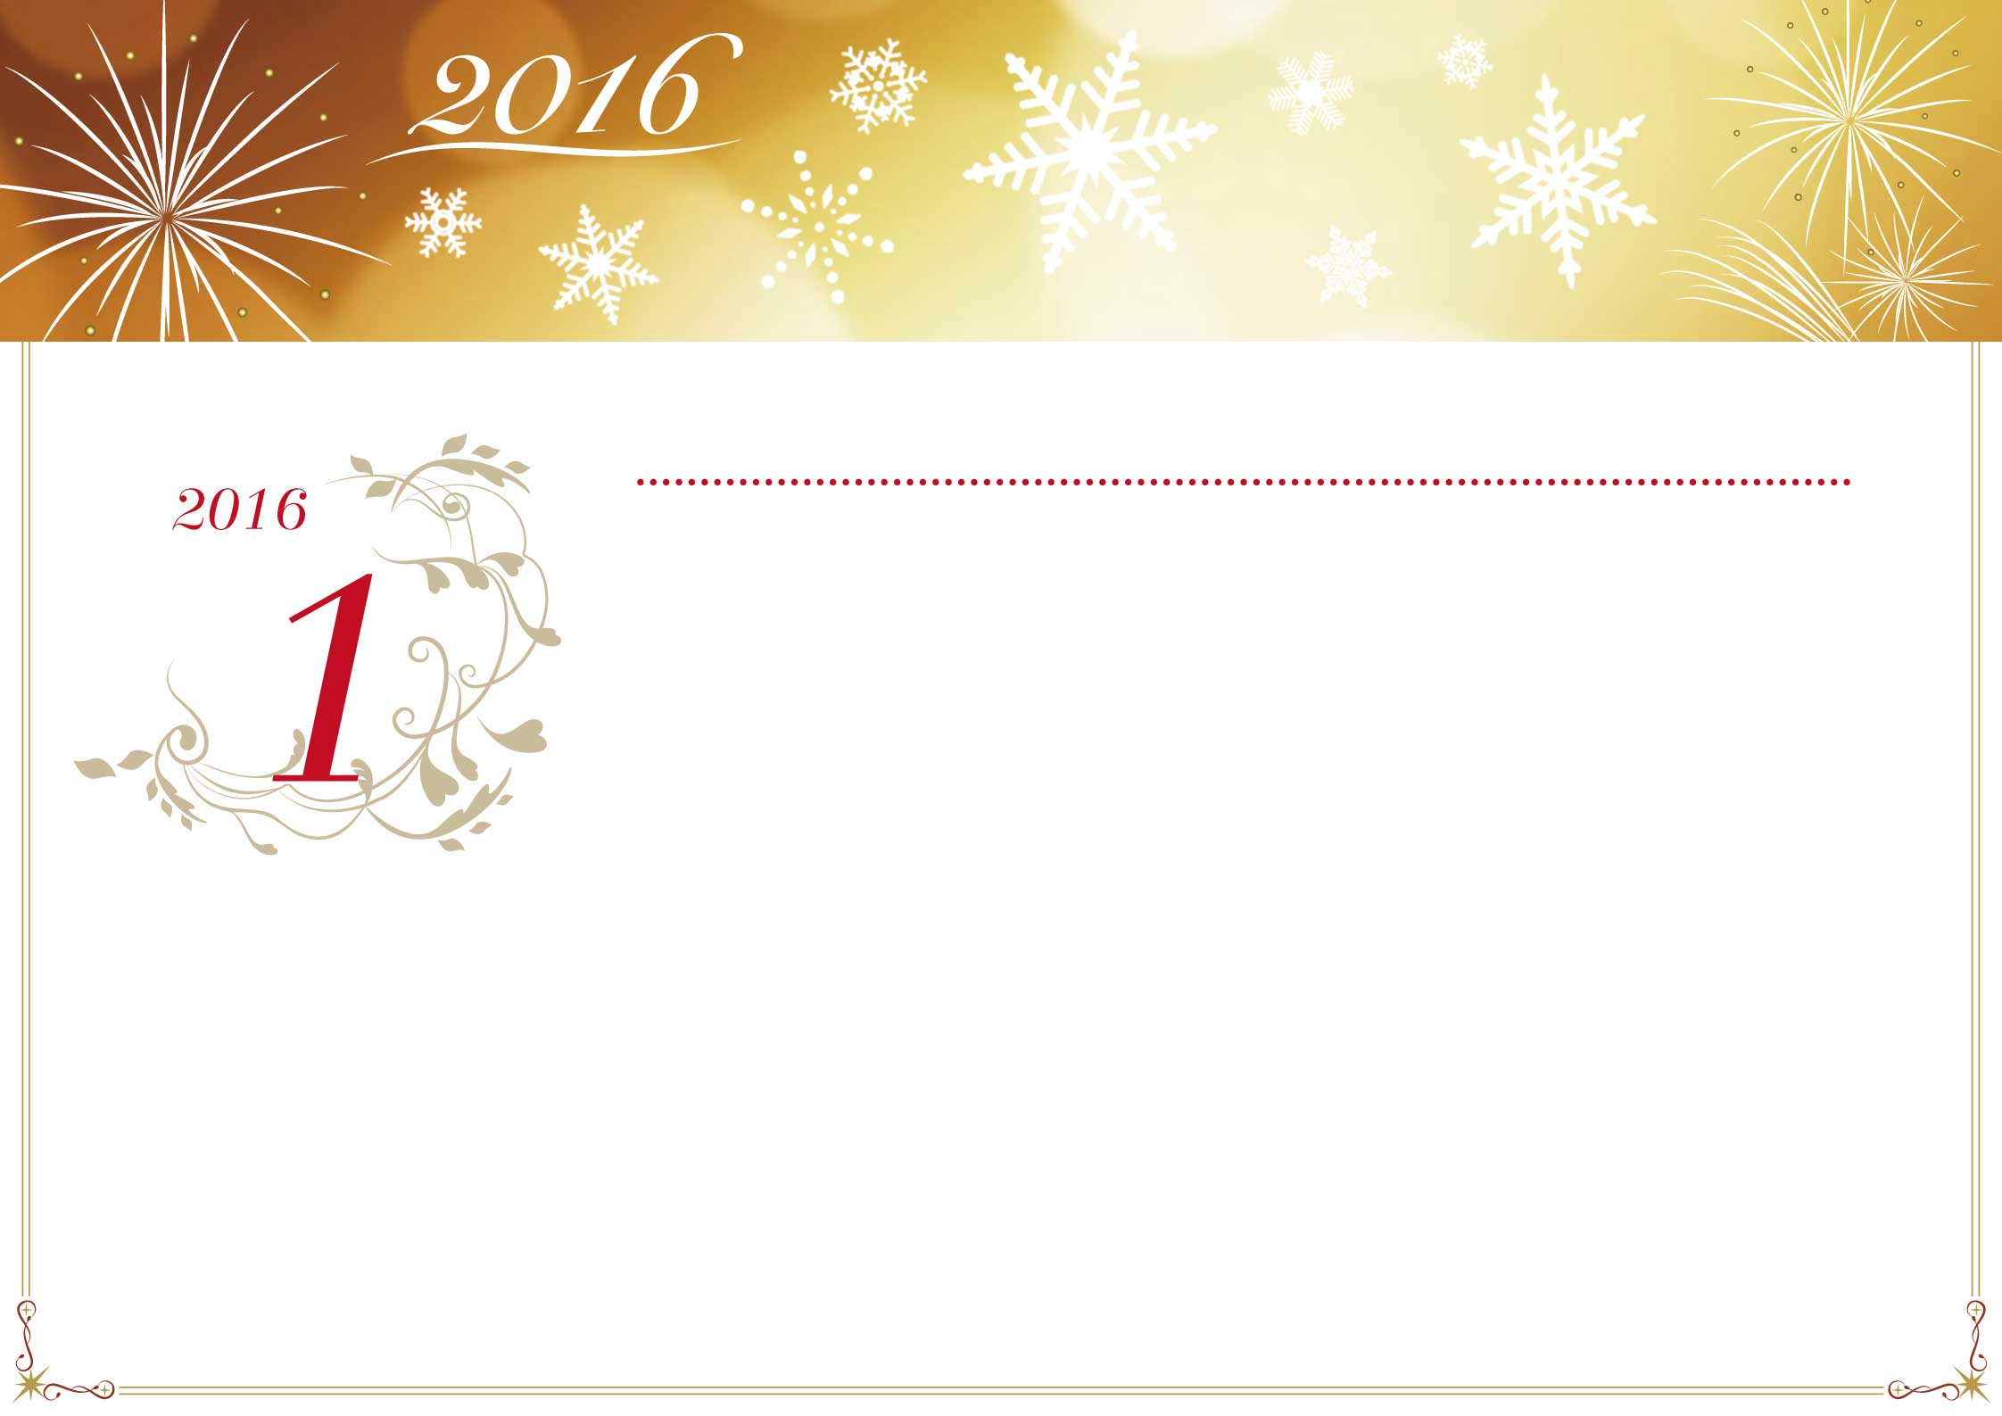

|  |  |  |  |  |  |  |
| --- | --- | --- | --- | --- | --- | --- |
| Lundi | Mardi | Mercredi | Jeudi | Vendredi | Samedi | Dimanche |
|  |  |  |  |  |  |  |
| 28 | 29 | 30 | 31 | 1 | 2 | 3 |
|  |  |  |  | Jour de l’An |  |  |
| 4 | 5 | 6 | 7 | 8 | 9 | 10 |
|  |  |  |  |  |  |  |
| 11 | 12 | 13 | 14 | 15 | 16 | 17 |
|  |  |  |  |  |  |  |
| 18 | 19 | 20 | 21 | 22 | 23 | 24 |
|  |  |  |  |  |  |  |
| 25 | 26 | 27 | 28 | 29 | 30 | 31 |
|  |  |  |  |  |  |  |
| 1 | 2 | 3 | 4 | 5 | 6 | 7 |
|  |  |  |  |  |  |  |

*Janvier*

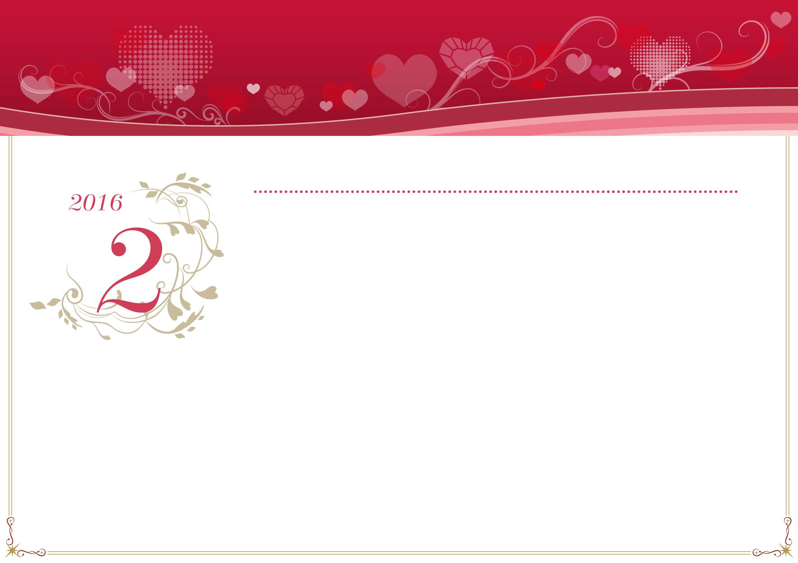

|  |  |  |  |  |  |  |
| --- | --- | --- | --- | --- | --- | --- |
| Lundi | Mardi | Mercredi | Jeudi | Vendredi | Samedi | Dimanche |
|  |  |  |  |  |  |  |
| 1 | 2 | 3 | 4 | 5 | 6 | 7 |
|  |  |  |  |  |  |  |
| 8 | 9 | 10 | 11 | 12 | 13 | 14 |
|  |  |  |  |  |  |  |
| 15 | 16 | 17 | 18 | 19 | 20 | 21 |
|  |  |  |  |  |  |  |
| 22 | 23 | 24 | 25 | 26 | 27 | 28 |
|  |  |  |  |  |  |  |
| 29 | 1 | 2 | 3 | 4 | 5 | 6 |
|  |  |  |  |  |  |  |
| 7 | 8 | 9 | 10 | 11 | 12 | 13 |
|  |  |  |  |  |  |  |

*Février*



|  |  |  |  |  |  |  |
| --- | --- | --- | --- | --- | --- | --- |
| Lundi | Mardi | Mercredi | Jeudi | Vendredi | Samedi | Dimanche |
|  |  |  |  |  |  |  |
| 29 | 1 | 2 | 3 | 4 | 5 | 6 |
|  |  |  |  |  |  |  |
| 7 | 8 | 9 | 10 | 11 | 12 | 13 |
|  |  |  |  |  |  |  |
| 14 | 15 | 16 | 17 | 18 | 19 | 20 |
|  |  |  |  |  |  |  |
| 21 | 22 | 23 | 24 | 25 | 26 | 27 |
|  |  |  |  |  |  | Pâques |
| 28 | 29 | 30 | 31 | 1 | 2 | 3 |
| Lundi de Pâques |  |  |  |  |  |  |
| 4 | 5 | 6 | 7 | 8 | 9 | 10 |
|  |  |  |  |  |  |  |

*Mars*

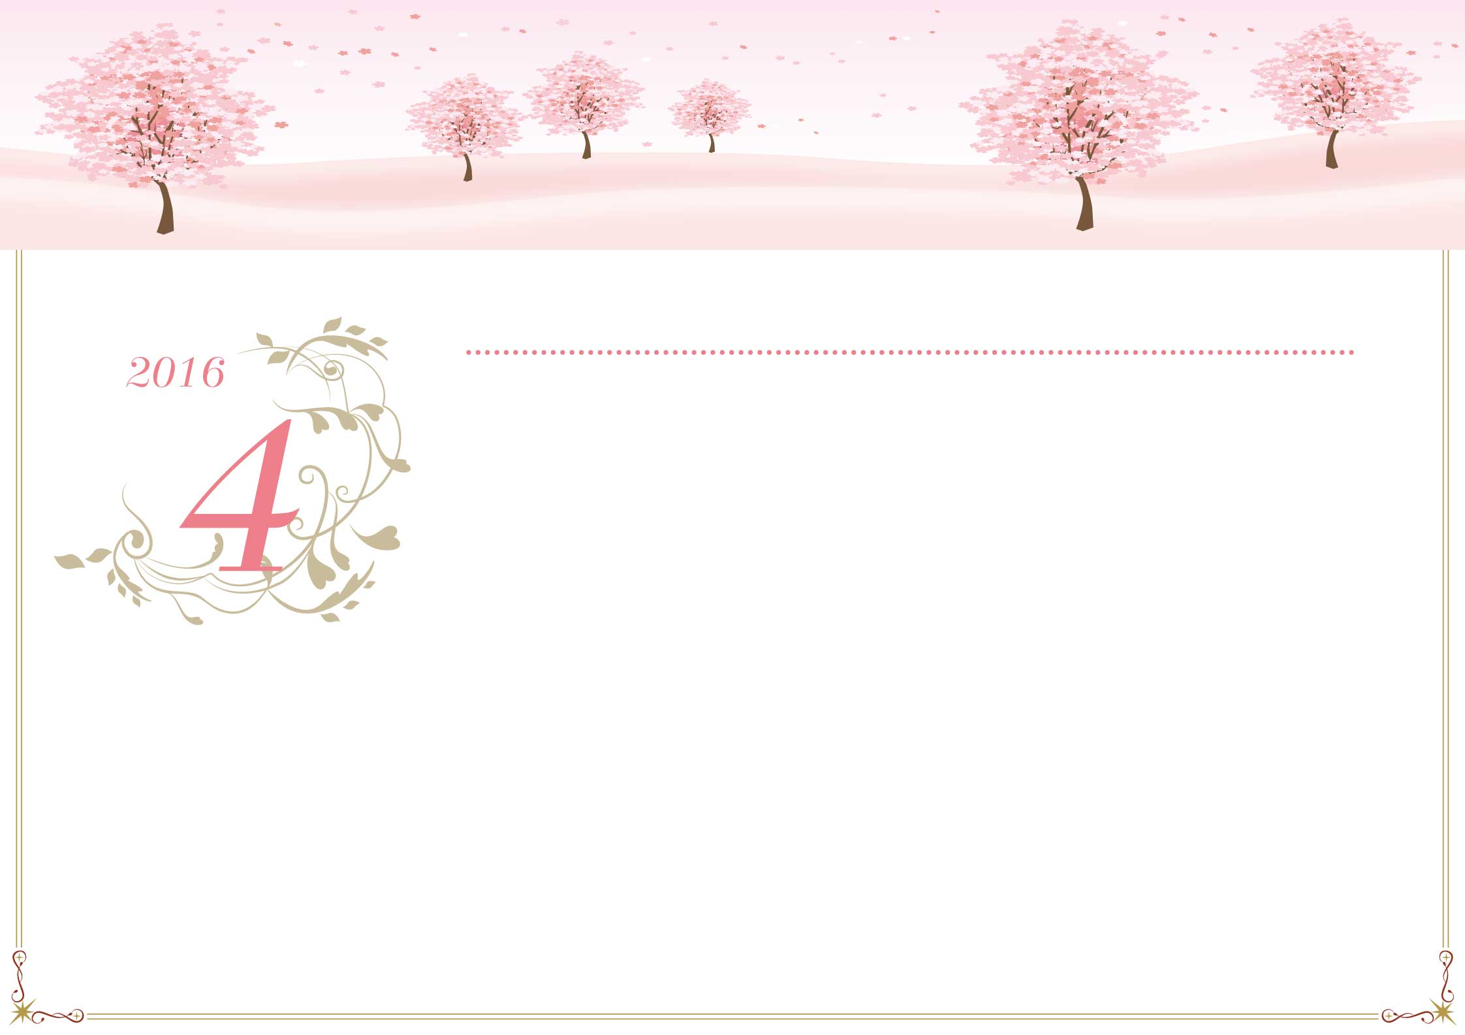

|  |  |  |  |  |  |  |
| --- | --- | --- | --- | --- | --- | --- |
| Lundi | Mardi | Mercredi | Jeudi | Vendredi | Samedi | Dimanche |
|  |  |  |  |  |  |  |
| 28 | 29 | 30 | 31 | 1 | 2 | 3 |
|  |  |  |  |  |  |  |
| 4 | 5 | 6 | 7 | 8 | 9 | 10 |
|  |  |  |  |  |  |  |
| 11 | 12 | 13 | 14 | 15 | 16 | 17 |
|  |  |  |  |  |  |  |
| 18 | 19 | 20 | 21 | 22 | 23 | 24 |
|  |  |  |  |  |  |  |
| 25 | 26 | 27 | 28 | 29 | 30 | 1 |
|  |  |  |  |  |  |  |
| 2 | 3 | 4 | 5 | 6 | 7 | 8 |
|  |  |  |  |  |  |  |

*Avril*



|  |  |  |  |  |  |  |
| --- | --- | --- | --- | --- | --- | --- |
| Lundi | Mardi | Mercredi | Jeudi | Vendredi | Samedi | Dimanche |
|  |  |  |  |  |  |  |
| 25 | 26 | 27 | 28 | 29 | 30 | 1 |
|  |  |  |  |  |  | Fête du Travail |
| 2 | 3 | 4 | 5 | 6 | 7 | 8 |
|  |  |  | Ascension |  |  | Victoire 1945 |
| 9 | 10 | 11 | 12 | 13 | 14 | 15 |
|  |  |  |  |  |  | Pentecôte |
| 16 | 17 | 18 | 19 | 20 | 21 | 22 |
| Lundi de Pentecôte |  |  |  |  |  |  |
| 23 | 24 | 25 | 26 | 27 | 28 | 29 |
|  |  |  |  |  |  |  |
| 30 | 31 | 1 | 2 | 3 | 4 | 5 |
|  |  |  |  |  |  |  |

*Mai*



|  |  |  |  |  |  |  |
| --- | --- | --- | --- | --- | --- | --- |
| Lundi | Mardi | Mercredi | Jeudi | Vendredi | Samedi | Dimanche |
|  |  |  |  |  |  |  |
| 30 | 31 | 1 | 2 | 3 | 4 | 5 |
|  |  |  |  |  |  |  |
| 6 | 7 | 8 | 9 | 10 | 11 | 12 |
|  |  |  |  |  |  |  |
| 13 | 14 | 15 | 16 | 17 | 18 | 19 |
|  |  |  |  |  |  |  |
| 20 | 21 | 22 | 23 | 24 | 25 | 26 |
|  |  |  |  |  |  |  |
| 27 | 28 | 29 | 30 | 1 | 2 | 3 |
|  |  |  |  |  |  |  |
| 4 | 5 | 6 | 7 | 8 | 9 | 10 |
|  |  |  |  |  |  |  |

*Juin*

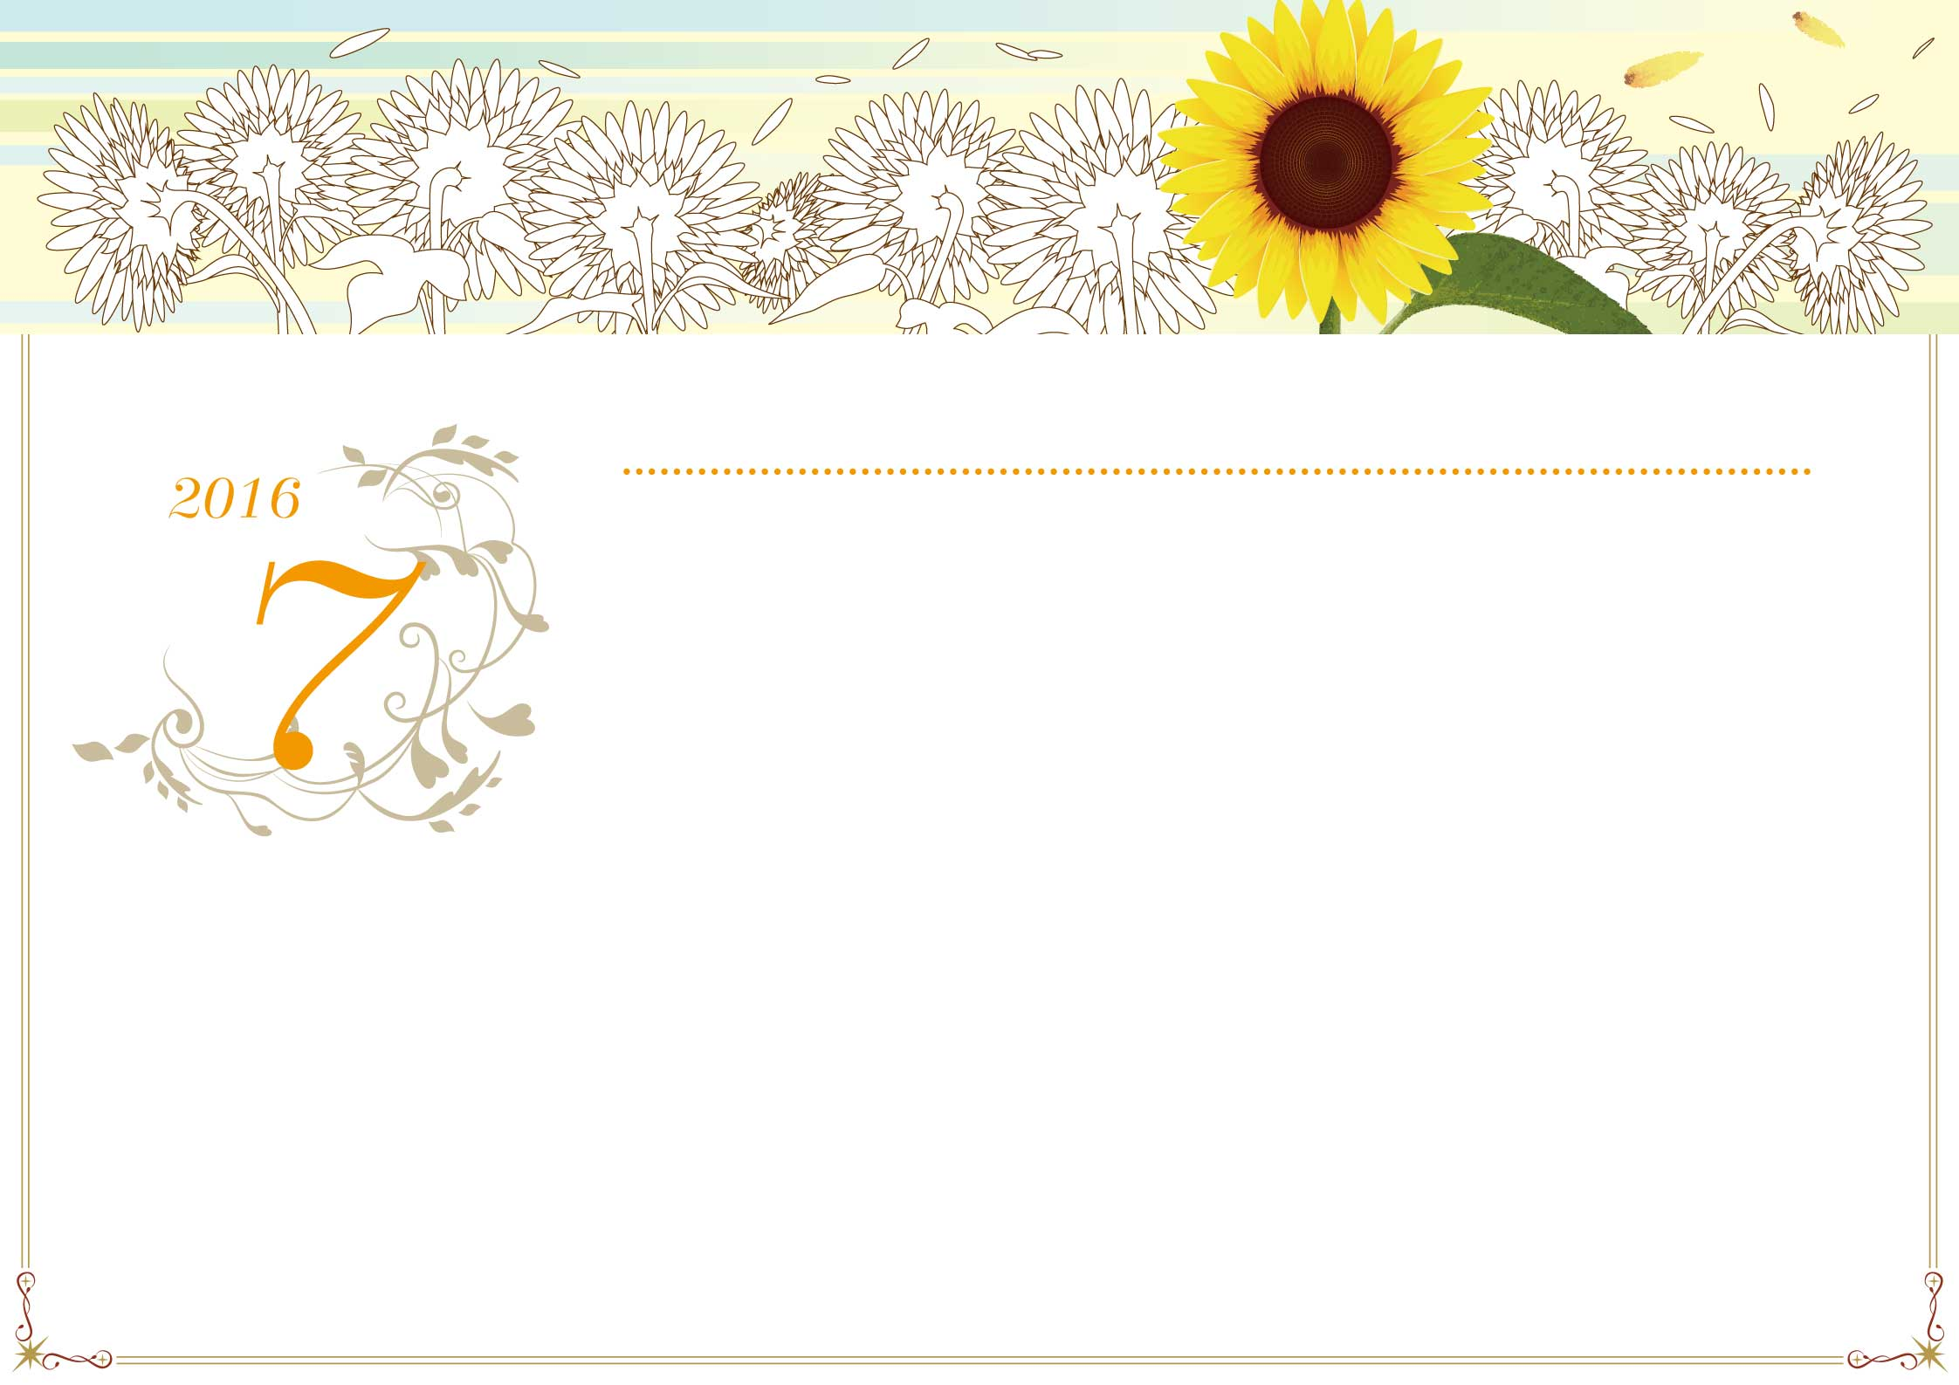

|  |  |  |  |  |  |  |
| --- | --- | --- | --- | --- | --- | --- |
| Lundi | Mardi | Mercredi | Jeudi | Vendredi | Samedi | Dimanche |
|  |  |  |  |  |  |  |
| 27 | 28 | 29 | 30 | 1 | 2 | 3 |
|  |  |  |  |  |  |  |
| 4 | 5 | 6 | 7 | 8 | 9 | 10 |
|  |  |  |  |  |  |  |
| 11 | 12 | 13 | 14 | 15 | 16 | 17 |
|  |  |  | Fête Nationale |  |  |  |
| 18 | 19 | 20 | 21 | 22 | 23 | 24 |
|  |  |  |  |  |  |  |
| 25 | 26 | 27 | 28 | 29 | 30 | 31 |
|  |  |  |  |  |  |  |
| 1 | 2 | 3 | 4 | 5 | 6 | 7 |
|  |  |  |  |  |  |  |

*Juillet*

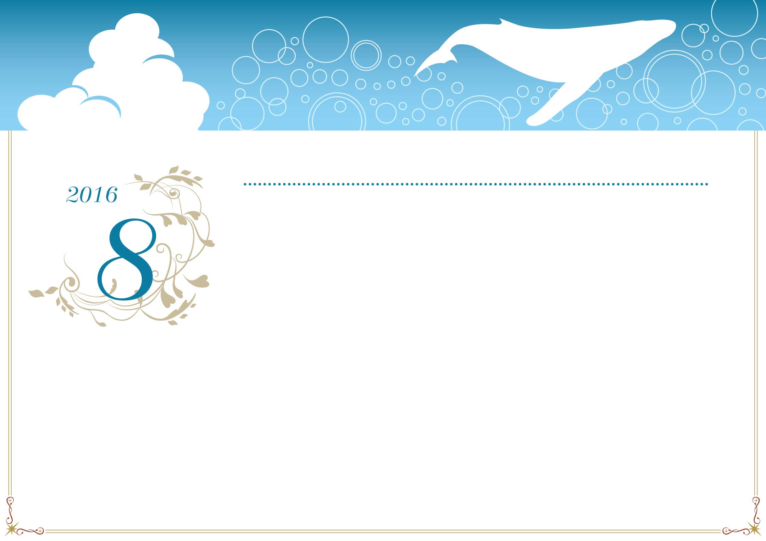

|  |  |  |  |  |  |  |
| --- | --- | --- | --- | --- | --- | --- |
| Lundi | Mardi | Mercredi | Jeudi | Vendredi | Samedi | Dimanche |
|  |  |  |  |  |  |  |
| 1 | 2 | 3 | 4 | 5 | 6 | 7 |
|  |  |  |  |  |  |  |
| 8 | 9 | 10 | 11 | 12 | 13 | 14 |
|  |  |  |  |  |  |  |
| 15 | 16 | 17 | 18 | 19 | 20 | 21 |
| Assomption |  |  |  |  |  |  |
| 22 | 23 | 24 | 25 | 26 | 27 | 28 |
|  |  |  |  |  |  |  |
| 29 | 30 | 31 | 1 | 2 | 3 | 4 |
|  |  |  |  |  |  |  |
| 5 | 6 | 7 | 8 | 9 | 10 | 11 |
|  |  |  |  |  |  |  |

*Août*

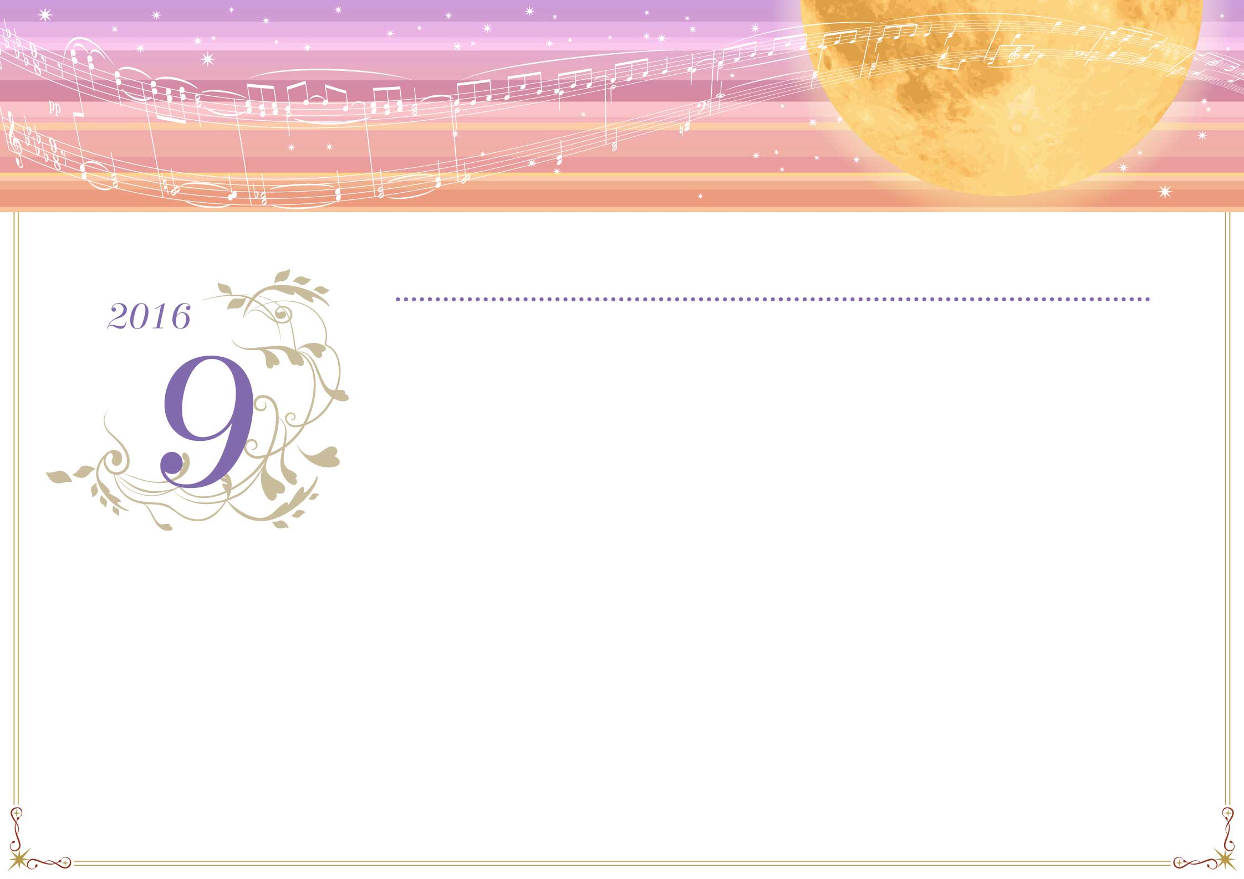

|  |  |  |  |  |  |  |
| --- | --- | --- | --- | --- | --- | --- |
| Lundi | Mardi | Mercredi | Jeudi | Vendredi | Samedi | Dimanche |
|  |  |  |  |  |  |  |
| 29 | 30 | 31 | 1 | 2 | 3 | 4 |
|  |  |  |  |  |  |  |
| 5 | 6 | 7 | 8 | 9 | 10 | 11 |
|  |  |  |  |  |  |  |
| 12 | 13 | 14 | 15 | 16 | 17 | 18 |
|  |  |  |  |  |  |  |
| 19 | 20 | 21 | 22 | 23 | 24 | 25 |
|  |  |  |  |  |  |  |
| 26 | 27 | 28 | 29 | 30 | 1 | 2 |
|  |  |  |  |  |  |  |
| 3 | 4 | 5 | 6 | 7 | 8 | 9 |
|  |  |  |  |  |  |  |

*Septembre*

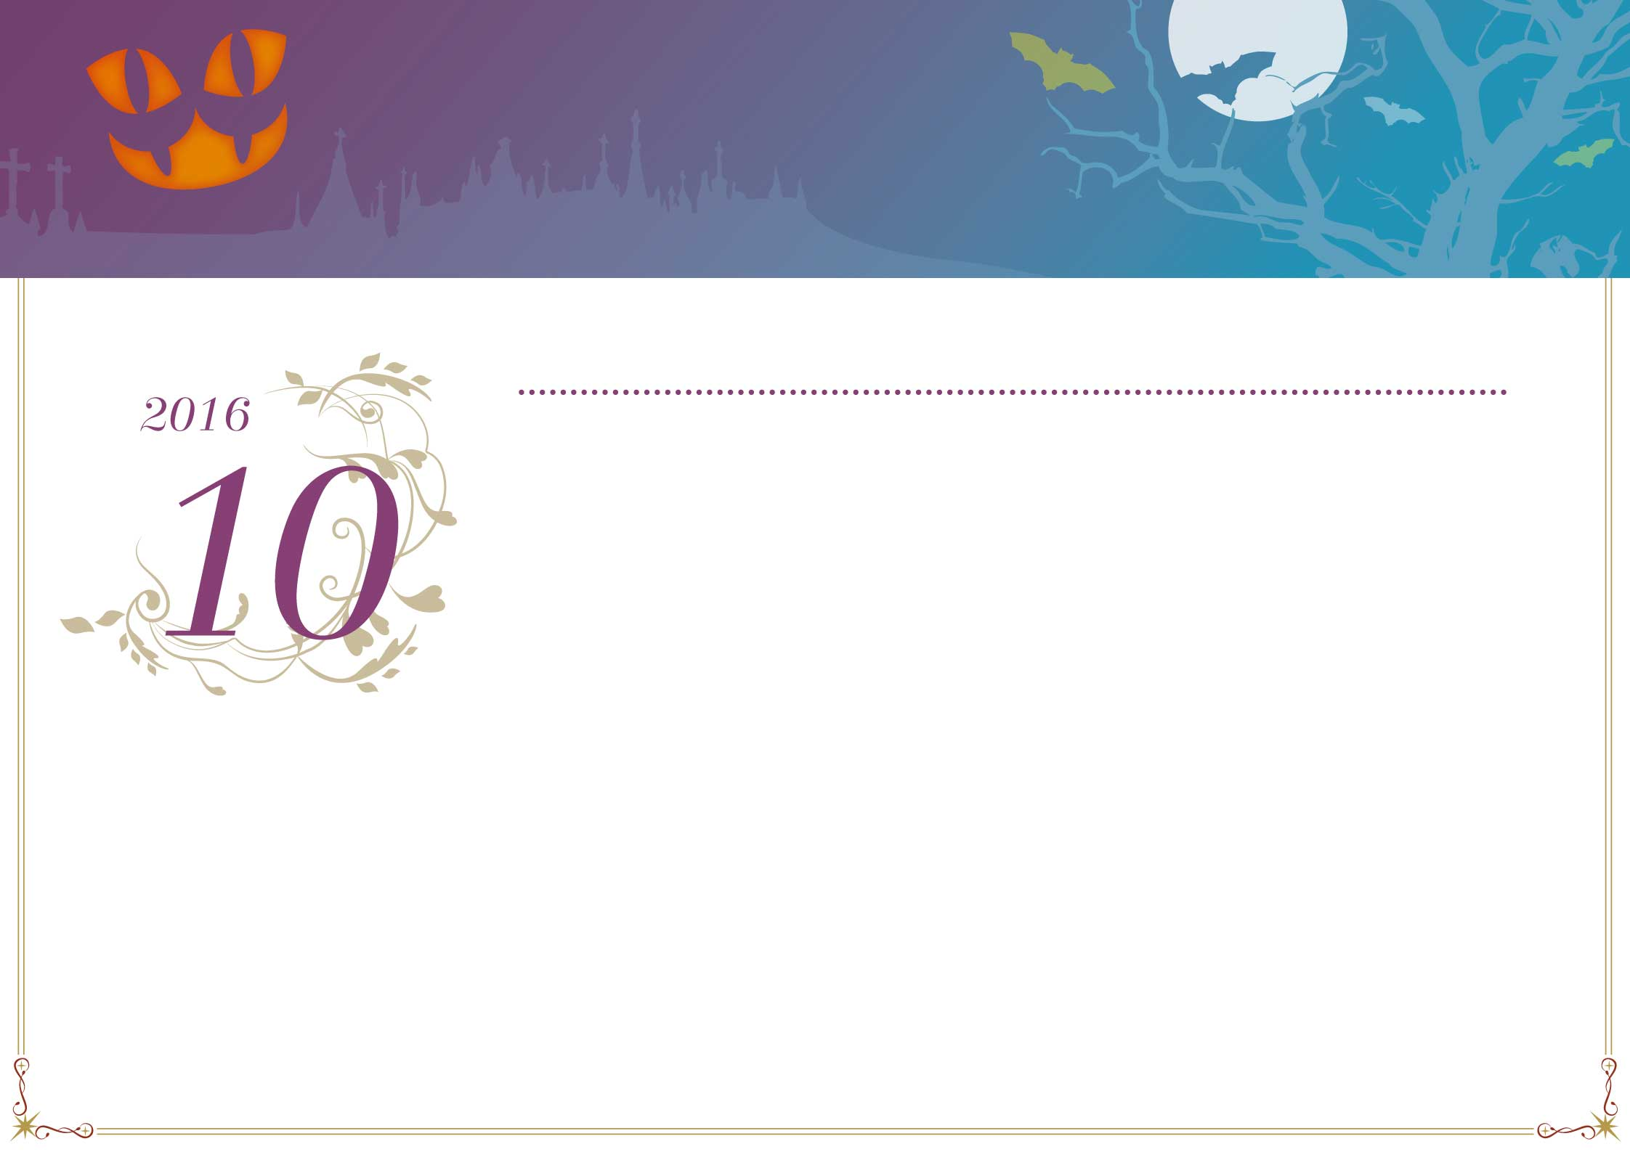

|  |  |  |  |  |  |  |
| --- | --- | --- | --- | --- | --- | --- |
| Lundi | Mardi | Mercredi | Jeudi | Vendredi | Samedi | Dimanche |
|  |  |  |  |  |  |  |
| 26 | 27 | 28 | 29 | 30 | 1 | 2 |
|  |  |  |  |  |  |  |
| 3 | 4 | 5 | 6 | 7 | 8 | 9 |
|  |  |  |  |  |  |  |
| 10 | 11 | 12 | 13 | 14 | 15 | 16 |
|  |  |  |  |  |  |  |
| 17 | 18 | 19 | 20 | 21 | 22 | 23 |
|  |  |  |  |  |  |  |
| 24 | 25 | 26 | 27 | 28 | 29 | 30 |
|  |  |  |  |  |  |  |
| 31 | 1 | 2 | 3 | 4 | 5 | 6 |
|  |  |  |  |  |  |  |

*Octobre*

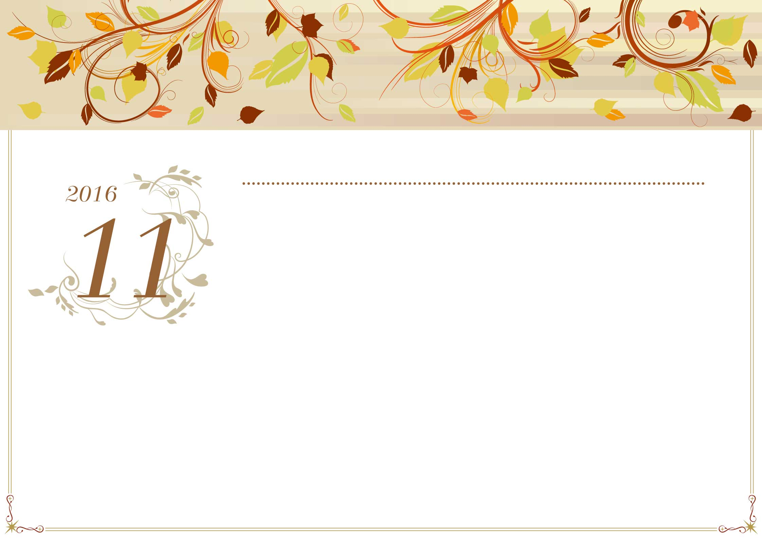

|  |  |  |  |  |  |  |
| --- | --- | --- | --- | --- | --- | --- |
| Lundi | Mardi | Mercredi | Jeudi | Vendredi | Samedi | Dimanche |
|  |  |  |  |  |  |  |
| 31 | 1 | 2 | 3 | 4 | 5 | 6 |
|  | Toussaint |  |  |  |  |  |
| 7 | 8 | 9 | 10 | 11 | 12 | 13 |
|  |  |  |  | Armistice 1918 |  |  |
| 14 | 15 | 16 | 17 | 18 | 19 | 20 |
|  |  |  |  |  |  |  |
| 21 | 22 | 23 | 24 | 25 | 26 | 27 |
|  |  |  |  |  |  |  |
| 28 | 29 | 30 | 1 | 2 | 3 | 4 |
|  |  |  |  |  |  |  |
| 5 | 6 | 7 | 8 | 9 | 10 | 11 |
|  |  |  |  |  |  |  |

*Novembre*

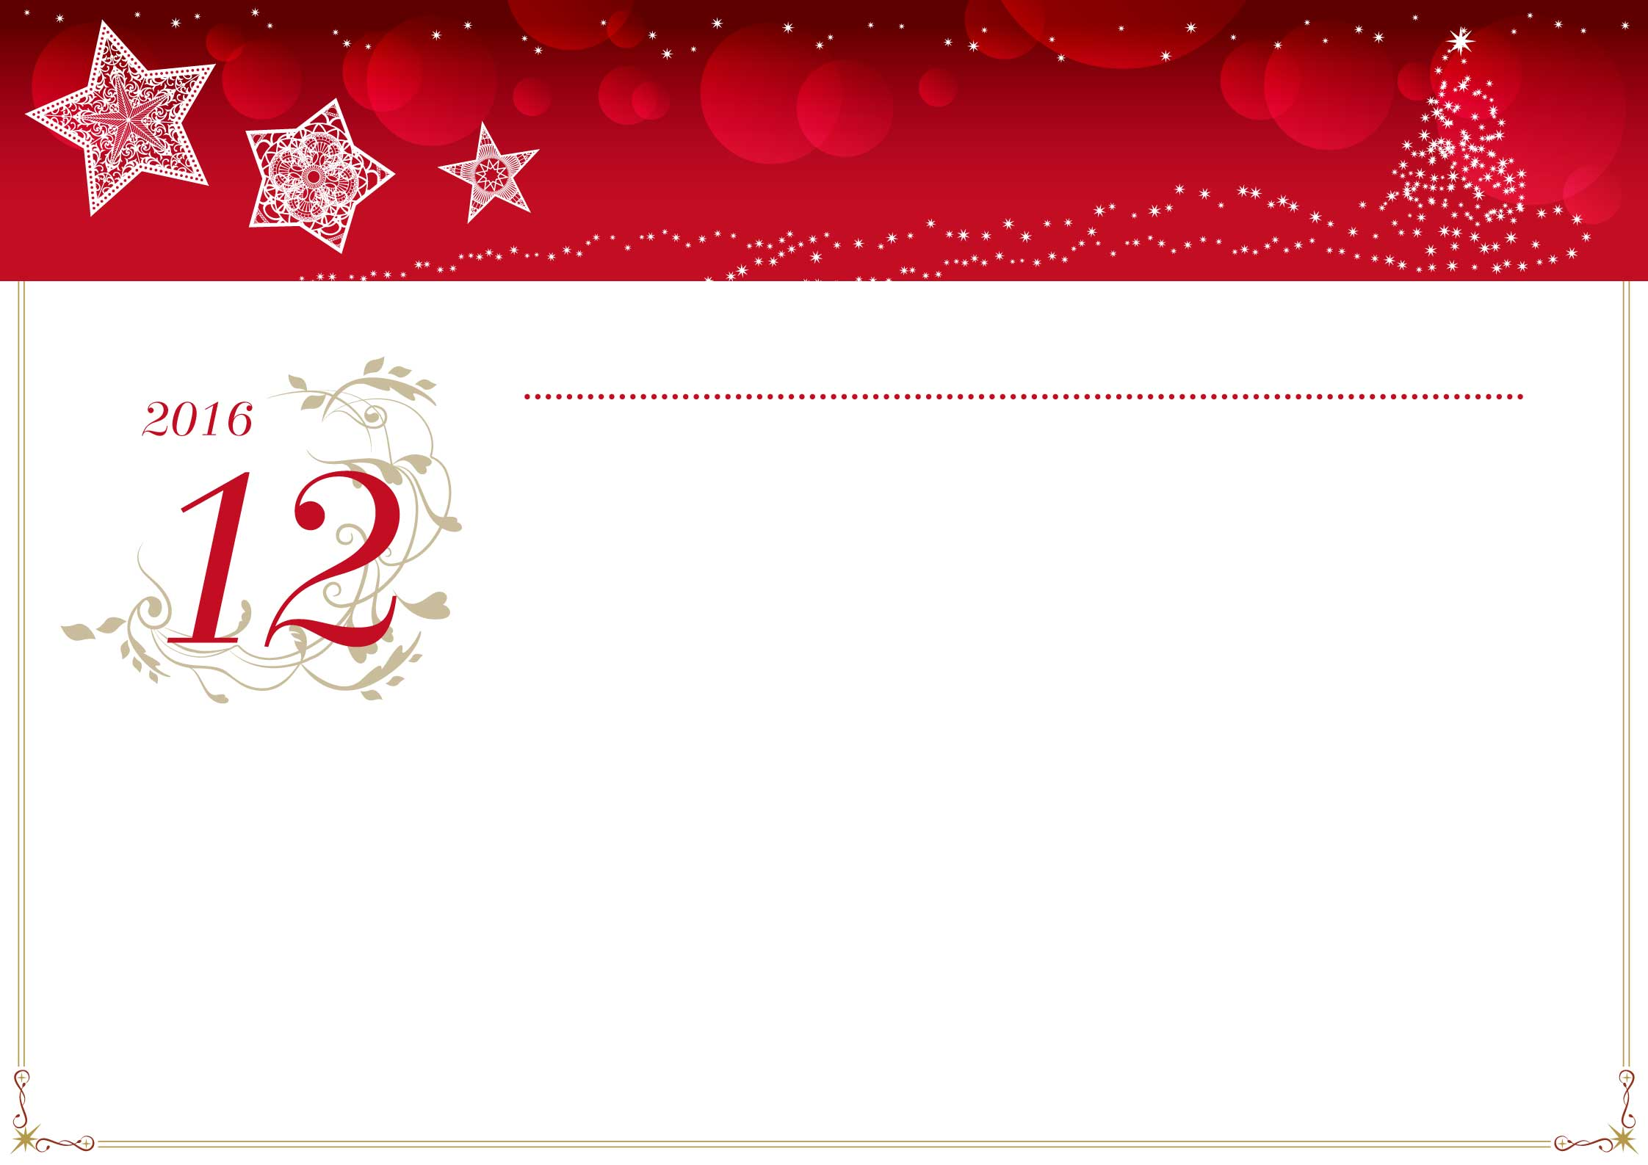

|  |  |  |  |  |  |  |
| --- | --- | --- | --- | --- | --- | --- |
| Lundi | Mardi | Mercredi | Jeudi | Vendredi | Samedi | Dimanche |
|  |  |  |  |  |  |  |
| 28 | 29 | 30 | 1 | 2 | 3 | 4 |
|  |  |  |  |  |  |  |
| 5 | 6 | 7 | 8 | 9 | 10 | 11 |
|  |  |  |  |  |  |  |
| 12 | 13 | 14 | 15 | 16 | 17 | 18 |
|  |  |  |  |  |  |  |
| 19 | 20 | 21 | 22 | 23 | 24 | 25 |
|  |  |  |  |  |  | Noël |
| 26 | 27 | 28 | 29 | 30 | 31 | 1 |
|  |  |  |  |  |  |  |
| 2 | 3 | 4 | 5 | 6 | 7 | 8 |
|  |  |  |  |  |  |  |

*Décembre*