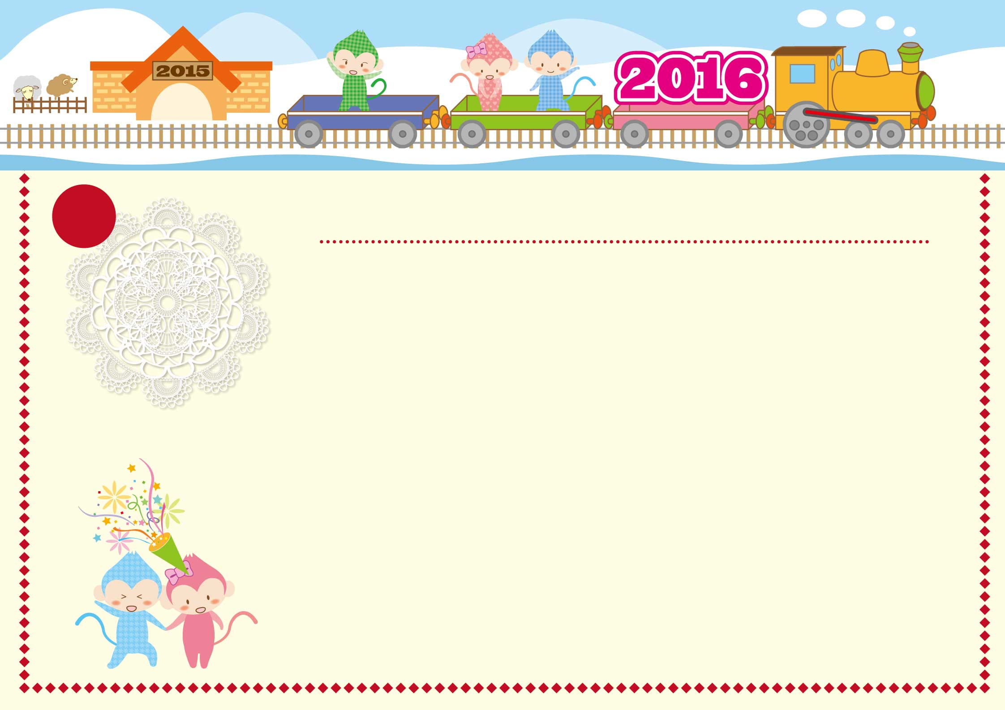

|  |  |  |  |  |  |  |
| --- | --- | --- | --- | --- | --- | --- |
| **Lundi** | **Mardi** | **Mercredi** | **Jeudi** | **Vendredi** | **Samedi** | **Dimanche** |
|  |  |  |  |  |  |  |
| **28** | **29** | **30** | **31** | **1** | **2** | **3** |
|  |  |  |  | **Jour de l’An** |  |  |
| **4** | **5** | **6** | **7** | **8** | **9** | **10** |
|  |  |  |  |  |  |  |
| **11** | **12** | **13** | **14** | **15** | **16** | **17** |
|  |  |  |  |  |  |  |
| **18** | **19** | **20** | **21** | **22** | **23** | **24** |
|  |  |  |  |  |  |  |
| **25** | **26** | **27** | **28** | **29** | **30** | **31** |
|  |  |  |  |  |  |  |
| **1** | **2** | **3** | **4** | **5** | **6** | **7** |
|  |  |  |  |  |  |  |

Janvier

1

2016

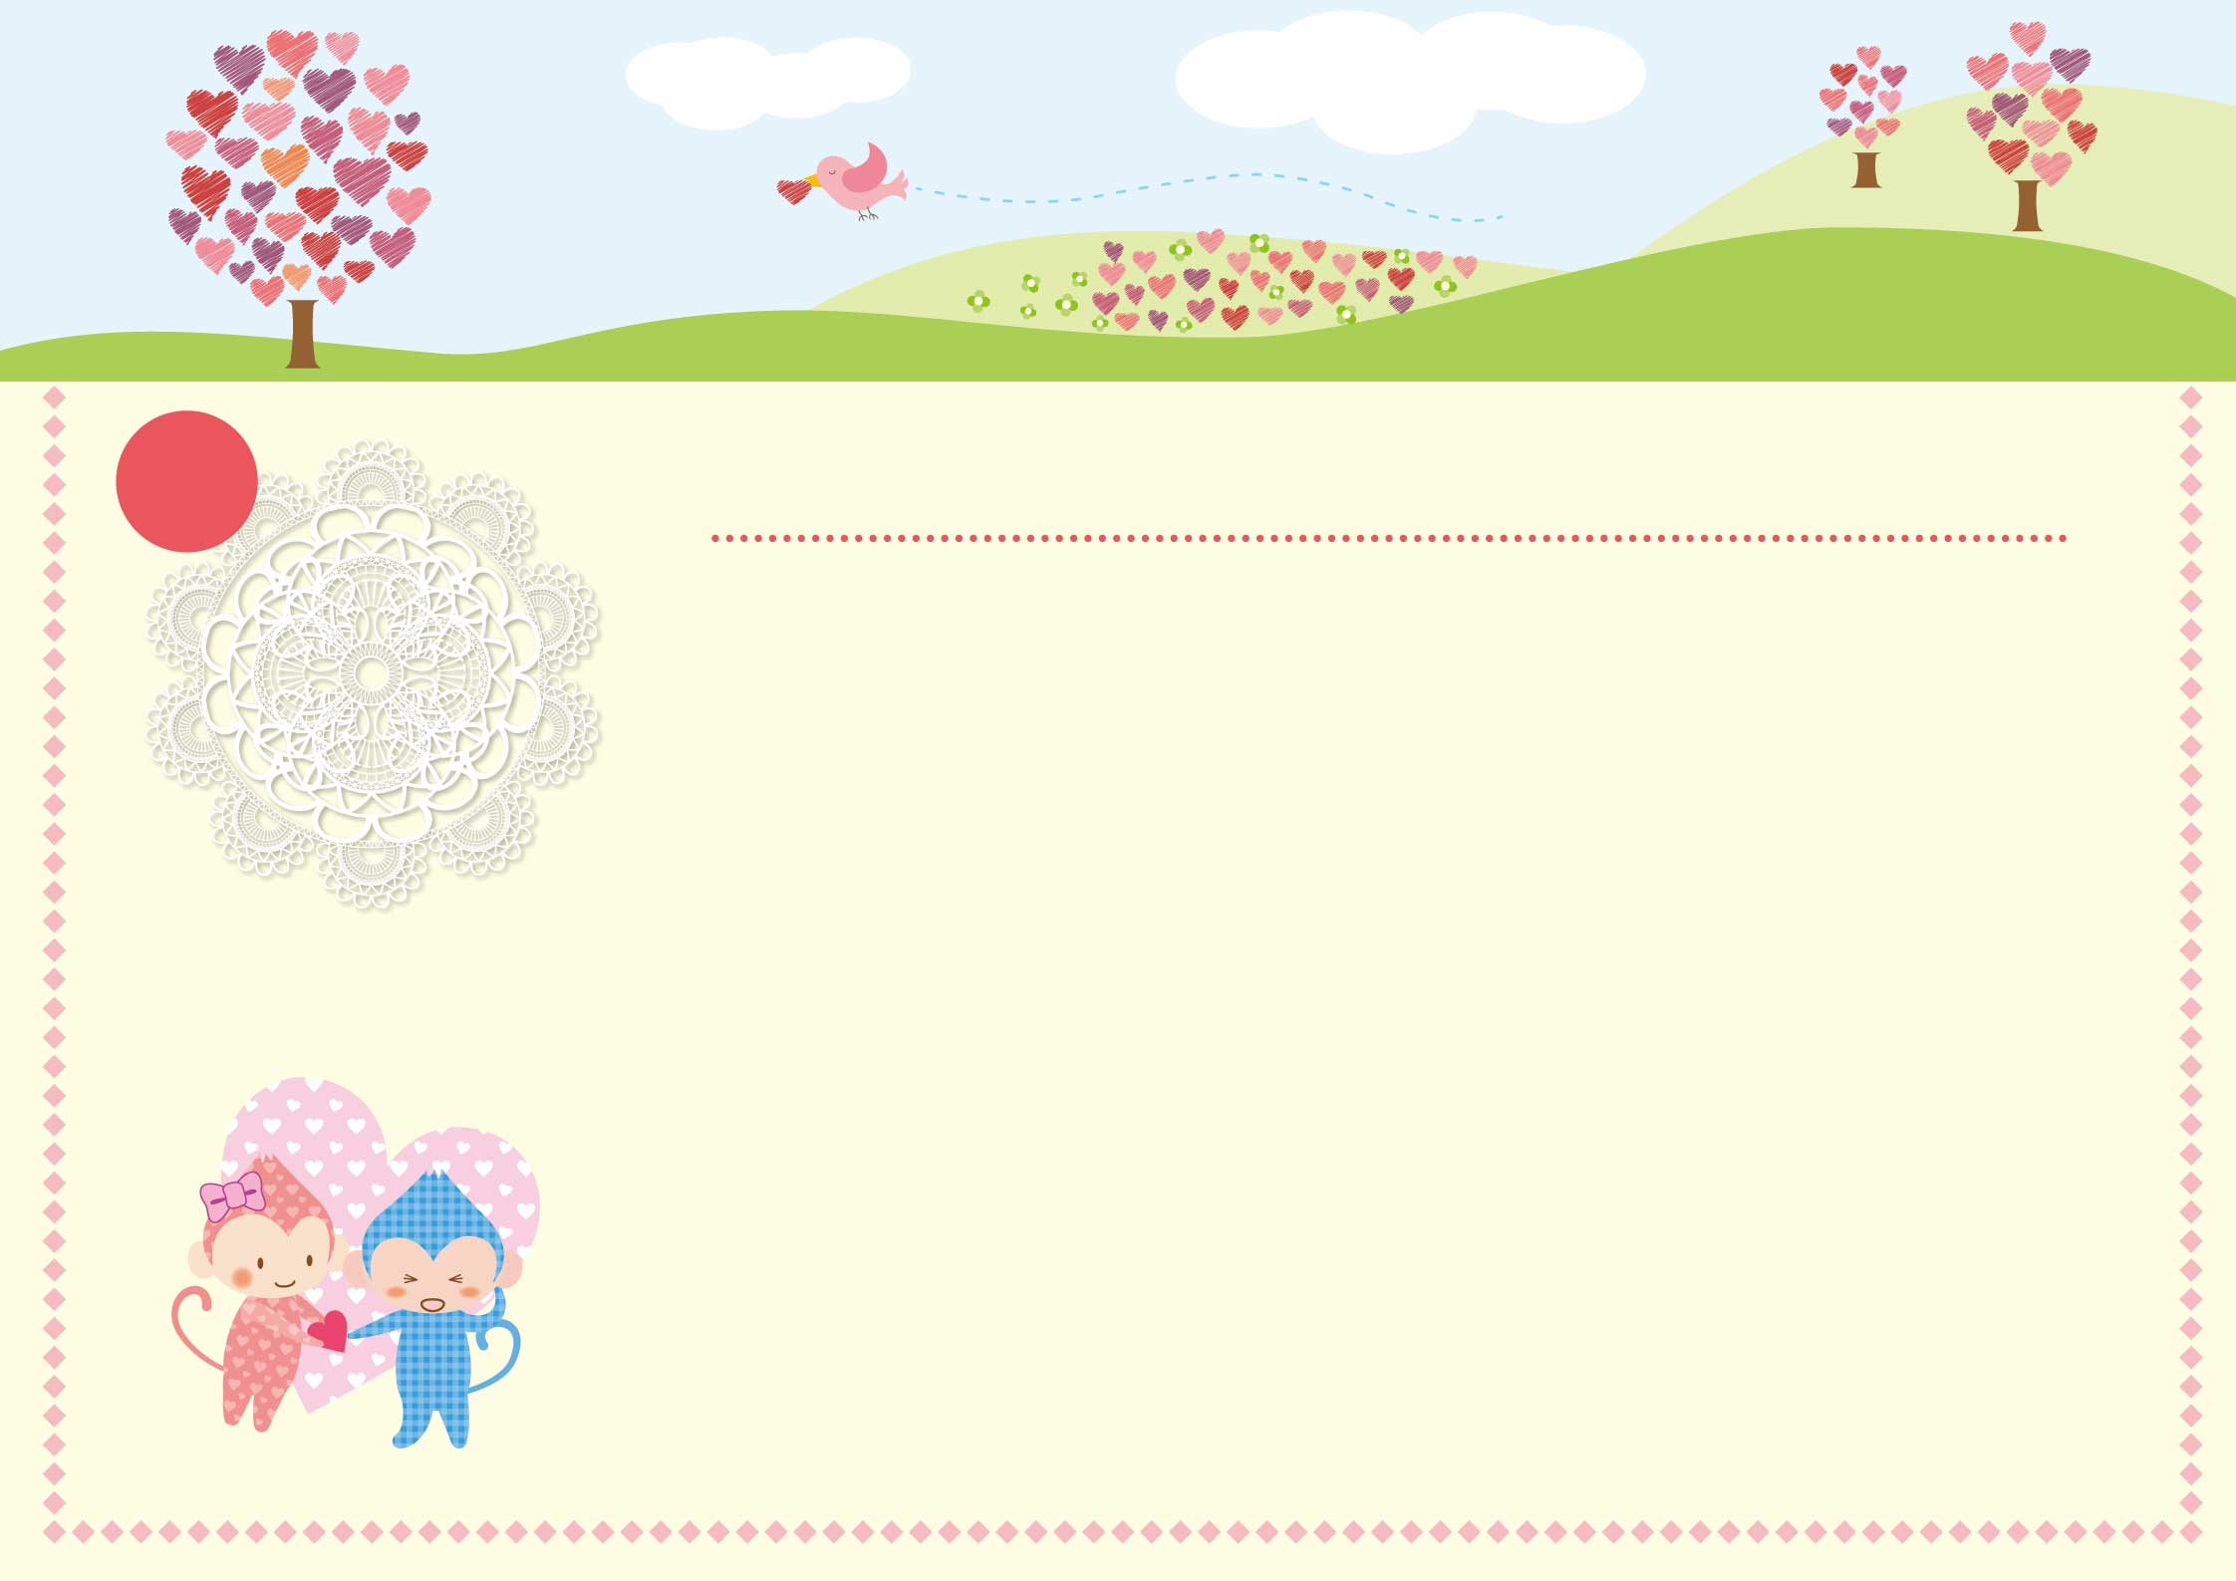

2016

|  |  |  |  |  |  |  |
| --- | --- | --- | --- | --- | --- | --- |
| **Lundi** | **Mardi** | **Mercredi** | **Jeudi** | **Vendredi** | **Samedi** | **Dimanche** |
|  |  |  |  |  |  |  |
| **1** | **2** | **3** | **4** | **5** | **6** | **7** |
|  |  |  |  |  |  |  |
| **8** | **9** | **10** | **11** | **12** | **13** | **14** |
|  |  |  |  |  |  |  |
| **15** | **16** | **17** | **18** | **19** | **20** | **21** |
|  |  |  |  |  |  |  |
| **22** | **23** | **24** | **25** | **26** | **27** | **28** |
|  |  |  |  |  |  |  |
| **29** | **1** | **2** | **3** | **4** | **5** | **6** |
|  |  |  |  |  |  |  |
| **7** | **8** | **9** | **10** | **11** | **12** | **13** |
|  |  |  |  |  |  |  |

2

Février

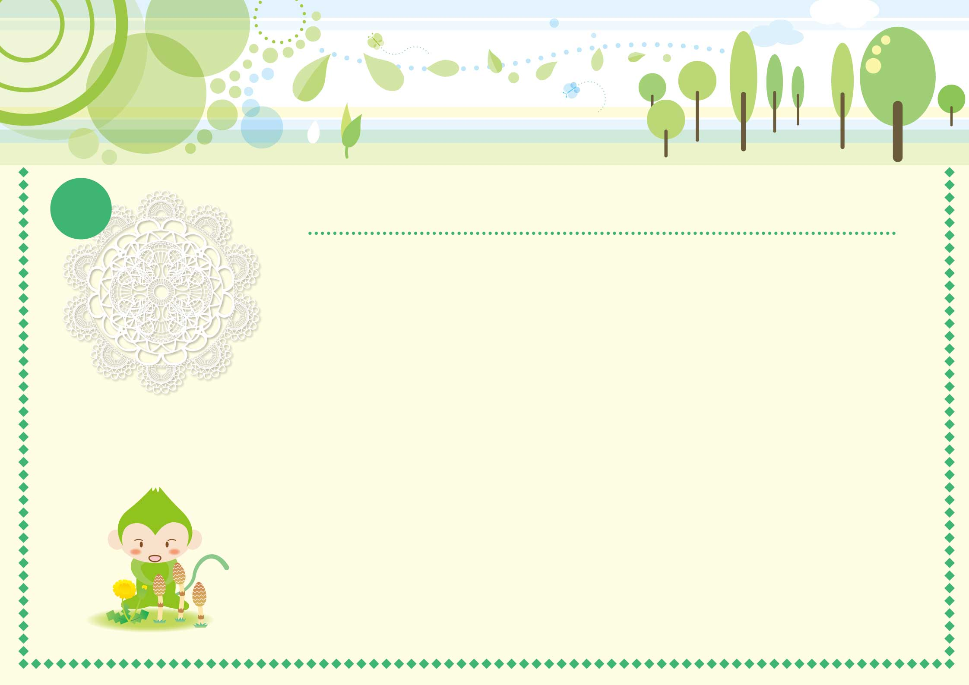

2016

|  |  |  |  |  |  |  |
| --- | --- | --- | --- | --- | --- | --- |
| **Lundi** | **Mardi** | **Mercredi** | **Jeudi** | **Vendredi** | **Samedi** | **Dimanche** |
|  |  |  |  |  |  |  |
| **29** | **1** | **2** | **3** | **4** | **5** | **6** |
|  |  |  |  |  |  |  |
| **7** | **8** | **9** | **10** | **11** | **12** | **13** |
|  |  |  |  |  |  |  |
| **14** | **15** | **16** | **17** | **18** | **19** | **20** |
|  |  |  |  |  |  |  |
| **21** | **22** | **23** | **24** | **25** | **26** | **27** |
|  |  |  |  |  |  | **Pâques** |
| **28** | **29** | **30** | **31** | **1** | **2** | **3** |
| **Lundi de Pâques** |  |  |  |  |  |  |
| **4** | **5** | **6** | **7** | **8** | **9** | **10** |
|  |  |  |  |  |  |  |

Mars

3

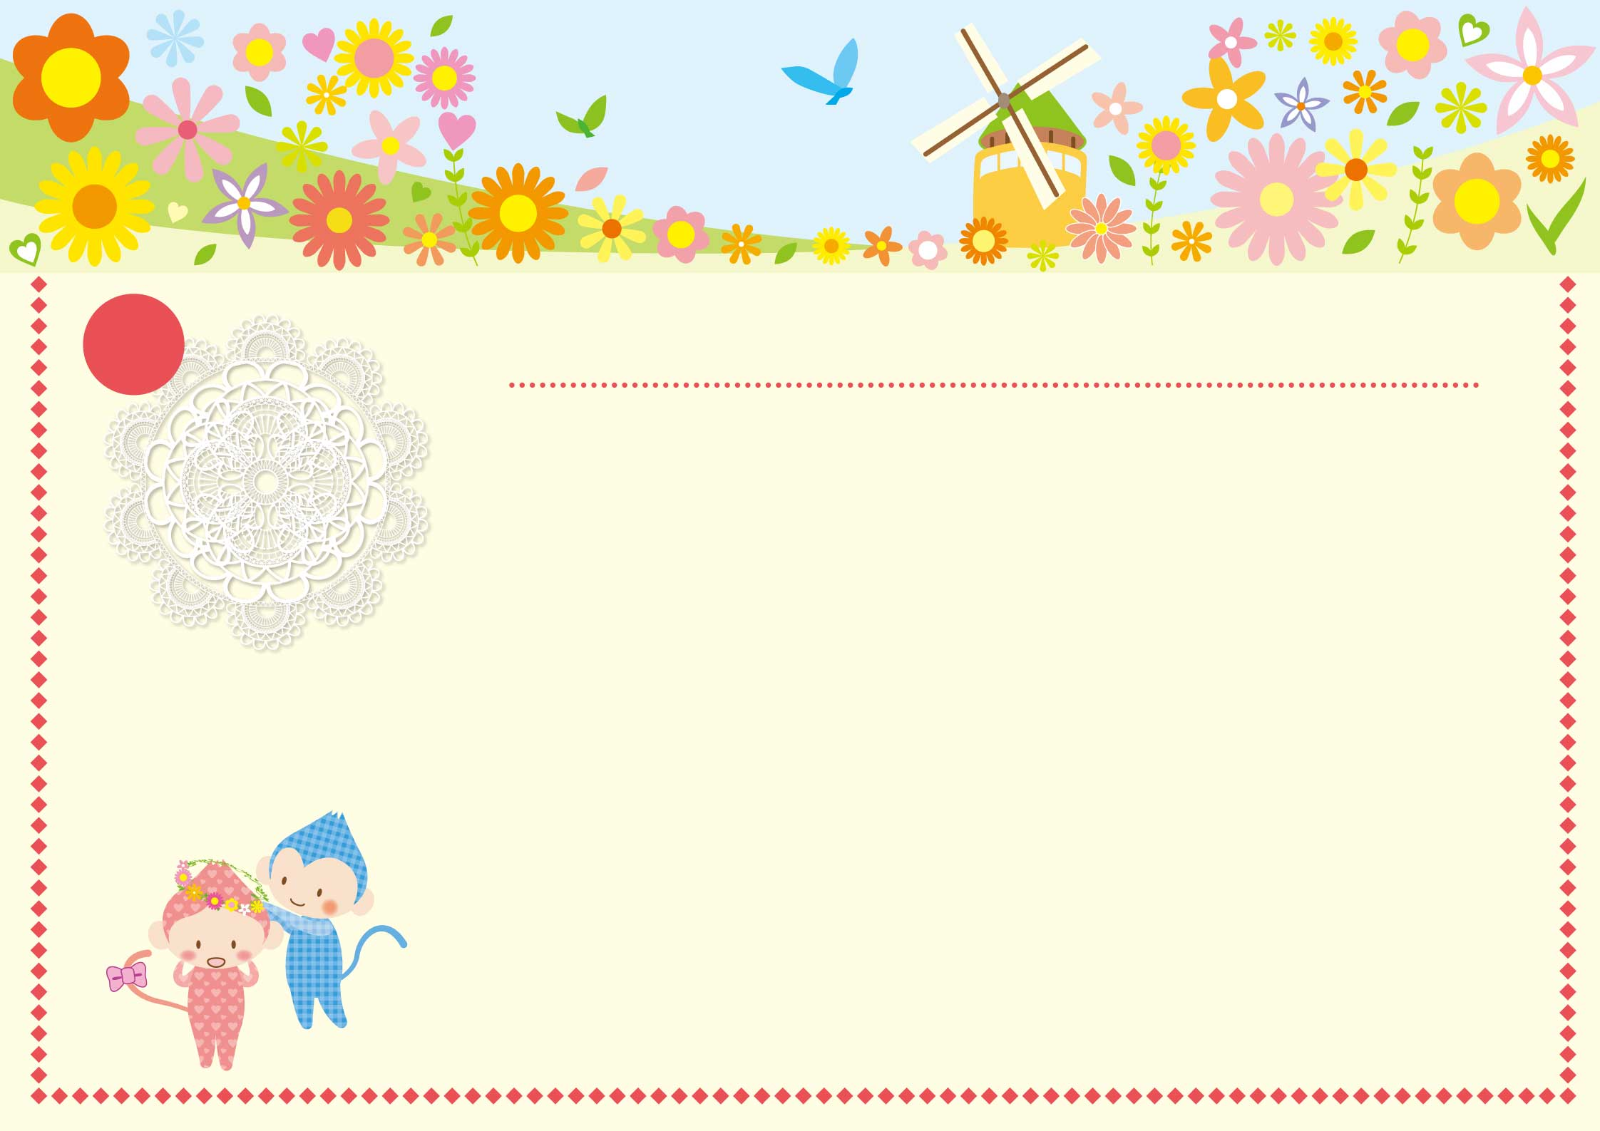

2016

|  |  |  |  |  |  |  |
| --- | --- | --- | --- | --- | --- | --- |
| **Lundi** | **Mardi** | **Mercredi** | **Jeudi** | **Vendredi** | **Samedi** | **Dimanche** |
|  |  |  |  |  |  |  |
| **28** | **29** | **30** | **31** | **1** | **2** | **3** |
|  |  |  |  |  |  |  |
| **4** | **5** | **6** | **7** | **8** | **9** | **10** |
|  |  |  |  |  |  |  |
| **11** | **12** | **13** | **14** | **15** | **16** | **17** |
|  |  |  |  |  |  |  |
| **18** | **19** | **20** | **21** | **22** | **23** | **24** |
|  |  |  |  |  |  |  |
| **25** | **26** | **27** | **28** | **29** | **30** | **1** |
|  |  |  |  |  |  |  |
| **2** | **3** | **4** | **5** | **6** | **7** | **8** |
|  |  |  |  |  |  |  |

Avril

4

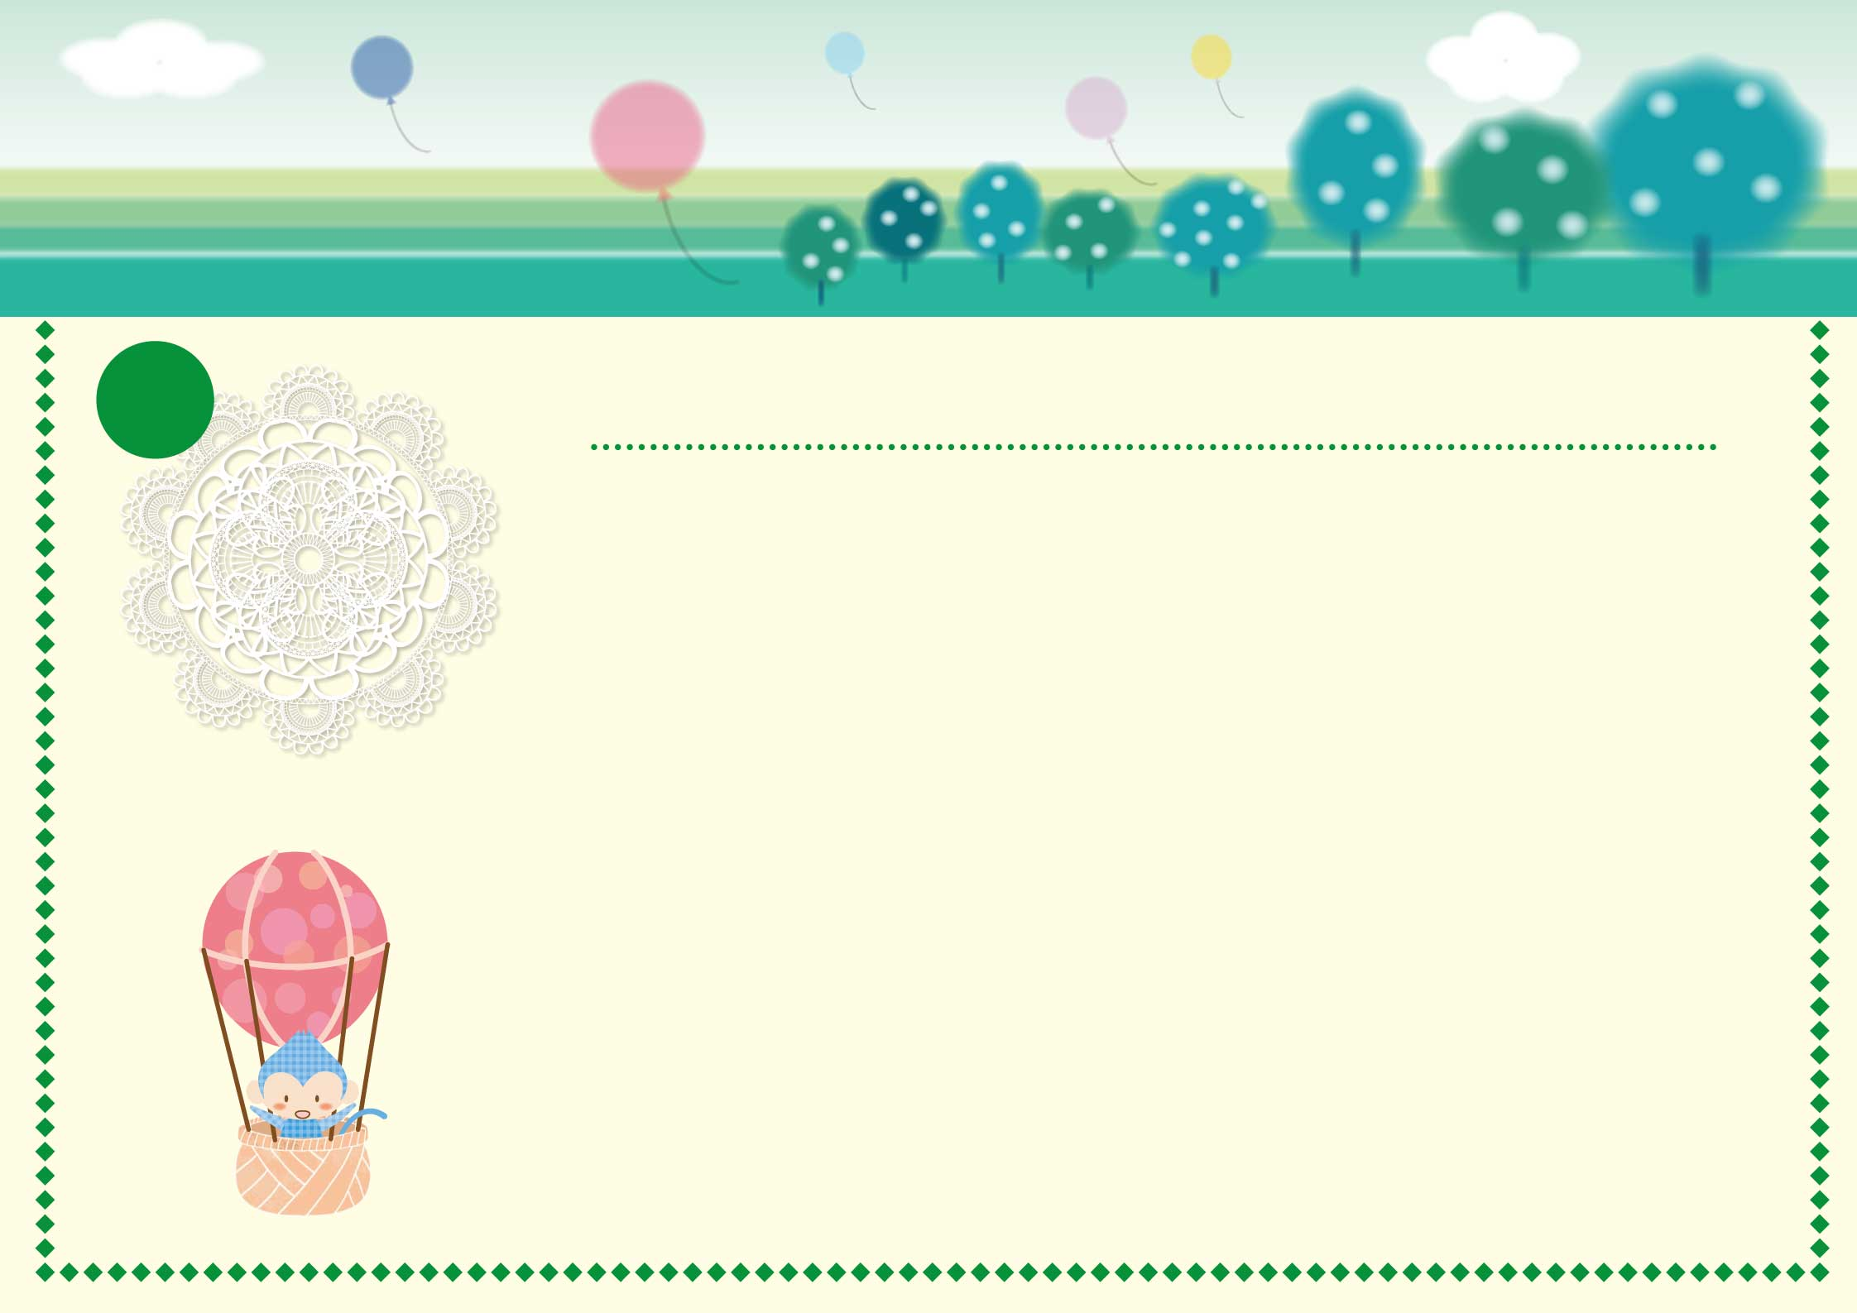

2016

|  |  |  |  |  |  |  |
| --- | --- | --- | --- | --- | --- | --- |
| **Lundi** | **Mardi** | **Mercredi** | **Jeudi** | **Vendredi** | **Samedi** | **Dimanche** |
|  |  |  |  |  |  |  |
| **25** | **26** | **27** | **28** | **29** | **30** | **1** |
|  |  |  |  |  |  | **Fête du Travail** |
| **2** | **3** | **4** | **5** | **6** | **7** | **8** |
|  |  |  | **Ascension** |  |  | **Victoire 1945** |
| **9** | **10** | **11** | **12** | **13** | **14** | **15** |
|  |  |  |  |  |  | **Pentecôte** |
| **16** | **17** | **18** | **19** | **20** | **21** | **22** |
| **Lundi de Pentecôte** |  |  |  |  |  |  |
| **23** | **24** | **25** | **26** | **27** | **28** | **29** |
|  |  |  |  |  |  |  |
| **30** | **31** | **1** | **2** | **3** | **4** | **5** |
|  |  |  |  |  |  |  |

Mai

5



2016

|  |  |  |  |  |  |  |
| --- | --- | --- | --- | --- | --- | --- |
| **Lundi** | **Mardi** | **Mercredi** | **Jeudi** | **Vendredi** | **Samedi** | **Dimanche** |
|  |  |  |  |  |  |  |
| **30** | **31** | **1** | **2** | **3** | **4** | **5** |
|  |  |  |  |  |  |  |
| **6** | **7** | **8** | **9** | **10** | **11** | **12** |
|  |  |  |  |  |  |  |
| **13** | **14** | **15** | **16** | **17** | **18** | **19** |
|  |  |  |  |  |  |  |
| **20** | **21** | **22** | **23** | **24** | **25** | **26** |
|  |  |  |  |  |  |  |
| **27** | **28** | **29** | **30** | **1** | **2** | **3** |
|  |  |  |  |  |  |  |
| **4** | **5** | **6** | **7** | **8** | **9** | **10** |
|  |  |  |  |  |  |  |

Juin

6

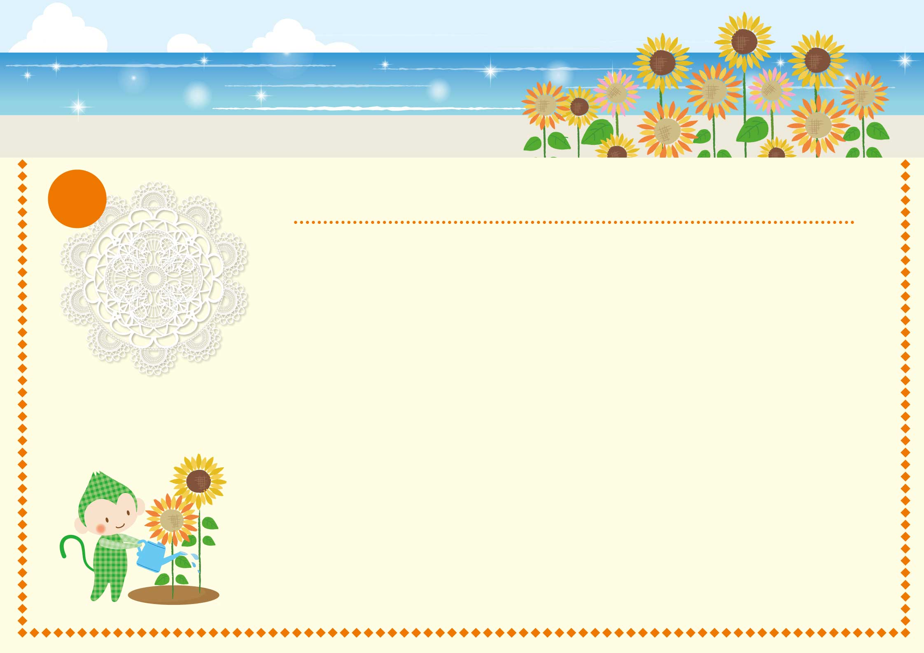

2016

|  |  |  |  |  |  |  |
| --- | --- | --- | --- | --- | --- | --- |
| **Lundi** | **Mardi** | **Mercredi** | **Jeudi** | **Vendredi** | **Samedi** | **Dimanche** |
|  |  |  |  |  |  |  |
| **27** | **28** | **29** | **30** | **1** | **2** | **3** |
|  |  |  |  |  |  |  |
| **4** | **5** | **6** | **7** | **8** | **9** | **10** |
|  |  |  |  |  |  |  |
| **11** | **12** | **13** | **14** | **15** | **16** | **17** |
|  |  |  | **Fête Nationale** |  |  |  |
| **18** | **19** | **20** | **21** | **22** | **23** | **24** |
|  |  |  |  |  |  |  |
| **25** | **26** | **27** | **28** | **29** | **30** | **31** |
|  |  |  |  |  |  |  |
| **1** | **2** | **3** | **4** | **5** | **6** | **7** |
|  |  |  |  |  |  |  |

Juillet

7

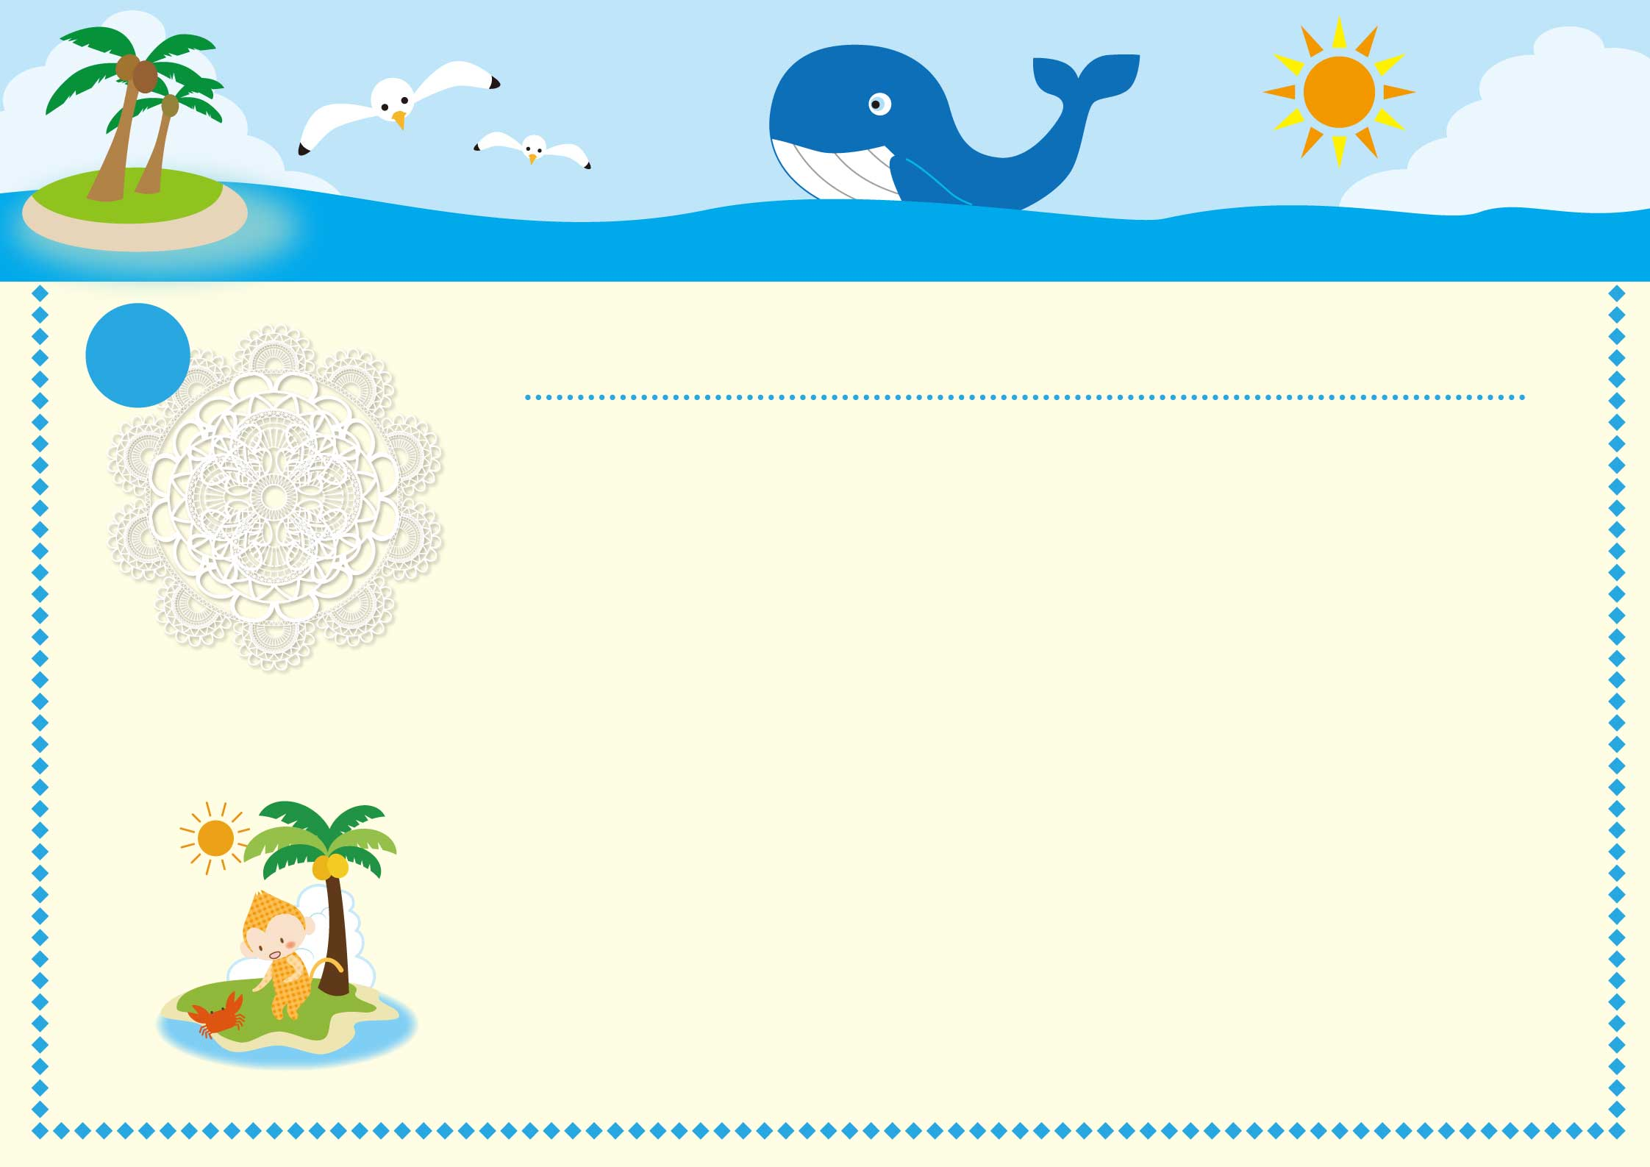

2016

|  |  |  |  |  |  |  |
| --- | --- | --- | --- | --- | --- | --- |
| **Lundi** | **Mardi** | **Mercredi** | **Jeudi** | **Vendredi** | **Samedi** | **Dimanche** |
|  |  |  |  |  |  |  |
| **1** | **2** | **3** | **4** | **5** | **6** | **7** |
|  |  |  |  |  |  |  |
| **8** | **9** | **10** | **11** | **12** | **13** | **14** |
|  |  |  |  |  |  |  |
| **15** | **16** | **17** | **18** | **19** | **20** | **21** |
| **Assomption** |  |  |  |  |  |  |
| **22** | **23** | **24** | **25** | **26** | **27** | **28** |
|  |  |  |  |  |  |  |
| **29** | **30** | **31** | **1** | **2** | **3** | **4** |
|  |  |  |  |  |  |  |
| **5** | **6** | **7** | **8** | **9** | **10** | **11** |
|  |  |  |  |  |  |  |

Août

8

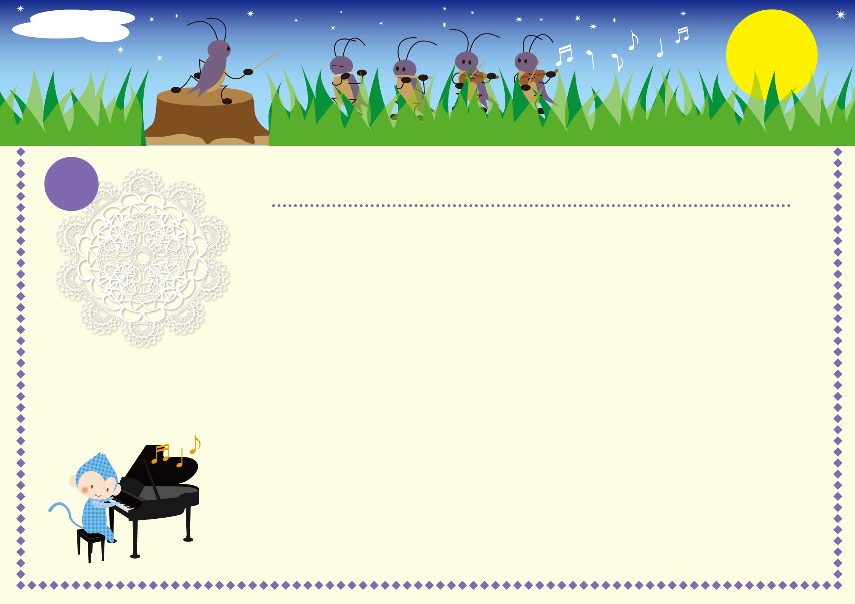

2016

|  |  |  |  |  |  |  |
| --- | --- | --- | --- | --- | --- | --- |
| **Lundi** | **Mardi** | **Mercredi** | **Jeudi** | **Vendredi** | **Samedi** | **Dimanche** |
|  |  |  |  |  |  |  |
| **29** | **30** | **31** | **1** | **2** | **3** | **4** |
|  |  |  |  |  |  |  |
| **5** | **6** | **7** | **8** | **9** | **10** | **11** |
|  |  |  |  |  |  |  |
| **12** | **13** | **14** | **15** | **16** | **17** | **18** |
|  |  |  |  |  |  |  |
| **19** | **20** | **21** | **22** | **23** | **24** | **25** |
|  |  |  |  |  |  |  |
| **26** | **27** | **28** | **29** | **30** | **1** | **2** |
|  |  |  |  |  |  |  |
| **3** | **4** | **5** | **6** | **7** | **8** | **9** |
|  |  |  |  |  |  |  |

Septembre

9

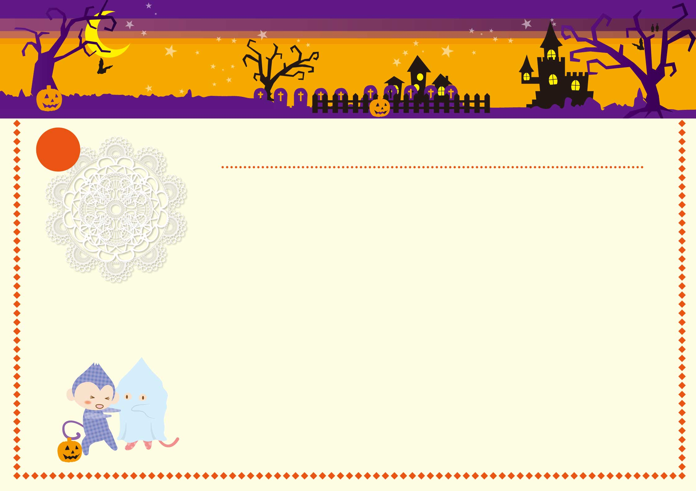

2016

|  |  |  |  |  |  |  |
| --- | --- | --- | --- | --- | --- | --- |
| **Lundi** | **Mardi** | **Mercredi** | **Jeudi** | **Vendredi** | **Samedi** | **Dimanche** |
|  |  |  |  |  |  |  |
| **26** | **27** | **28** | **29** | **30** | **1** | **2** |
|  |  |  |  |  |  |  |
| **3** | **4** | **5** | **6** | **7** | **8** | **9** |
|  |  |  |  |  |  |  |
| **10** | **11** | **12** | **13** | **14** | **15** | **16** |
|  |  |  |  |  |  |  |
| **17** | **18** | **19** | **20** | **21** | **22** | **23** |
|  |  |  |  |  |  |  |
| **24** | **25** | **26** | **27** | **28** | **29** | **30** |
|  |  |  |  |  |  |  |
| **31** | **1** | **2** | **3** | **4** | **5** | **6** |
|  |  |  |  |  |  |  |

Octobre

10

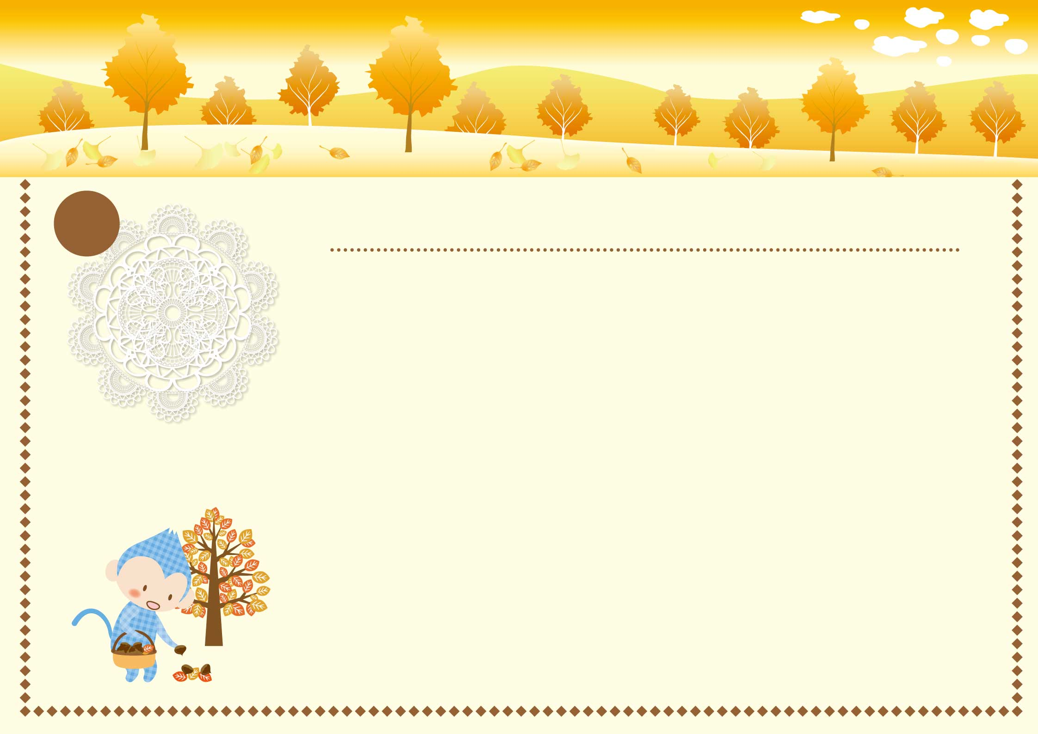

2016

|  |  |  |  |  |  |  |
| --- | --- | --- | --- | --- | --- | --- |
| **Lundi** | **Mardi** | **Mercredi** | **Jeudi** | **Vendredi** | **Samedi** | **Dimanche** |
|  |  |  |  |  |  |  |
| **31** | **1** | **2** | **3** | **4** | **5** | **6** |
|  | **Toussaint** |  |  |  |  |  |
| **7** | **8** | **9** | **10** | **11** | **12** | **13** |
|  |  |  |  | **Armistice 1918** |  |  |
| **14** | **15** | **16** | **17** | **18** | **19** | **20** |
|  |  |  |  |  |  |  |
| **21** | **22** | **23** | **24** | **25** | **26** | **27** |
|  |  |  |  |  |  |  |
| **28** | **29** | **30** | **1** | **2** | **3** | **4** |
|  |  |  |  |  |  |  |
| **5** | **6** | **7** | **8** | **9** | **10** | **11** |
|  |  |  |  |  |  |  |

Novembre

11

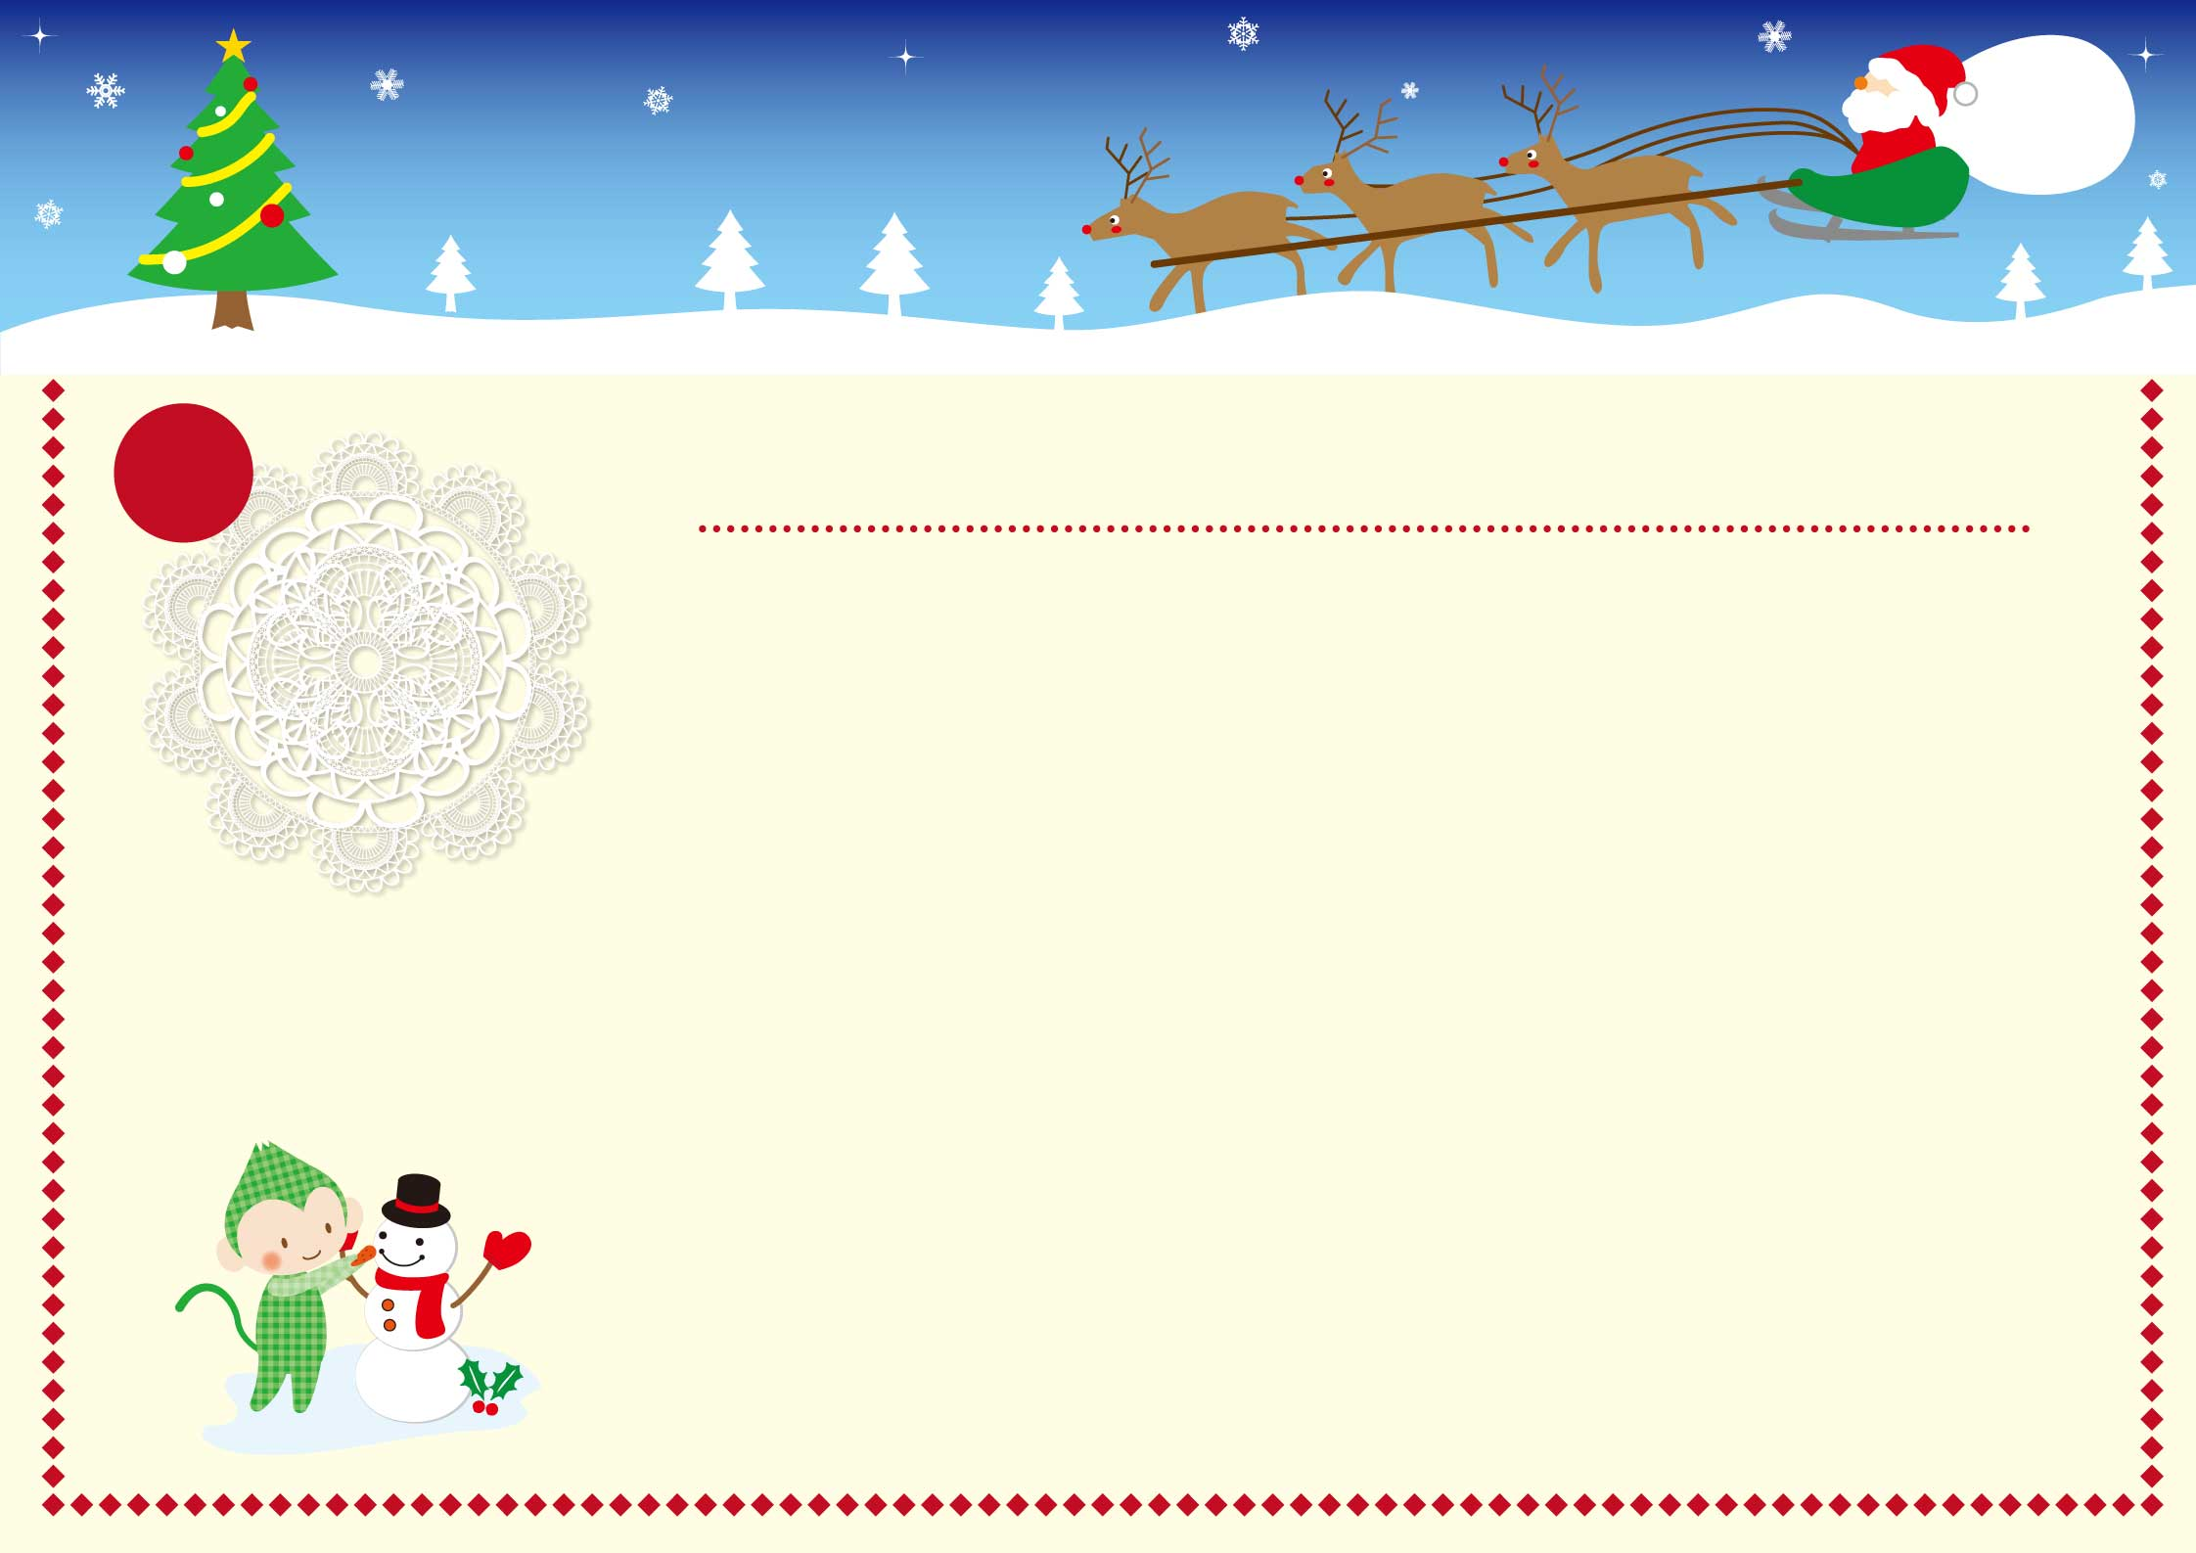

2016

|  |  |  |  |  |  |  |
| --- | --- | --- | --- | --- | --- | --- |
| **Lundi** | **Mardi** | **Mercredi** | **Jeudi** | **Vendredi** | **Samedi** | **Dimanche** |
|  |  |  |  |  |  |  |
| **28** | **29** | **30** | **1** | **2** | **3** | **4** |
|  |  |  |  |  |  |  |
| **5** | **6** | **7** | **8** | **9** | **10** | **11** |
|  |  |  |  |  |  |  |
| **12** | **13** | **14** | **15** | **16** | **17** | **18** |
|  |  |  |  |  |  |  |
| **19** | **20** | **21** | **22** | **23** | **24** | **25** |
|  |  |  |  |  |  | **Noël** |
| **26** | **27** | **28** | **29** | **30** | **31** | **1** |
|  |  |  |  |  |  |  |
| **2** | **3** | **4** | **5** | **6** | **7** | **8** |
|  |  |  |  |  |  |  |

Décembre

12