 | 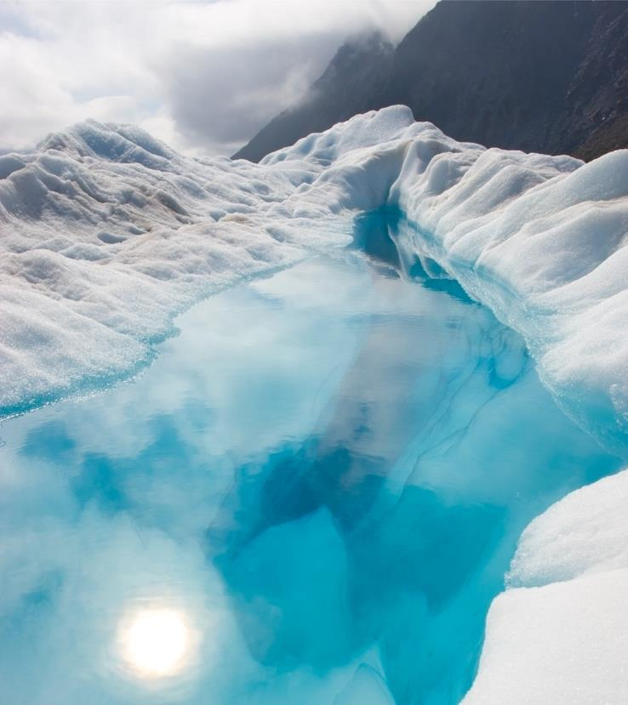
 | [Select here to add a picture caption.]
January 2017 | Sunday Monday Tuesday Wednesday Thursday Friday Saturday  1 2 3 4 5 6 7  8 9 10 11 12 13 14  [To replace the photo, just delete it and then, on the Insert tab, click Picture.]  15 16 17 18 19 20 21  [To replace any placeholder text, just select it and then begin typing.]  22 23 24 25 26 27 28  29 30 31 1 2 3 4  5 6 7 8 9 10 11
 | 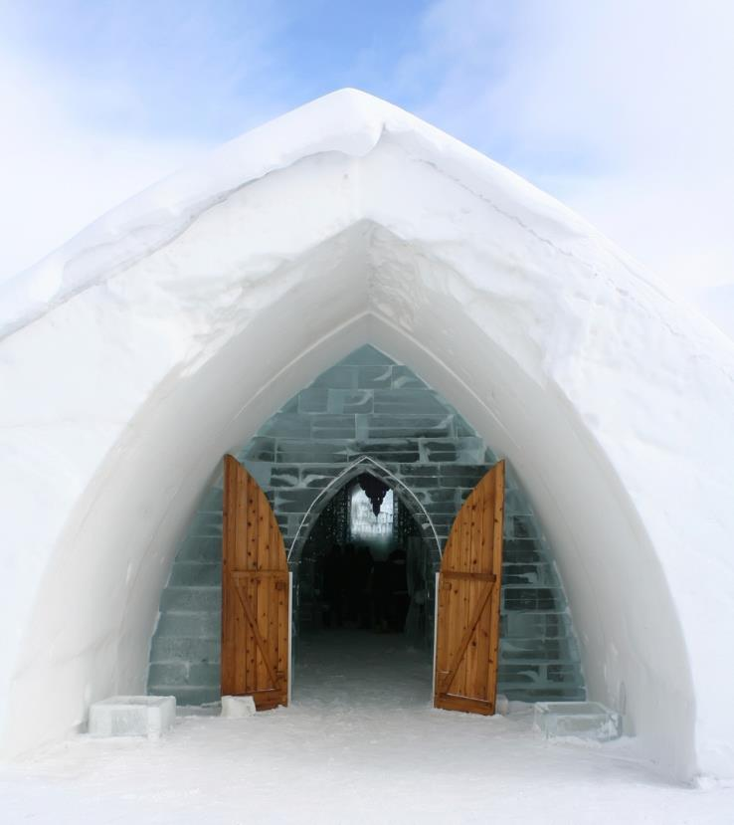
 | [Select here to add a picture caption.]
February 2017 | Sunday Monday Tuesday Wednesday Thursday Friday Saturday  29 30 31 1 2 3 4  5 6 7 8 9 10 11  12 13 14 15 16 17 18  19 20 21 22 23 24 25  26 27 28 1 2 3 4  5 6 7 8 9 10 11
 | 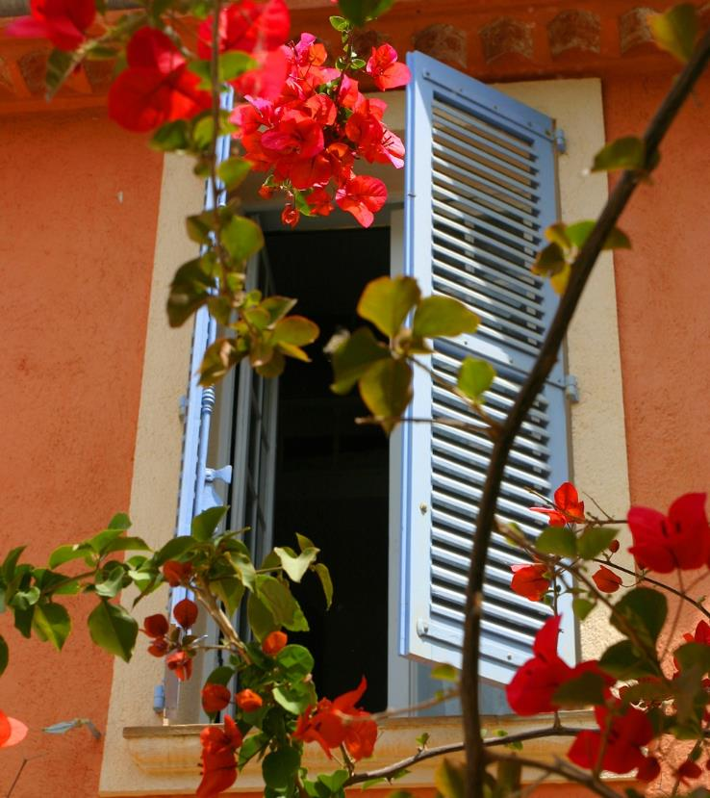
 | [Select here to add a picture caption.]
March 2017 | Sunday Monday Tuesday Wednesday Thursday Friday Saturday  26 27 28 1 2 3 4  5 6 7 8 9 10 11  12 13 14 15 16 17 18  19 20 21 22 23 24 25  26 27 28 29 30 31 1  2 3 4 5 6 7 8
 | [Select here to add a picture caption.]
April 2017 | Sunday Monday Tuesday Wednesday Thursday Friday Saturday  26 27 28 29 30 31 1  2 3 4 5 6 7 8  9 10 11 12 13 14 15  16 17 18 19 20 21 22  23 24 25 26 27 28 29  30 1 2 3 4 5 6
 | 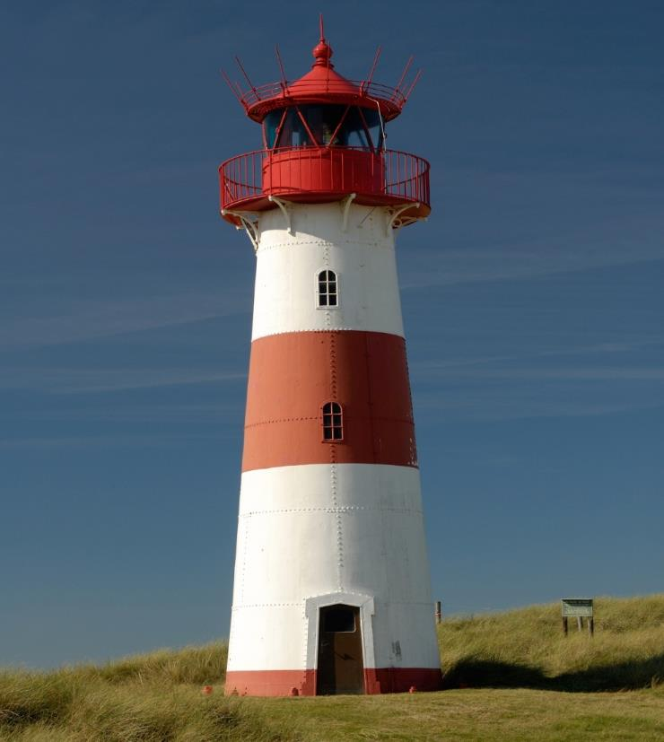
 | [Select here to add a picture caption.]
May 2017 | Sunday Monday Tuesday Wednesday Thursday Friday Saturday  30 1 2 3 4 5 6  7 8 9 10 11 12 13  14 15 16 17 18 19 20  21 22 23 24 25 26 27  28 29 30 31 1 2 3  4 5 6 7 8 9 10
 | 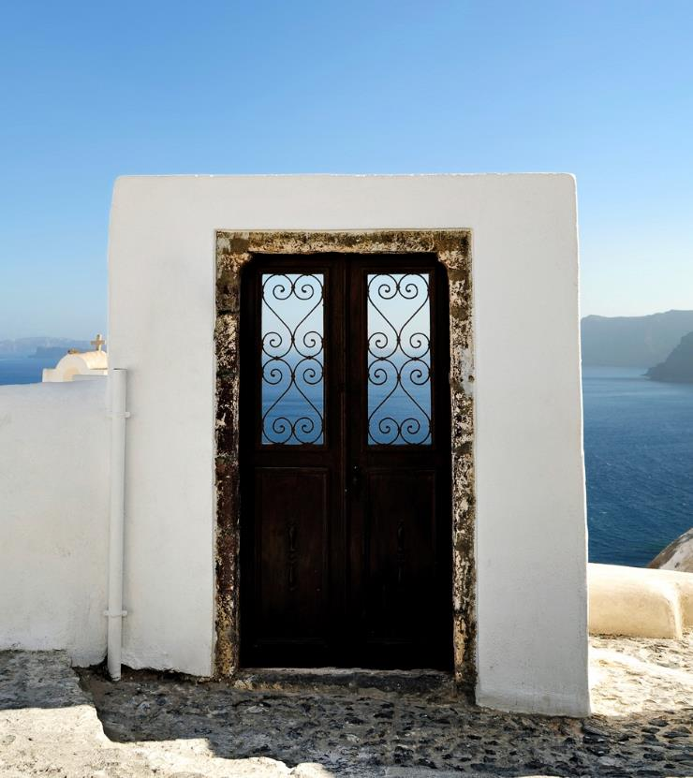
 | [Select here to add a picture caption.]
June 2017 | Sunday Monday Tuesday Wednesday Thursday Friday Saturday  28 29 30 31 1 2 3  4 5 6 7 8 9 10  11 12 13 14 15 16 17  18 19 20 21 22 23 24  25 26 27 28 29 30 1  2 3 4 5 6 7 8
 | 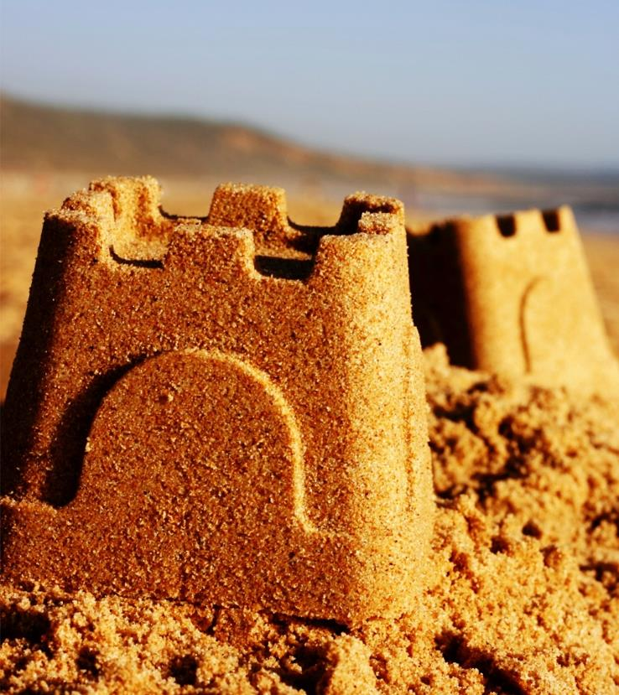
 | [Select here to add a picture caption.]
July 2017 | Sunday Monday Tuesday Wednesday Thursday Friday Saturday  25 26 27 28 29 30 1  2 3 4 5 6 7 8  9 10 11 12 13 14 15  16 17 18 19 20 21 22  23 24 25 26 27 28 29  30 31 1 2 3 4 5
 | 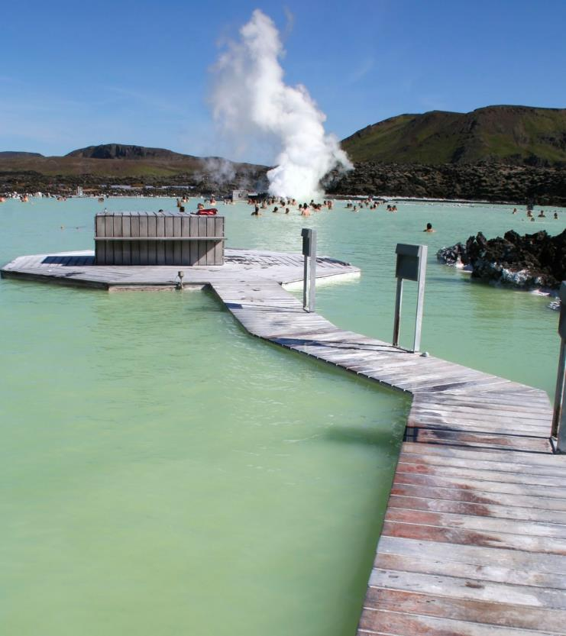
 | [Select here to add a picture caption.]
August 2017 | Sunday Monday Tuesday Wednesday Thursday Friday Saturday  30 31 1 2 3 4 5  6 7 8 9 10 11 12  13 14 15 16 17 18 19  20 21 22 23 24 25 26  27 28 29 30 31 1 2  3 4 5 6 7 8 9
 | 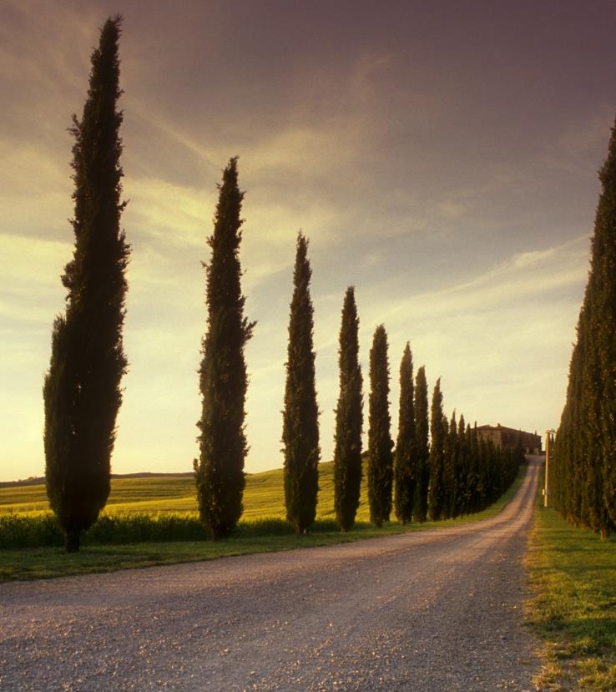
 | [Select here to add a picture caption.]
September 2017 | Sunday Monday Tuesday Wednesday Thursday Friday Saturday  27 28 29 30 31 1 2  3 4 5 6 7 8 9  10 11 12 13 14 15 16  17 18 19 20 21 22 23  24 25 26 27 28 29 30  1 2 3 4 5 6 7
 | 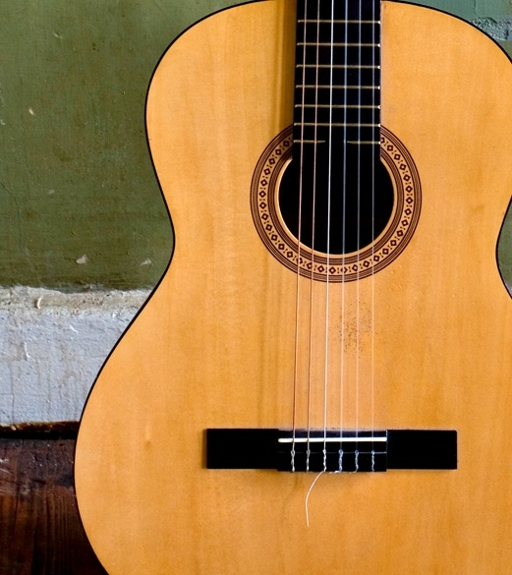
 | [Select here to add a picture caption.]
October 2017 | Sunday Monday Tuesday Wednesday Thursday Friday Saturday  1 2 3 4 5 6 7  8 9 10 11 12 13 14  15 16 17 18 19 20 21  22 23 24 25 26 27 28  29 30 31 1 2 3 4  5 6 7 8 9 10 11
 | 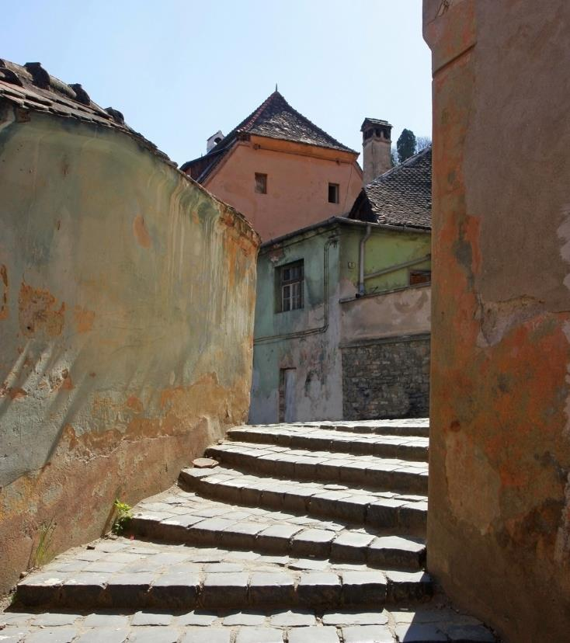
 | [Select here to add a picture caption.]
November 2017 | Sunday Monday Tuesday Wednesday Thursday Friday Saturday  29 30 31 1 2 3 4  5 6 7 8 9 10 11  12 13 14 15 16 17 18  19 20 21 2 23 24 25  26 27 28 29 30 1 2  3 4 5 6 7 8 9
 | [Select here to add a picture caption.]
December 2017 | Sunday Monday Tuesday Wednesday Thursday Friday Saturday  26 27 28 29 30 1 2  3 4 5 6 7 8 9  10 11 12 13 14 15 16  17 18 19 20 21 22 23  24 25 26 27 28 29 30  31 1 2 3 4 5 6

