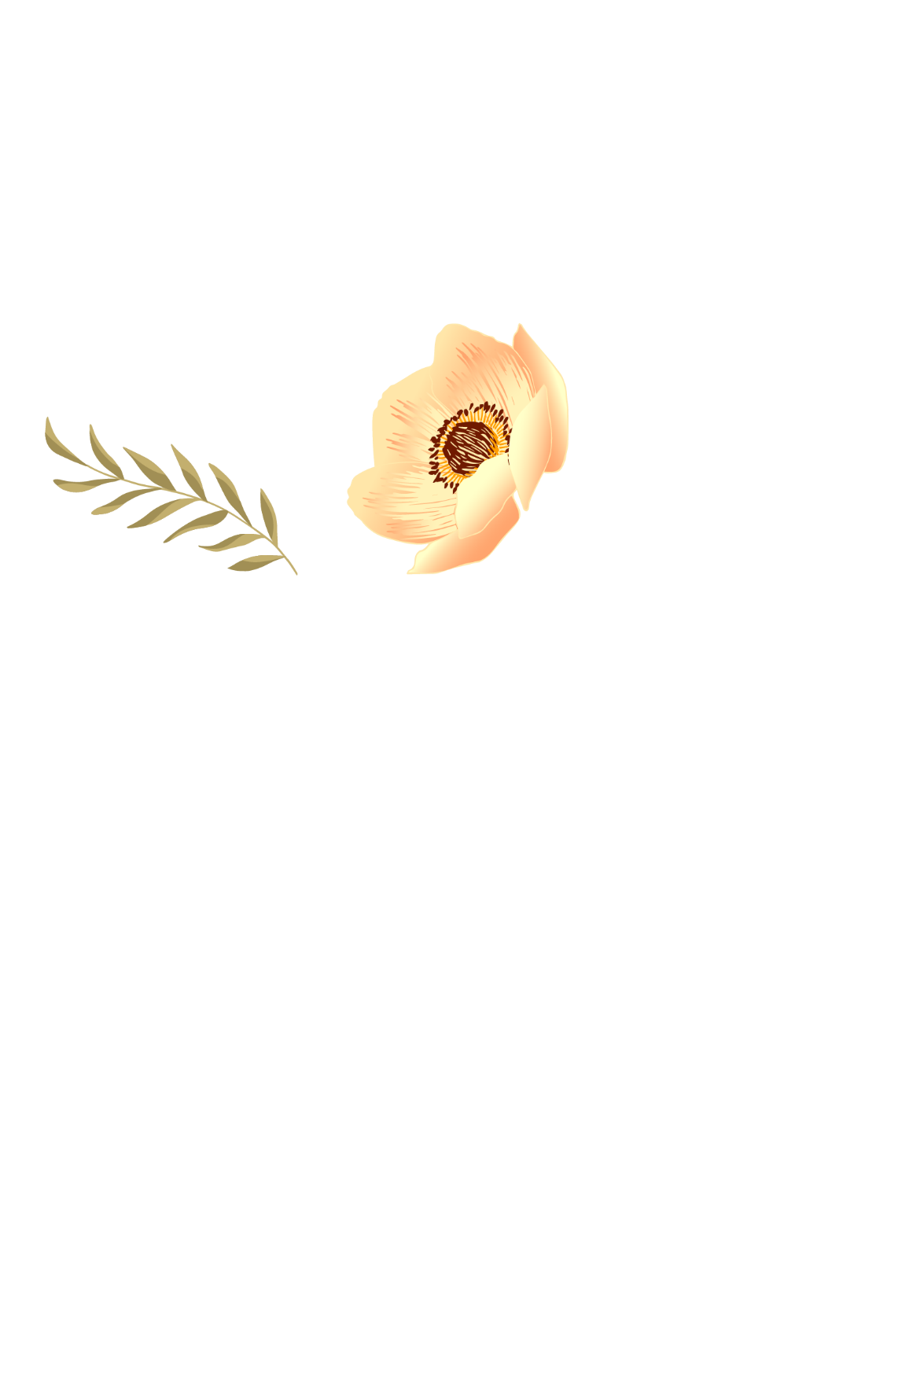

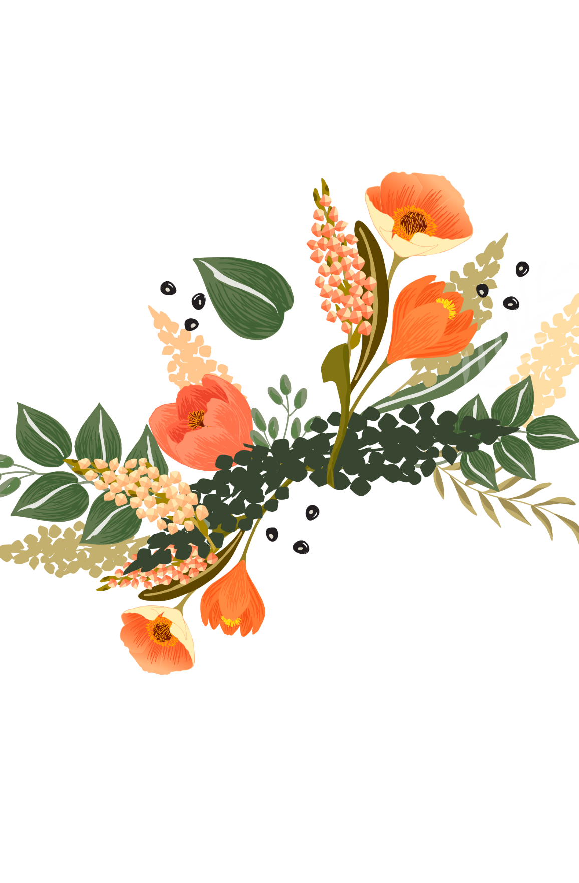

|  |  |
| --- | --- |
|  | MOM |

|  |  |
| --- | --- |
|  | Thank you for being such an  amazing role model for me  throughout the years. |

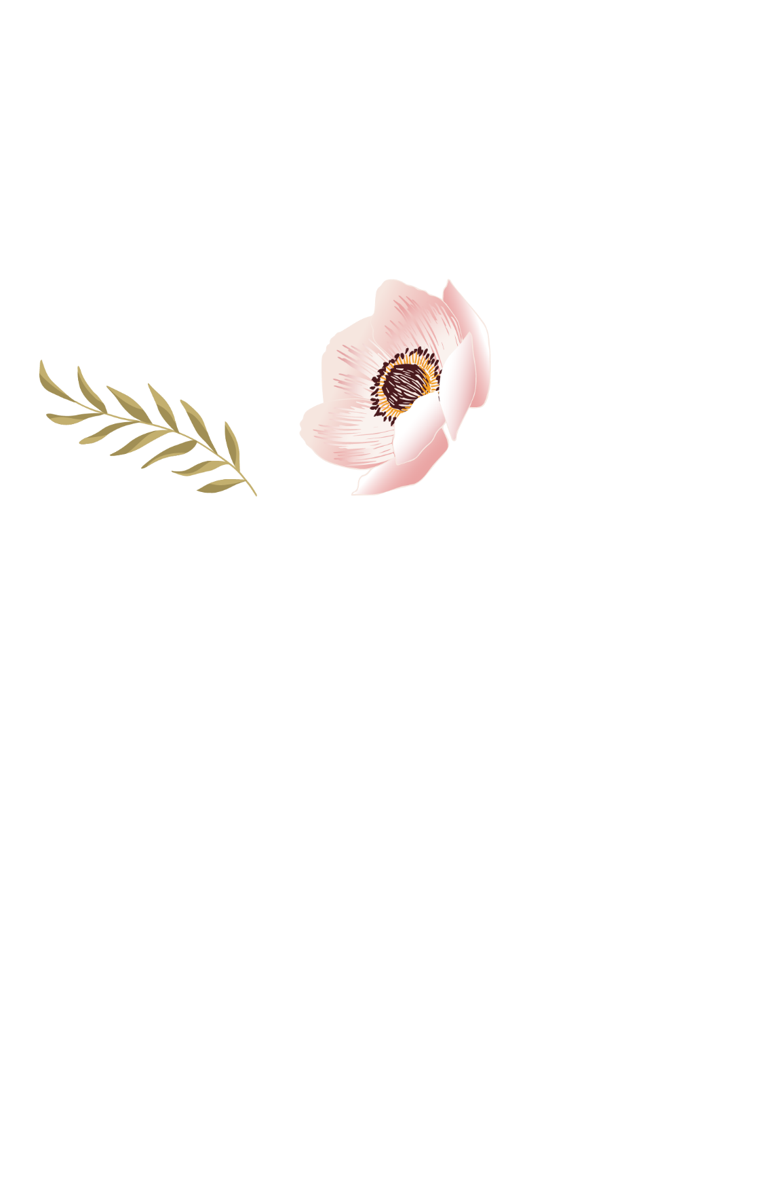

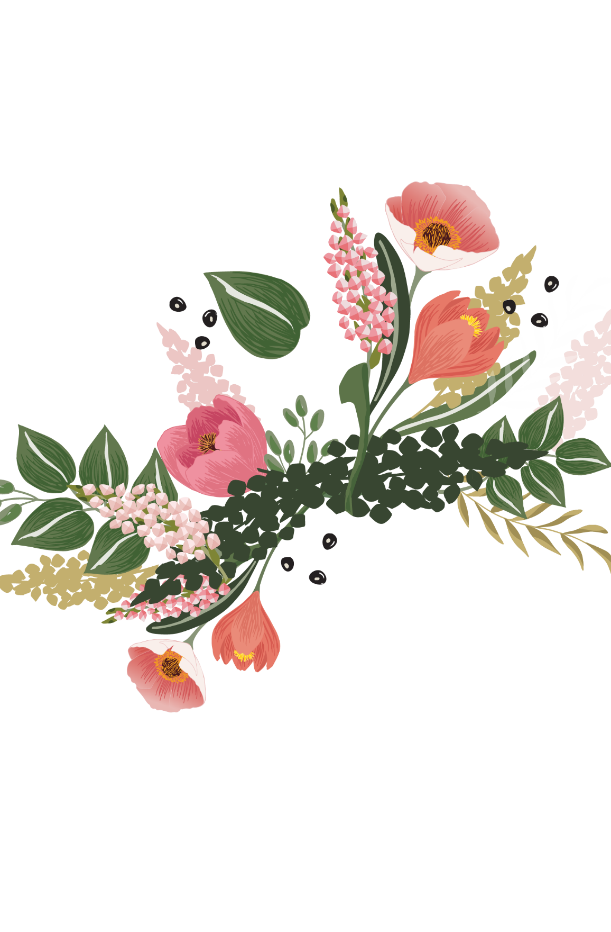

|  |  |
| --- | --- |
|  | MOM |

|  |  |
| --- | --- |
|  | Thank you for being such an  amazing role model for me  throughout the years. |





|  |  |
| --- | --- |
|  | MOM |

|  |  |
| --- | --- |
|  | Thank you for being such an  amazing role model for me  throughout the years. |