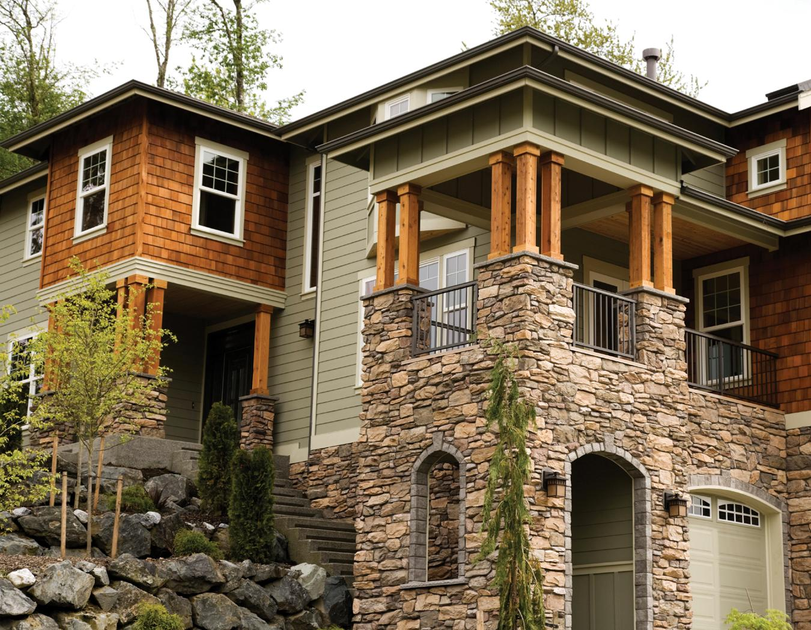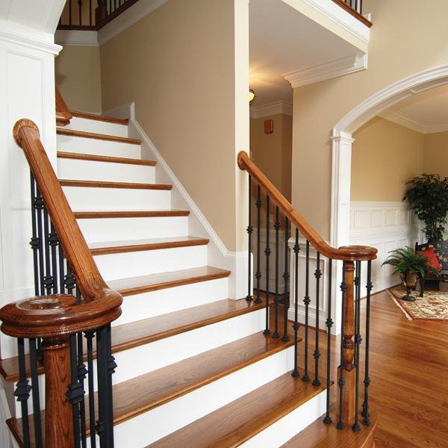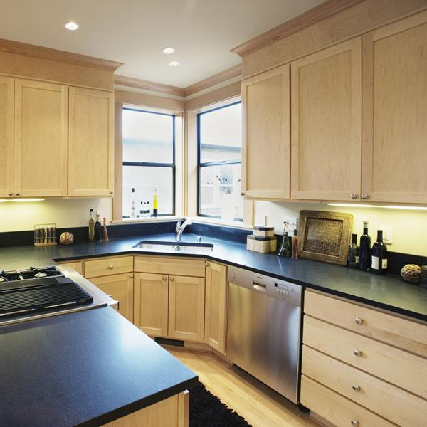

*open*

**TODAY**

View

REAL ESTATE

COMPANY

**555-543-5432**

www.yourwebsitehere.com

***$000,000***

*Exceptional Multi-Level Family Home*

***house***