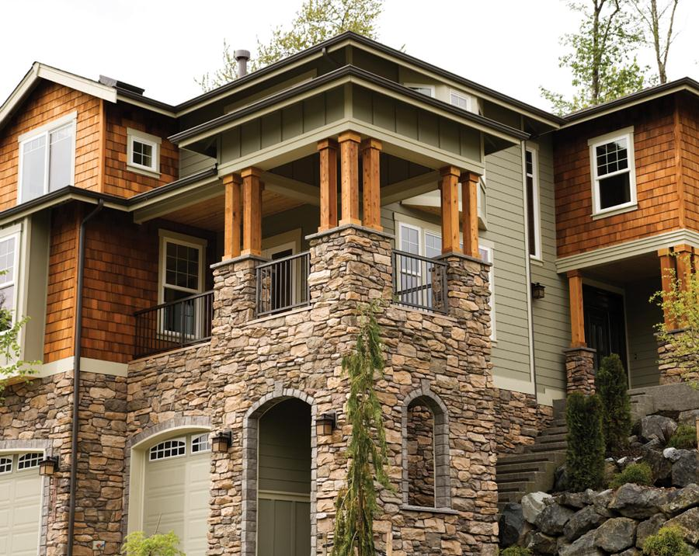

*Please Join Us for an Open House*

*Wednesday, April 19th from 2pm*

*5432 Any Street West, Townsville, State 54321*

*you’re*

***Invited***

*Please Join Us for an Open House*

*Wednesday, April 19th from 2pm*

*5432 Any Street West, Townsville, State 54321*

*you’re*

***Invited***

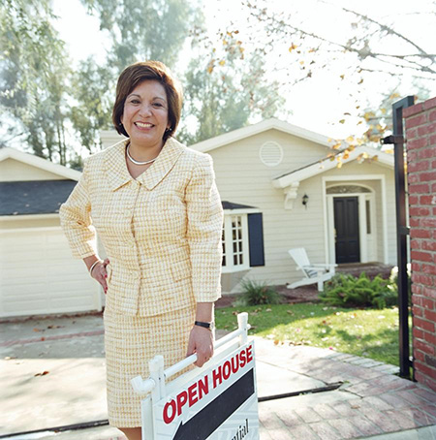[](https://www.layoutready.com/?utm_source=microsoft&utm_medium=file&utm_campaign=office_online)

Single Family Properly

Year Built: 0000

4 Total Bedroom(s)

2 Total Bath(s)

Approx 0000 sq. ft.

Forced Air Heat

***property details >>>***

*Exceptional Multi-Level Family Home*

First M. Lastname, Sales Agent

COMPANY

REAL ESTATE

Contact us at **555-543-5432** www.yourwebsitehere.com

*$000,000*

Air Conditioning

2 Car Garage

Composition Roof

Corner Lot

Approx 1.2 acre(s)

Vaulted Ceilings

Hardwood Floors

Slate Entry

Fenced Backyard

Sunken Family Room

Landscaped Garden

Fabulous City Views

Single Family Properly

Year Built: 0000

4 Total Bedroom(s)

2 Total Bath(s)

Approx 0000 sq. ft.

Forced Air Heat

***property details >>>***

*Exceptional Multi-Level Family Home*

First M. Lastname, Sales Agent

COMPANY

REAL ESTATE

Contact us at **555-543-5432** www.yourwebsitehere.com

*$000,000*

Air Conditioning

2 Car Garage

Composition Roof

Corner Lot

Approx 1.2 acre(s)

Vaulted Ceilings

Hardwood Floors

Slate Entry

Fenced Backyard

Sunken Family Room

Landscaped Garden

Fabulous City Views