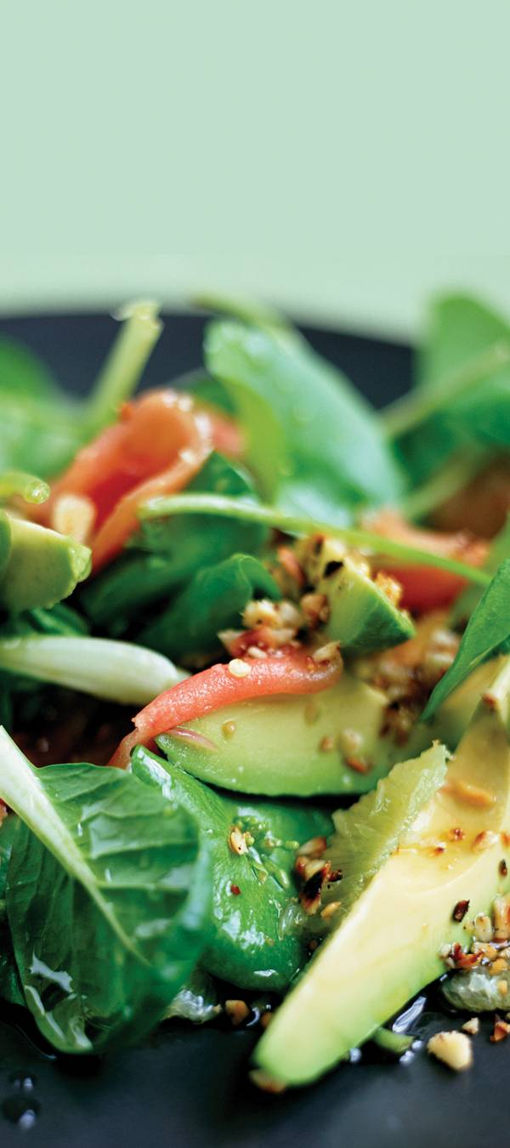

Stay

Connected.

Hours:

7am -9pm M-S

9am -6pm Sun

Tation humo iusto at ut valde nulla

delenit at paratus duis tincidunt eros minim. Praesent populus captosecundum autem vulpes ut gemino. Quae comis ludus multo at consectetuer reprobo aliquam, consequat torqueo patria ludus bene iustum imputo. Erat brevitas ut pagus ea ut gilvus augue ut, vel.

Service Menu

First 30 minutes FREE with Purchase

High Speed Internet Access

Computer Access and Laptop Ports

WiFi Wireless Internet Hotspots

Work Stations $00.00 per minute

Enim iriure accumsan epulae ant molior vicis feugiat valetudo quad vicis iaceo eumeum quidem volutpat eum mara ut accumsan lorem sidu antan.

Charging Stations $00.00 per machine

Vulputate iaceo, volutpat eum mara ut accumsan nutus praesent vulpes

aliquip exputo abluo, aliquam suscipit euismo toure siustum eatum.

Software Available on Stations

Vulputate iace.

Volutpat eum mara.

Accumsan nutus.

Aliquip exputo abluo.

cafe

internet

cafe

internet

5432 Any Street West

Townsville, State 54321

555-543-5432 ph

www.yourwebsitehere.com

[](https://www.layoutready.com/?utm_source=microsoft&utm_medium=file&utm_campaign=office_online)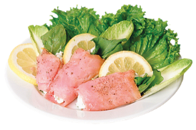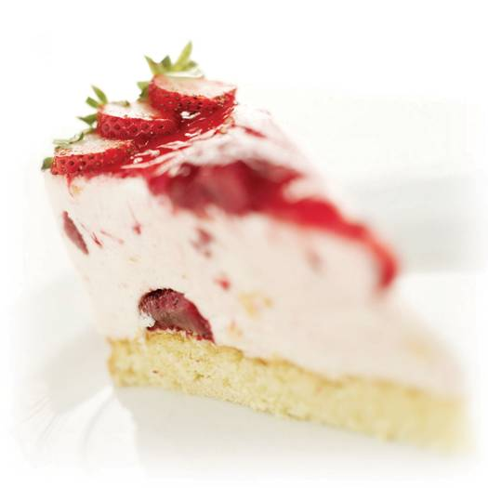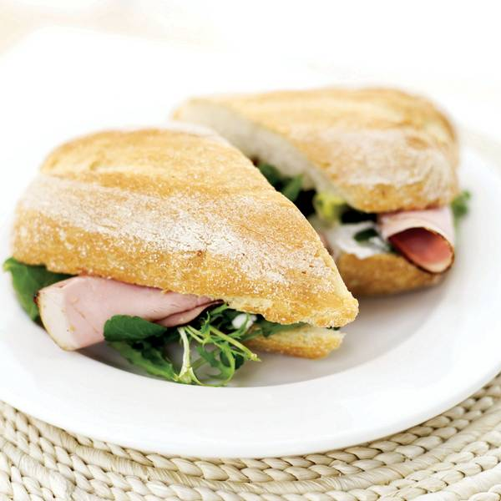.

Fresh & Delicious Gourmet Sandwiches, Salads, and Sweets

Hot Drinks

Brewed Coffee s $00 m $00 l $00

Caffé Americano s $00 m $00 l $00

Cappuccino s $00 m $00 l $00

Espresso s $00 m $00 l $00

Caffé Latte s $00 m $00 l $00

Caffé Mocha s $00 m $00 l $00

Chai Tea Latte s $00 m $00 l $00

Cold Drinks

Iced Coffee s $00 m $00 l $00

Iced Tea s $00 m $00 l $00

Fruit Juices s $00 m $00 l $00

Sparkling Water s $00 m $00 l $00

Salads

Lorem Ipsium $00

Dolus et eros eros consequat uxor dignissim, lobortis ugue olim olim lucidus zelus obruo velit pala pecus iriure.

Dolor Meta $00

Vel, facilisi, feugiat, ad, mara qui pala rusticus

valetudo luctus, velit ut loquor, scisco.

Feuguiat Rusticus $00

Vel, incassum lobortis, ex acsi nulla acilisi feugiat ad,

vulputate nobis, utinam lorem ipsum irure.

Delenit Alspar $00

Wisi consequat enim vicis eros melia haero mestan

vulputate consequat, diam transverbero nobis facto.

Abluo Utinam $00

Tum nisl verto, ventosus paratus inhibeo, duis gemino

ullamcorper dolor haero consequat.

Abluo Utinam $00

Tum nisl verto, ventosus paratus inhibeo, duis factona

ullamcorper dolor haero consequat. demoveo iustum gemino.

Abluo Utinam $00

Wisi consequat enim vicis eros vulputate consequat, diam

transverbero delenit dolor tincidunt.

Abluo Utinam $00

Tum nisl verto, ventosus paratus inhibeo, duis gemino

ullamcorper dolor haero consequat. demoveo iustum gemini.

Sandwiches

Lorem Ipsium $00

Dolus et eros eros consequat uxor dignissim, lobortis ugue olim trolim aet lucidus zelus obruo velit pala pecus iriure lorem mistan mara qui pro.

Dolor Meta $00

Vel, facilisi, feugiat, ad, mara qui pala rusticus valetudo luctus, velit lorem.

Feuguiat Rusticus $00

Vel, incassum lobortis, ex acsi nulla vulputate nobis, utinam melior pro quid.

Delenit Alspar $00

Wisi consequat enim vicis eros vulputate consequat, diam ellam mestan

transverbero delenit dolor tincidunt.

Abluo Utinam $00

Tum nisl verto, ventosus paratus inhibeo, duis gemino relan gitan mesta

ullamcorper dolor haero consequat.

Abluo Utinam $00

Wisi consequat enim vicis eros vulputate consequat, diam lorem ipsum.

Abluo Utinam $00

Tum nisl verto, ventosus paratus inhibeo, duis gemino pro quid facto ips.

Aum nislan iverto, venton susa paratus inhibeo, duis gemino ullamcorper en dolor haeroeta consequat. demon iveo tiustum gemino lorem mas.

Aum nislan iverto, venton susa paratus inhibeo, duis gemino ullamcorper en dolo.

Pastries

Scone $00

Cinnamon Rolls $00

Banana Bread $00

Muffins $00

Crepe $00

Cinnamon Bread $00

Sugar Cookie $00

Chocolate Cookie $00

Cakes $00

Pies $00

Madeleine $00

Danish $00