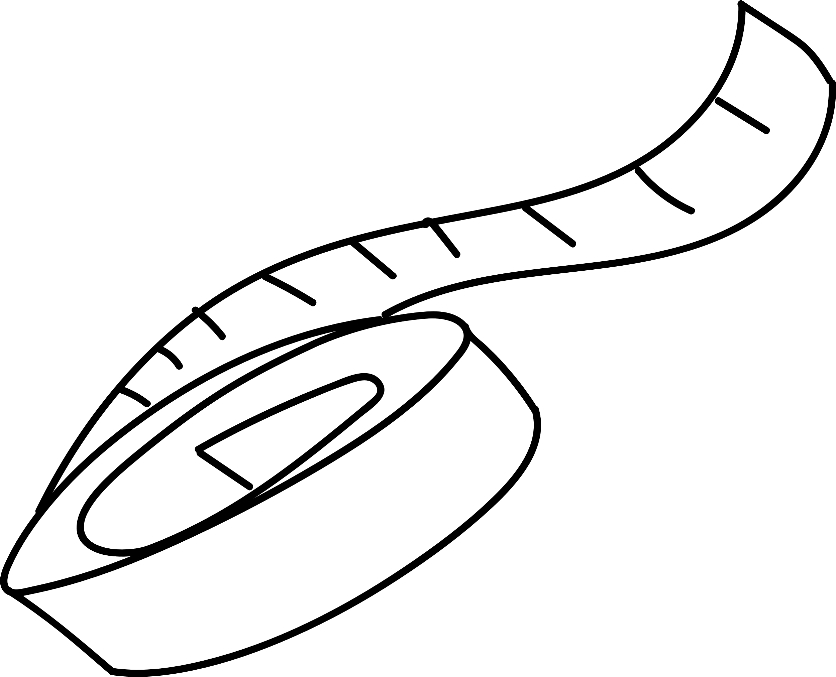

20XX



NUTRITION  
JOURNAL

Lorem Ipsum Dolor



# Healthy Snack Ideas



|  |  |  |  |  |  |  |  |  |  |  |
| --- | --- | --- | --- | --- | --- | --- | --- | --- | --- | --- |
|  | Nuts |  |  |  | Veg |  |  |  | Fruit |  |
|  |  |  |  |  |  |  |
|  | | |  |  | | |  |  | | |
|  | | |  | | |  |  |  |  |
|  | | |  | | |  |  | | |
|  |  |  |  | | |  |  | | |
|  |  |  |  |  |  |  |  |  |  |
|  | Seafood |  |  |  | Fish |  |  |  | Sweet |  |
|  |  |  |  |  |  |  |  |
|  | | |  |  | | |  |  | | |
|  | | |  |  | | |  |  | | |
|  | | |  |  |  |  |  |  | | |
|  | | |  |  |  |  |  |  |  |  |
|  |  |  |  |  |  |  |  |  |  |  |

|  |  |  |
| --- | --- | --- |
|  | Other |  |
|  |  |
|  | | |
|  | | |
|  | | |



# Weekly Food Log



|  |  |  |  |  |  |
| --- | --- | --- | --- | --- | --- |
|  | Sun |  | Mon |  | Tue |
|  |  |  |  |  |  |
|  |  |  |  |  |  |
|  |  |  |  |  |  |
|  |  |  |  |  |  |
|  |  |  |  |  |  |
|  |  |  |  |  |  |
|  | Wed |  | Thu |  | Notes |
|  |  |  |  |  |  |
|  |  |  |  |  |  |
|  |  |  |  |  |  |
|  |  |  |  |  |  |
|  |  |  |  |  |  |
|  |  |  |  |  |  |
|  | Fri |  | Sat |  |  |
|  |  |  |  |
|  |  |  |  |  |  |
|  |  |  |  |  |  |
|  |  |  |  |  |  |
|  |  |  |  |  |  |
|  |  |  |  |  |  |



# Water Tracker



## Month

|  |  |  |  |
| --- | --- | --- | --- |
| 1 |  | 16 |  |
| 2 |  | 17 |  |
| 3 |  | 18 |  |
| 4 |  | 19 |  |
| 5 |  | 20 |  |
| 6 |  | 21 |  |
| 7 |  | 22 |  |
| 8 |  | 23 |  |
| 9 |  | 24 |  |
| 10 |  | 25 |  |
| 11 |  | 26 |  |
| 12 |  | 27 |  |
| 13 |  | 28 |  |
| 14 |  | 29 |  |
| 15 |  | 30 |  |



##### Weight Tracker



|  |  |  |  |  |  |  |  |  |  |  |  |  |
| --- | --- | --- | --- | --- | --- | --- | --- | --- | --- | --- | --- | --- |
|  | Jan | Feb | Mar | Apr | May | Jun | Jul | Aug | Sep | Oct | Nov | Dec |
| 50 |  |  |  |  |  |  |  |  |  |  |  |  |
| 49 |  |  |  |  |  |  |  |  |  |  |  |  |
| 48 |  |  |  |  |  |  |  |  |  |  |  |  |
| 47 |  |  |  |  |  |  |  |  |  |  |  |  |
| 46 |  |  |  |  |  |  |  |  |  |  |  |  |
| 45 |  |  |  |  |  |  |  |  |  |  |  |  |
| 44 |  |  |  |  |  |  |  |  |  |  |  |  |
| 43 |  |  |  |  |  |  |  |  |  |  |  |  |
| 42 |  |  |  |  |  |  |  |  |  |  |  |  |
| 41 |  |  |  |  |  |  |  |  |  |  |  |  |
| 40 |  |  |  |  |  |  |  |  |  |  |  |  |
| 39 |  |  |  |  |  |  |  |  |  |  |  |  |
| 38 |  |  |  |  |  |  |  |  |  |  |  |  |

##### Measurements



|  |  |  |  |  |  |  |
| --- | --- | --- | --- | --- | --- | --- |
|  | Jan | Mar | May | Jul | Sep | Nov |
| Chest |  |  |  |  |  |  |
| Hips |  |  |  |  |  |  |
| Left Thigh |  |  |  |  |  |  |
| Right Thigh |  |  |  |  |  |  |
| Left Arm |  |  |  |  |  |  |
| Right Arm |  |  |  |  |  |  |



# Healthy Rewards



|  |  |  |
| --- | --- | --- |
| Start |  | Stage 1 |
|  |
|  |
|  |  | Stage 3 |
| Finish |  |  |



|  |  |
| --- | --- |
|  | Stage 2 |
|  | Stage 4 |



# Nutrition Goals



|  |  |  |
| --- | --- | --- |
|  | Goals Group 1 |  |
|  |  |
|  | | |
|  | | |
|  | | |
|  | | |

|  |  |  |  |  |  |  |
| --- | --- | --- | --- | --- | --- | --- |
|  | Goals Group 2 |  |  |  | Goals Group 3 |  |
|  |  |  |  |
|  |  |  |  |  |  |  |
|  |  |  |  |  |  |  |
|  |  |  |  |  |  |  |
|  |  |  |  |  |  |  |
|  |  |  |  |  |  |  |

|  |  |  |
| --- | --- | --- |
|  | Goals Group 4 |  |
|  |  |
|  | | |
|  | | |
|  | | |
|  | | |