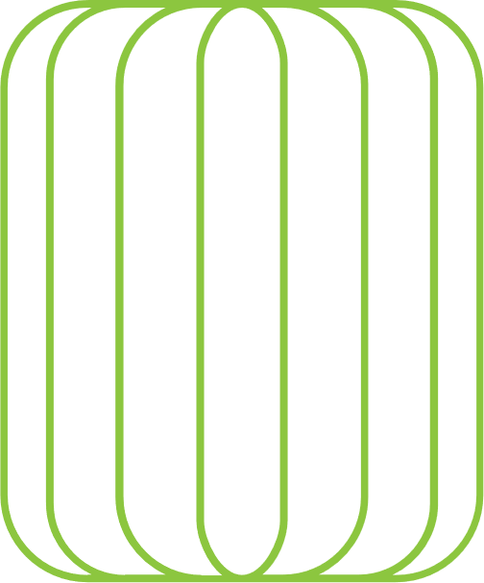

# CHINESE

New

Year

# PARTY

|  |  |  |
| --- | --- | --- |
|  |  |  |
| 5 FEB | Bellows College 4567 Main St, Buffalo, NY | 10 P.M. |
|  | The background is made up of a solid color box with a patterned design overtop. To remove the pattern, double click in the header, select the pattern, and hit Delete on your keyboard to remove it. If you wish to change the background altogether, first delete the pattern, then select the solid block. Choose “Fill” from the shortcut menu and choose “Picture” from the list. |  |