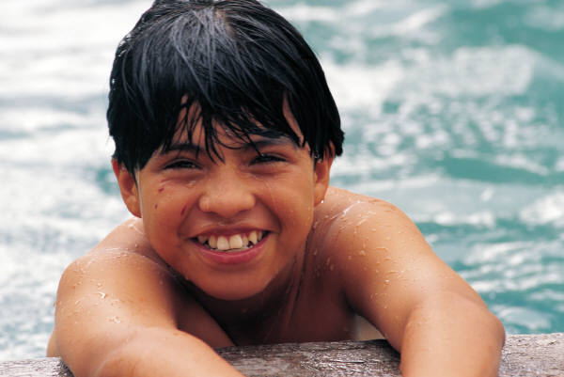

6

Please join us in celebrating Oliver’s sixth birthday with cake, candles, and many happy wishes. Bring the whole family!

Happy Birthday Oliver!

where:

4567 Main Streetwhen:

October 12

r.s.v.p.

555-0150, regrets only please