# thank you





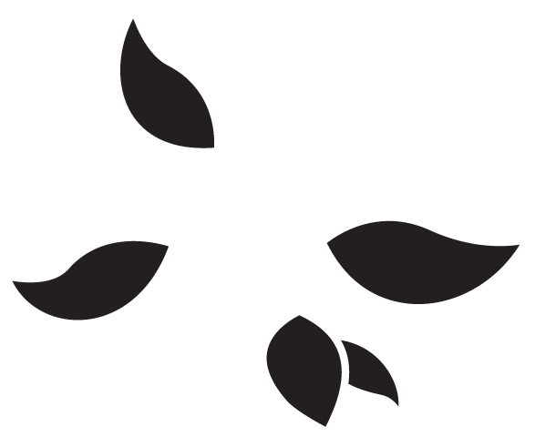













# thank you























Thank you!

Your thoughtfulness

means the

world to me.









Thank you!

Your thoughtfulness

means the

world to me.