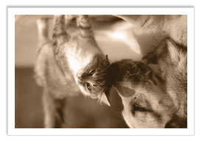

We may have our differences… but I’m so glad we’re friends!