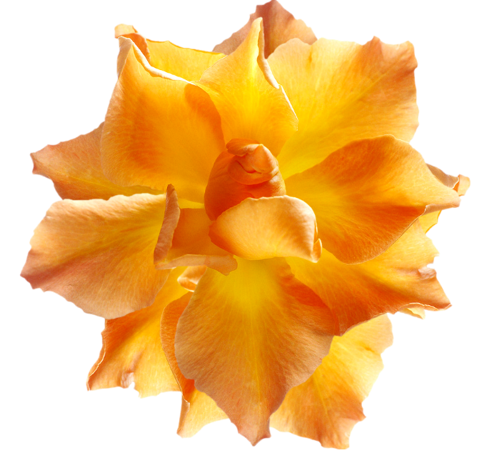

# Celebrate

## our differences

As we reflect on the life and wisdom of Martin Luther King, Jr., let us celebrate our differences and learn from each others’ experiences.

**Happy Martin Luther King Day!**

