Inside with heart graphic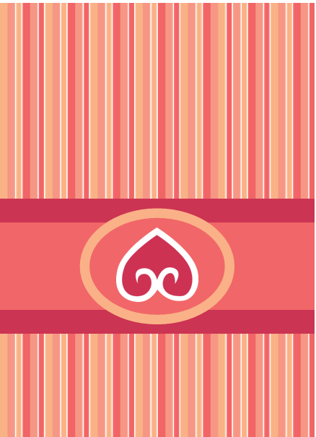

My heart belongs to you.