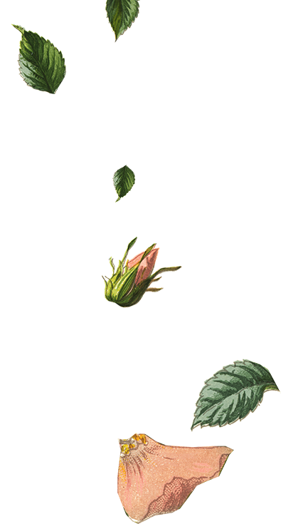

|  |  |  |
| --- | --- | --- |
|  | Please join |  |
|  | Flora Persson  For their Bridal Shower! |  |
|  |  |  |
|  | Please join |  |
|  | Flora Persson  For their Bridal Shower! |  |
|  |  |  |



|  |  |  |
| --- | --- | --- |
|  |  |  |
|  | **DATE:** [Date]  **TIME:** [Time]  **LOCATION:** [Location] |  |
|  | Registered at: [Store Name]RSVP by [Click to select date] to[Name] at [phone] |  |
|  |  |  |
|  | **DATE:** [Date]  **TIME:** [Time]  **LOCATION:** [Location] |  |
|  | Registered at: [Store Name]RSVP by [Click to select date] to[Name] at [phone] |  |