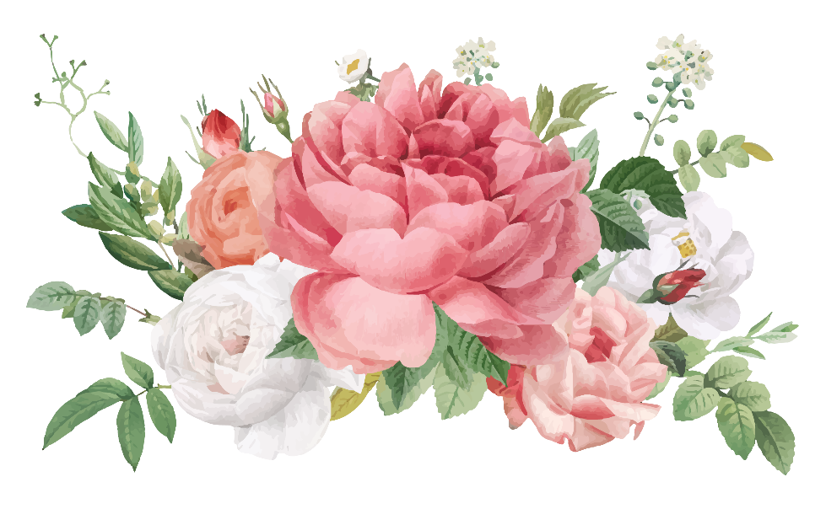

|  |  |  |  |
| --- | --- | --- | --- |
|  |  |  |  |
| Happy Mother’s Day! |  |  |  |
|  |  |  | Happy Mother’s Day! |

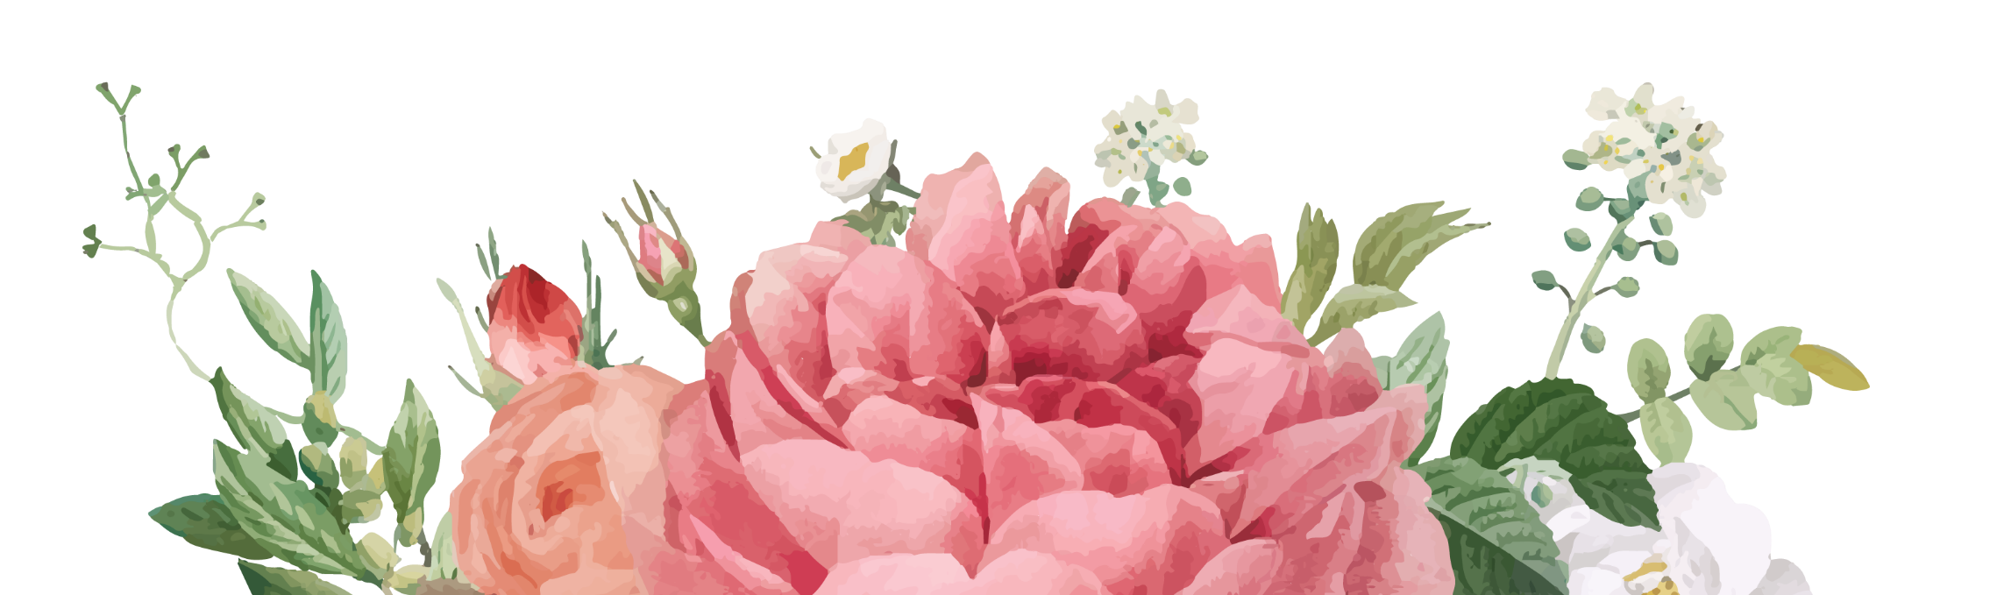

|  |  |  |  |
| --- | --- | --- | --- |
| You’re my best friend and mom rolled into one. |  |  | I love you! Your daughter, [Name] |