[TITLE OF YOUR EVENT]
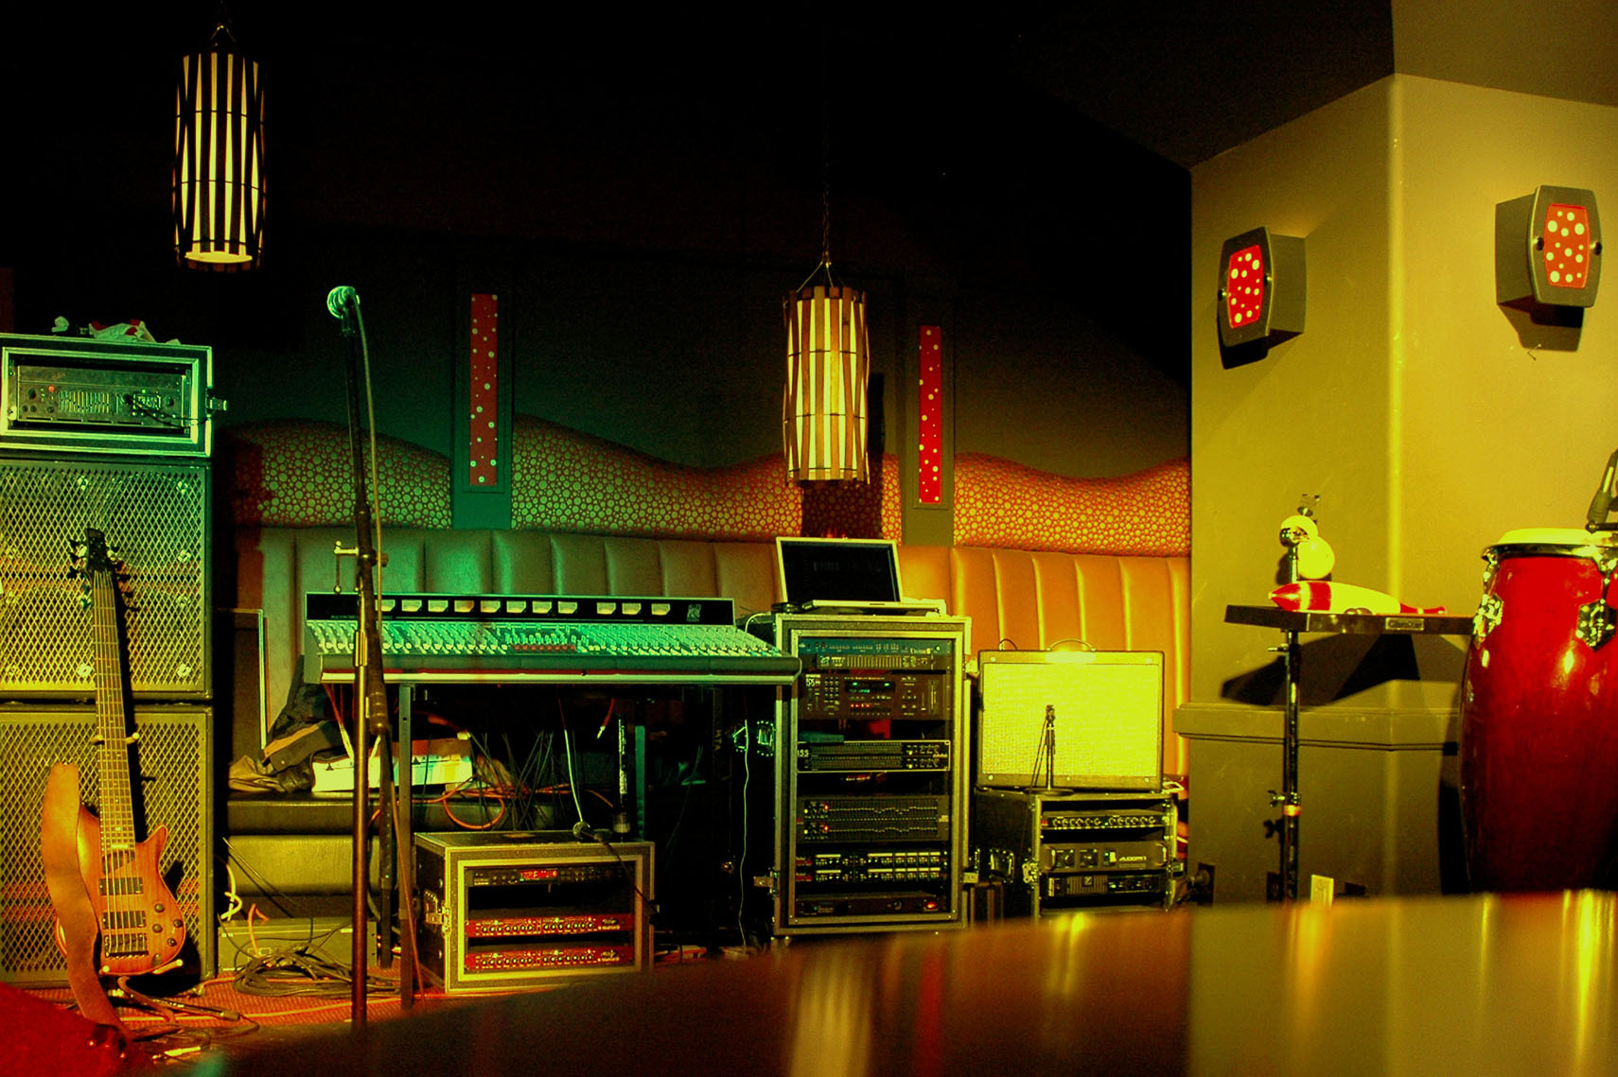
  - [Event Subtitle/Description]
[To replace any placeholder text (such as this), just select it and then begin typing. (Don’t include space to the right or left of the characters in your selection.)
To replace the photo, just delete it and then, on the Insert tab, click Picture.
Need to add text? Get any text formatting you see in this flyer with just a click on the Home tab, in the Styles group.]
[Event Date] [Event Time]
[Venue Name], [Street Address], [City, ST Zip Code]
[Web Address], [Email]

