Book title

|  |
| --- |
|  |

Teacher's name

Grade level(s)

School name

Book title

|  |  |
| --- | --- |
| Ernesto Mazza  Lesa Wallace  Lynette Yang  Author name  Author name | Author name  Author name  Author name  Author name  Author name |

Date

School name

Copyright © 2019

by Copyright holder name

ISBN: 123-45678-9

Printed in Country name

Table of contents

Jazz Hands by Lynette Yang 3

poetry by Ernesto Mazza 3

zest by Lesa Wallace 3

Poem title by Author 3

Authors 3

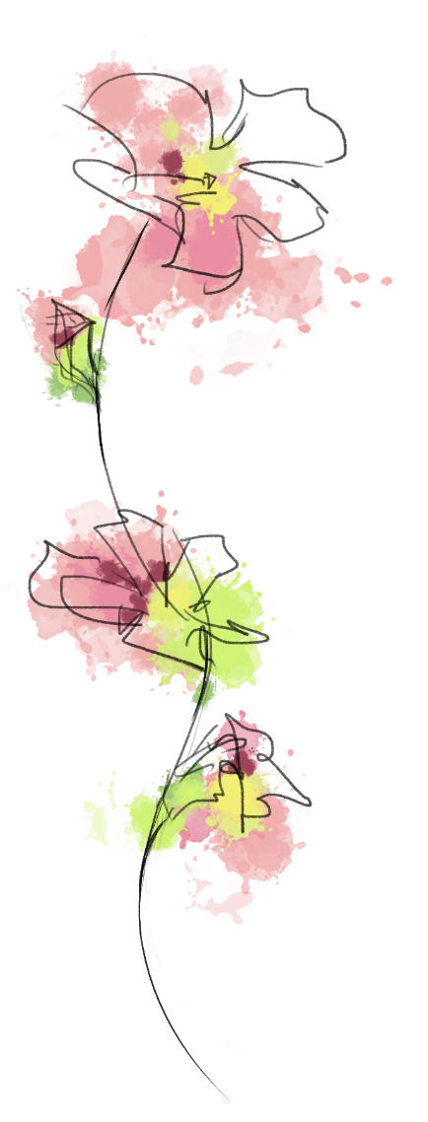Jazz Hands  
by Lynette Yang

what do you call it?

spread fingers and

shake or jingle

doesn't matter how old

how young the culture

recognised worldwide

comic or ironic

up, down, sideways

necessary to add a flourish

add pizzazz

excessive

percussive

immoderate

extravagant

dance

with jazz hands

poetry  
by Ernesto Mazza

patterns

oddly

evening

traces

round

you

zest  
by Lesa Wallace

orange delights, offends.

sweet, bright, bitter, refreshing.

colour controversy.

Poem title  
by Author

To get started straight away, simply tap any placeholder text (such as this) and start typing. Add new pages by putting the cursor in front of the “Authors” heading and going to Blank Page on the Insert tab.

Want something different? No problem! Change the look of the layout using font and paragraph styles on the Home tab.

When you’re ready to print, print on both sides, flipped on the short edge.

Want more? [Check out these tips for working with this template](https://go.microsoft.com/fwlink/?linkid=2086676).

# Authors

|  |  |
| --- | --- |
| Ernesto Mazza  Author  6th Grade | A young person wearing a white shirt |
| Lesa Wallace  Author  7th Grade |  |
| Lynette Yang  Author  10th Grade | A person with pink hair looking at the camera |
| Author name  Title  Organisation |  |