[Company Name]
  - [Brochure title or company tagline]
[This clean, professional brochure is designed for a single page, but you can easily add more content as needed to expand it. To view your brochure with all formatting and layout, on the View tab, choose Reading View.]
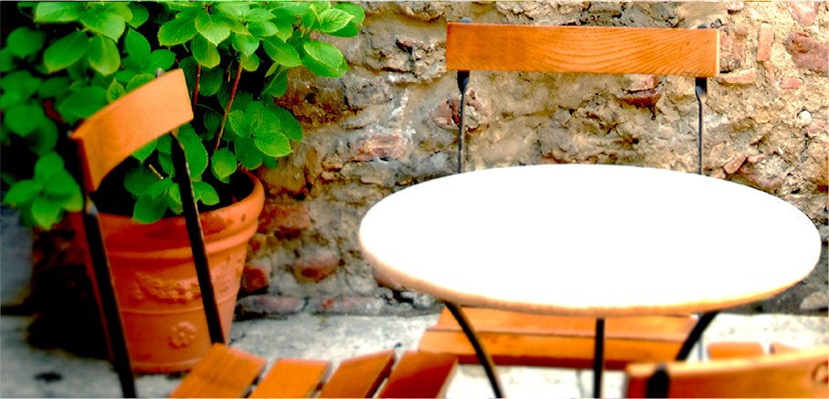

About us
[This is a great place for your ‘elevator pitch’. If you only had a few seconds to pitch your products or services to someone, what would you say?]
[Add a picture caption here] | Price quote:  [Not presenting a product that you want to quote? Consider using this space for a summary of services or a couple of your best customer testimonials.]  Limited time offer: [Price]

[Get started straight away]
[It’s easy to make this brochure your own…]
- [To get any text formatting you see in this document with just a tap, on the Home tab, take a look at the Styles gallery.]
- [To replace a photo, select or delete it. Then, on the Insert tab, choose Picture.]

Contact us
Phone: [Enter phone number] | Email: [Enter email address] | Web: [Enter website]

