5-Day Trip Planner
Day  1 | Destination: [Where are you going?]  Where to eat: [What’s for breakfast?]  What to do: [Got tickets for a great show?]  Where to stay: [Beach bungalow or friend’s sofa?]  How to get there: [Plane, train or GPS?]
Day  2 | [To replace any placeholder text (such as this), just select a line or paragraph of text and start typing. For best results, don’t include space to the left or right of the characters in your selection.]
Day  3 | [To replace a placeholder photo with your own, delete it. Then, on the Insert tab of the ribbon, click Picture.] | 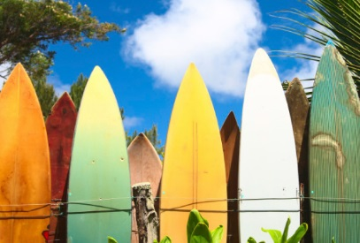
Day  4 | Destination: [Where are you going?]  Where to eat: [What’s for breakfast?]  What to do: [Got tickets for a great show?]  Where to stay: [Beach bungalow or friend’s sofa?]  How to get there: [Plane, train or GPS?] | 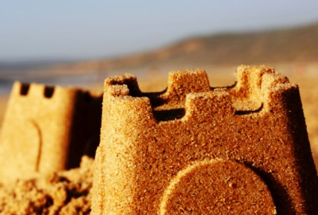
Day  5 | Destination: [Where are you going?]  Where to eat: [What’s for breakfast?]  What to do: [Got tickets for a great show?]  Where to stay: [Beach bungalow or friend’s sofa?]  How to get there: [Plane, train or GPS?]

